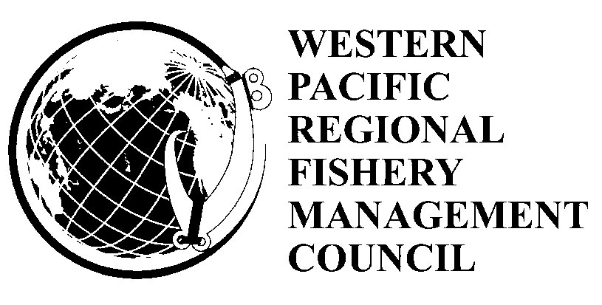

Summary of Action Items

1. Potential Modifications to the American Samoa Pelagic Longline Limited Entry Permit Program

The American Samoa longline fishery, which primarily targets albacore tuna, is managed under the Western Pacific Regional Fishery Management Council’s (Council) Fishery Ecosystem Plan for Pacific Pelagic Fisheries of the Western Pacific Region. In 2002, the Council recommended a vessel size-based limited entry system for the American Samoa longline fishery with criteria for participation in the fishery. The management objectives of the limited entry program are to: 1) prevent local depletion, 2) maintain sustained community participation in the fishery, 3) ensure opportunities for participation by indigenous American Samoans, 4) reduce gear conflicts, and 5) minimize fish bycatch. In 2003, small vessel participation in the fishery began to steadily contract due to what is believed to be from the combination of high economic costs such as fuel, bait, safety equipment and reduced albacore catch rates. In 2005, NMFS implemented the program and issued a total of 60 permits to qualified candidates amongst four vessel size classes. The American Samoa longline fishery has undergone substantial shift in participation in terms of vessel sizes, from a fishery once dominated by small vessels (37 active in 2002) generally less than 40 feet in length, to a large vessel fishery with all but one vessel over 50 feet (25 active in 2009). The lack of participation in the small vessel fleet is concerning to the Council, as this fleet when active is believed to provide important socio-cultural and economic benefits to the American Samoa fishing community. A regulatory amendment to the Pelagic Fisheries Ecosystem Plan considers potential modifications to the limited entry program to reduce programmatic barriers that may be limiting small vessel participation, which in turn, may be affecting sustained community and indigenous American Samoan participation in the longline fishery.

2. Potential Modifications to American Samoa Large Vessel (≥50 ft) Prohibited Area

A draft regulatory amendment to the Pelagics Fishery Ecosystem Plan proposes to modify the large vessel prohibited area (LVPA) around American Samoa, which is generally a 0-50 nm rectangle around Tutuila, Manua Islands, Rose Atoll in the south and another 0-50-nm rectangle around Swains Island. The LVPA, which was recommended by the Council in 1998 and implemented by NMFS in 2002, was a response by the Council to concerns by small scale (< 50 ft length overall (LOA)) alia longliners and troll fishermen that they would be outcompeted for tunas and other pelagic fish by an expanding large scale (≥ 50 ft LOA) longline fleet. The LVPA successfully separated the large longliners to an “offshore” area outside of 50 nm from the alia and troll vessels that typically fish within a “nearshore” area (0-50 nm). Hook density in the offshore area has risen since 2002, while hook density in the nearshore area has been significantly reduced as the alia longline fleet has contracted to a single operational vessel and troll fishing has been greatly reduced from its peak during the 1980s and 1990s. Further, no major fishing operation has been developed on Swains Island, which continues to be inhabited by less than 10 people, engaged in a largely subsistence lifestyle and dependant on copra harvesting. As such the need for physical separation between the two sectors is not as warranted

The offshore area outside of the LVPA is approximately 260,000 km ²; however, the establishment of incongruent boundaries between the LVPA and the Rose Atoll Marine National Monument in 2009 further reduced fishing area available to the large vessel fleet by approximately 6175 km² to 253,825 km². Hook density within the offshore area outside of the LVPA has been observed since 2006 to be at levels at or above levels associated with gear conflict. For these reasons, the Council is considering potential modifications to the boundaries of the LVPA.

