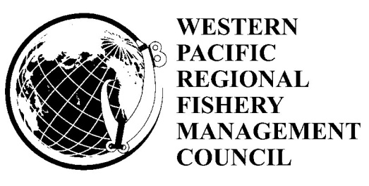

Hawaii Archipelago Fishery Ecosystem Plan Advisory Panel Meeting

April 13-14, 2011
9:00 a.m. – 5:00 p.m.
Council Conference Room
1164 Bishop Street Suite 1400
Honolulu, Hawaii

Day 1: Wednesday, April 13, 2011

- National Fisheries Mandates and Issues
  - Coastal and Marine Spatial Planning
    - Overview of CMSP Roy Morioka
    - Community CMSP Workshop Sylvia Spalding
  - Update on Annual Catch Limits Paul Dalzell/Sarah Pautzke
  - Report on ACL and Catch Share Workshops Roy Morioka

- Upcoming Fishery Management Actions
  - Options for Non-Commercial Fishery Data Reporting Joshua DeMello Josh DeMello
  - Hawaiian Archipelago Bottomfish EFH and HAPC review Chris Kelley
  - Status of State Bottomfish Regulatory Changes Alton Miyasaka
  - Options for Limited Entry of Offshore Aquaculture Joshua DeMello

- Coral Reef Funded Projects
  - Kona Crab Stock Assessment Lennon Thomas
  - Black Coral Mapping Daniel Wagner
  - Deepwater Chorusing Phenomenon Marc Lammers
  - Report on Tournament Sampling Eddie Ebisui
  - Upcoming Coral Reef Projects Joshua DeMello

- Public Comment on Day 1 agenda items

Day 2: Thursday, April 14, 2011

- Council and Advisory Panel Responsibilities
  - Introductions AP Members
  - Council and MSA Overview Joshua DeMello
  - Advisory Panel Responsibilities Mark Mitsuyasu AP Members

- Protected Species Issues
  - Insular False Killer Whale Listing Under ESA Laura McCue
  - Spinner Dolphin and Human Interaction EIS and Rule-making Krista Graham
  - Hawaiian Monk Seal Programmatic EIS Jeff Walters
  - Public Comment
  - Discussion and Recommendations Ed Watamura

- Review of Previous Day Presentations Joshua DeMello
  - Review of Action Items
  - Discussion and AP Recommendations Ed Watamura

- Hawaii Fishery Issues Alton Miyasaka
  - Aquaculture Update Joshua DeMello
  - MHI Bottomfish Update Mark Mitsuyasu
  - Ocean Regulatory Regime Review Initiative Melissa Bos
  - Other Hawaii Fishery Issues AP Members
  - Public Comment
  - Discussion & Recommendations Ed Watamura

- Ecosystems and Communities
  - Report on Hoolei Ia Puwalu Charles Kaaiai
  - MRIP/NSWAR Update Joshua DeMello
  - Community Monitoring Tacklebox Mark Mitsuyasu
  - Public Comment
  - Discussion and Recommendations Ed Watamura

- Public Comment on Day 2 agenda items

- Discussion and Review of AP Recommendations Ed Watamura

