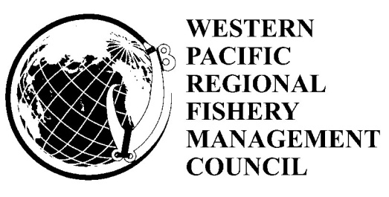

DRAFT AGENDA

152nd Meeting of the Western Pacific Regional Fishery Management Council

October 19, 2011
Executive and Budget Standing Committee
Pelagics and International Standing Committee

Western Pacific Fishery Council Conference Room
1164 Bishop Street, Suite 1400
Honolulu, Hawaii 96813
Phone: (808) 522-8220
Fax (808) 522-8226

October 19-22, 2011
Council Meeting
Laniakea YWCA-Fuller Hall
1040 Richards Street
Honolulu Ahupuaa
Kona Moku
Honolulu, Hawaii 96813
Phone: (808) 538-7061
Fax: (808) 521-8416

Wednesday  October 19  Council Office | Thursday,  October 20  Fuller Hall | Friday  October 21  Fuller Hall | Saturday  October 22  Fuller Hall
Exec & Bud  Standing Com  8:00 a.m. - 10:00 a.m. | 9:00 am – 6:00 pm | 9:00 am –  6:00 pm | 8:30 am -  1:00 pm
Pelagic & Int.
Standing Com
10:00 a.m.
Noon
Council Mtg  Fuller Hall  2:00 – 6:00 p.m | Fishers Forum  Waikiki Aquarium  6:00 p.m.

Notice to Public

Please note the actual order and timing of agenda items may vary somewhat from the proposed agenda. For example, items not completed on the scheduled day will be carried over to the next day. Items may be moved to an earlier or later time than shown on this Proposed Agenda or rescheduled for a different time during the week. In accordance with the Magnuson-Stevens Fishery Conservation and Management Act, fishery management regulatory actions not contained in this agenda may come before this Council for discussion. However, such issues may not be the subject of formal Council action during this meeting, unless they are emergency in nature.

To present oral testimony or comments at this meeting, fill-out a comment card, and indicate the agenda item on which you wish to speak. Cards are available at the sign-in desk outside the Council meeting room. Oral testimony is limited to three minutes. Please identify yourself and whom you represent at the beginning of your testimony. Public comment on non-agenda items will be taken on Thursday, October 20, 2011, from 4:00 p.m. to 5:00 p.m.

Written comments received by October 14, 2011, will be copied and distributed to Council members prior to the meeting. After October 14, 2011 it is the submitter’s responsibility to provide Council staff with an adequate number of copies to ensure coverage of the Council (a minimum of 40 copies).

Financial interest statements for the appointed Council members are available for inspection at the Council Office at the meeting.

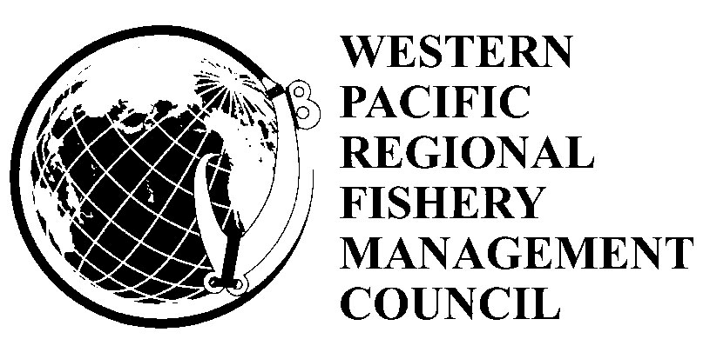

Draft Agenda
152nd Council Meeting
October 19-22, 2011

Wednesday, October 19, 2011
Council Office

Executive and Budget Standing Committee 8:00 a.m. – 10:00 a.m.
Pelagic and International Standing Committee 10:00 a.m. – Noon

Wednesday, October 19, 2011
Laniakea YWCA-Fuller Hall

Council Meeting 2:00 p.m. – 6:00 p.m.

Thursday, October 20, 2011
Laniakea YWCA-Fuller Hall

Council Meeting 9:00 a.m. – 6:00 p.m.

Thursday, October 20, 2011
Waikiki Aquarium
Fishers Forum 6:00 p.m. – 9:00 p.m.

Friday, October 21, 2011
Laniakea YWCA-Fuller Hall
Council Meeting 9:00 a.m. – 6:00 p.m.

Saturday, October 22, 2011
Laniakea YWCA-Fuller Hall
Council Meeting 8:30 a.m. – 1:00 p.m.

Wednesday, October 19, 2011
8:00 a.m. – Noon
Council Office

Executive and Budget Standing Committee 8:00 a.m. – 10:00 a.m.
Pelagic and International Standing Committee 10:00 a.m. – Noon

Wednesday, October 19, 2011
2:00 p.m. – 6:00 p.m.
Laniakea YWCA-Fuller Hall

- Introductions

- Approval of the 152nd Agenda

- Approval of the 151st Meeting Minutes

- Executive Director’s Report

- Agency Reports
  - National Marine Fisheries Service
    - Pacific Islands Regional Office
    - Pacific Islands Fisheries Science Center
  - NOAA Regional Counsel
  - US Fish and Wildlife Service
  - Enforcement
    - US Coast Guard
    - NMFS Office for Law Enforcement
    - NOAA General Counsel for Enforcement and Litigation
  - Public Comment
  - Council Discussion and Action

Thursday, October 20, 2011
9:00 a.m. – 6:00 p.m.
Laniakea YWCA-Fuller Hall

- Program Planning and Research
  - Specification of Annual Catch Limits (ACTION ITEM)
    - Species with No MSY, Existing Quota, or Reference Points (Tier 5)
      - Coral Reef Fish for All Island Areas
      - Vulnerable Species for All Island Areas
      - Mollusks, Crustaceans, Other Invertebrates for All Island Areas
    - Species with MSY, Existing Quota, or Reference Points (Tier 3 and 4)
      - Coastal Pelagics in Hawaii
      - Non-Finfish for All Island Areas
        - Lobster
        - Kona Crab
        - Deepwater Shrimp
        - Black Corals
        - Precious Corals
      - Bottomfish
        - BMUS in American Samoa, Guam, CNMI
        - Non Deep 7 for Hawaii
  - Report on EFH Review for AS, GU, CNMI Bottomfish and Other MUS
  - Coastal Marine Spatial Planning
    - Regional Initiatives
    - Report on Coastal Marine Spatial Planning Workshop
    - Indigenous Climate Change Summit
  - Review of the WPRFMC 5-Year Research Priorities
  - Cooperative Research Priorities
  - CDP Proposal: Traditional Fishing Training Program and Exemption to the MHI Pelagic Longline Closed Area (Action Item)
  - Report on NMFS Bio-Sampling Program
  - Update on National/Regional Marine Recreational Fishing
  - Hawaii, Regional, National & International Education and Outreach
  - SSC Recommendations
  - Hawaii Plan Team, Non-Commercial Advisory Panel and
Bottomfish Advisory Review Board Recommendations
  - Response to NMFS Letter on Council Recommended Fishing
Regulations for Marine National Monuments
  - Public Hearing
  - Council Discussion and Action

Lunch 1:00 p.m. – 2:00 p.m.

- Marianas Archipelago
  - Arongo Flaeey
  - Isla Informe
  - Legislative Report
  - Enforcement Issues
  - Report on Marianas TMNM Science and Expo Wkshp
  - Community Activities and Issues
    - Marianas Military Range Complex EIS Scoping
  - Education and Outreach Initiatives
  - SSC Recommendations
  - Public Comments
  - Council Discussion and Action

- American Samoa Archipelago
  - Motu Lipoti
  - Fono Report
  - Enforcement Issues
  - Update on Community Fisheries Development
  - Community Activities and Issues
  - Education and Outreach Initiatives
  - SSC Recommendations
  - Public Comments
  - Council Discussion and Action

- Public Comment on Non-Agenda Items

6:00 p.m. – 9:00 p.m. Fishers Forum

Code of Conduct for Hawaii’s Ocean Users
Waikiki Aquarium

Friday, October 21, 2011 9:00 a.m. - 6:00 p.m.

- Hawaii Archipelago
  - Moku Pepa
  - Legislative Report
  - Enforcement Issues
  - Recommendations on Hawaii Non-Commercial
Data Collection (ACTION ITEM)
  - Bottomfish
    - Update on Bottomfish Life History Information
    - Draft Amendment for HI Bottomfish EFH (ACTION ITEM)
  - Community Projects, Activities and Issues
      - Report on Hawaii Regulatory Review Initiative
      - Maunalei Ahupua`a Restoration Project
      - Report on the Kona Integrated Ecosystem Assessment Workshop
      - Report on Community FADs
      - Update from State on Shark Fining Policy
      - Report on Open Ocean Aquaculture Project
  - Non-Commercial Fisheries Data Advisory Committee and
Hawaii Plan Team Recommendations
  - SSC Recommendations
  - Public Hearing
  - Council Discussion and Action

Lunch 1:00 p.m. – 2:00 p.m.

- Pelagic & International Fisheries
  - Recommendations on American Samoa Swordfish Fishery (ACTION ITEM)
  - Striped Marlin Catch Limits(ACTION ITEM)
  - Information on Yellowfin Tuna Around the Hawaiian Islands
Management Implications
  - American Samoa and Hawaii Longline Quarterly Reports
  - International Fisheries Meetings
    - Kobe III
    - Kobe III Bycatch Working Group
    - WCPFC Science Committee
    - WCPFC Northern Committee
    - WCPFC Technical Compliance Committee
    - International Scientific Committee 11th Meeting
    - NP RFMO PrepCon
  - Disapproved Amendments
  - SSC Discussion and Recommendations
  - Pelagics Standing Committee Recommendations
  - Public Hearing
  - Council Discussion and Action

Saturday, October 22, 2011 8:30 a.m. – 1:00 p.m.

- Protected Species
  - Loggerhead Turtle Final Listing Rule and New Biological Opinion
  - False Killer Whale Take Reduction Plan Proposed Rule and
Take Reduction Team Meeting
  - Proposed 2012 List of Fisheries
  - Endangered Species Act Section 4 (Listing and Critical Habitat) Update
  - Update on Council Turtle Program
  - SSC Recommendations
  - Public Comment
  - Council Discussion and Action

10:30 Break

- Administrative Matters
  - Financial Reports
  - Administrative Reports
  - SOPP Review and Changes
  - Council Family Changes
  - Meetings and Workshops
  - Other Business
  - Standing Committee Recommendations
  - Public Comment
  - Council Discussion and Action

- Appointment of Council Officers

- Other Business

-PAU-

