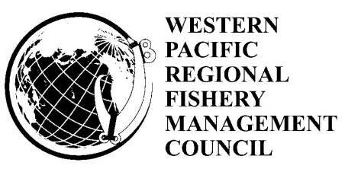

Mariana Archipelago Fishery Ecosystem Plan
Regional Ecosystem Advisory Committee and
Advisory Panel

Thursday, August 22, 2013
, Saipan
9:00 a.m. – 3:00 p.m.

Agenda

- Welcome and Introductions Arnold Palacio
- Status Report on 157th Council Meeting Recommendations regarding CNMI Jack Ogumoro
- CNMI Commercial Dock Development Study
  - Contract & Project Status Mark Mitsuyasu
  - Overview of draft Dock Development Plan Study Fred Smith
    - Existing Conditions (Sites, Loading, Design Criteria, Mooring, Berthing, Utilities, etc)
    - Land-side support facilities
    - Preliminary Alternatives
      - Outer Cove Mariana
      - Puerto Rico Dump (PRD)
      - Echo Dock
      - Sea Plan Ramp
    - Environmental Consideration and Permits John Gourley
    - Discussion
  - Evaluation of Preliminary Alternatives Fred Smith
  - Discussion on Preferred Site Location Arnold Palacios
- Council Coral Reef Grant Priorities and Projects Josh DeMello
- Revising the Large Vessel Closure for CNMI Bottomfish Mark Mitsuyasu
- Other Business Arnold Palacios
- Public Comment
- Discussion and Recommendations Arnold Palacios

