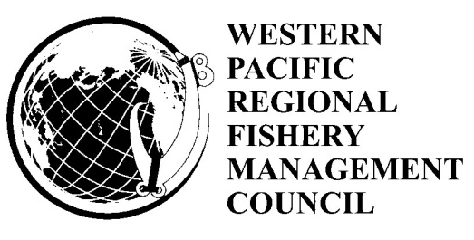(Draft v2 5/26/12)

**DRAFT AGENDA**

**154th Meeting of the Western Pacific Regional Fishery Management Council**

June 25-29, 2012

Council Meeting

Laniakea YWCA-Fuller Hall

1040 Richards Street

Honolulu Ahupuaa

Kona Moku

Honolulu, Hawaii 96813

Phone: (808) 538-7061

Fax: (808) 521-8416

|  |  |  |  |  |
| --- | --- | --- | --- | --- |
| **154th Council Meeting Schedule** | | | | |
| *Monday,*  *June 25* | *Tuesday,*  *June 26* | *Wednesday*  *June 27* | *Thursday,*  *June 28* |  |
| 10:00 a.m. – Noon  Pelagic and International Standing Committee Meeting | 9:00 a.m. – Noon  Council Meeting  *Agency Reports* | 8:30 a.m. – Noon  Council Meeting  *Protected Species and*  *American Samoa* | 8:30 a.m. – 12:30  Council Meeting  *Hawaii Archipelago and PRIAs* |  |
| 12:30 p.m. –  3:00 p.m.  Executive and Budget Standing Committee Meeting | 1:30 p.m. – 4:30 p.m.  Council Meeting  *Program Planning and Research* | 1:30 p.m. – 5:30 p.m.  Council Meeting  *Marianas Archipelago*  *and*  *Pelagics and International* | *(Working Lunch)*  1:00 p.m. – 4:00 p.m.  Council Meeting  *Administrative and Budget* |  |
|  | 4:30 p.m. – 5:30 p.m.  Public Comment on Non-agenda Items | 6:00 p.m. – 9:00 p.m.  Fishers Forum |  |  |

***Notice to Public***

Please note the actual order and timing of agenda items may vary somewhat from the proposed agenda. For example, items not completed on the scheduled day will be carried over to the next day. Items may be moved to an earlier or later time than shown on this Proposed Agenda or rescheduled for a different time during the week. In accordance with the Magnuson-Stevens Fishery Conservation and Management Act, fishery management regulatory actions not contained in this agenda may come before this Council for discussion. However, such issues may not be the subject of formal Council action during this meeting, unless they are emergency in nature.

**To present oral testimony or comments at this meeting**, fill-out a comment card, and indicate the agenda item on which you wish to speak. Cards are available at the sign-in desk outside the Council meeting room. Oral testimony is limited to three minutes. Please identify yourself and whom you represent at the beginning of your testimony. Public comment on non-agenda items will be taken on Tuesday, June 26, 2012, from 4:30 p.m. to 5:30 p.m.

**Written comments received by June 22, 2012,** will be copied and distributed to Council members prior to the meeting. **After June 22, 2012** it is the submitter’s responsibility to provide Council staff with an adequate number of copies at the meeting to ensure coverage of the Council (a minimum of 40 copies).

Financial interest statements for the appointed Council members are available for inspection at the Council Office at the meeting.

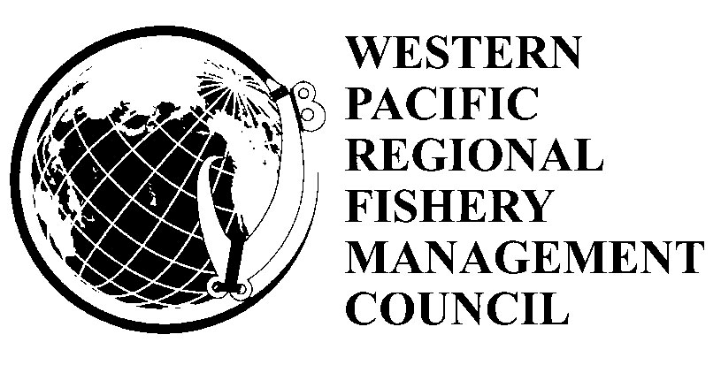

**Draft Agenda**

**154th Council Meeting**

June 25, 2012

Standing Committee Meetings

Council Office

1164 Bishop St. Suite 1400

Honolulu Ahupuaa

Kona Moku

Honolulu, Hawaii 96813

Phone: (808) 522-8220

Fax: (808) 522-8226

Pelagic and International Standing Committee Meeting Monday, 10:00 a.m. – Noon

Executive and Budget Standing Committee Meeting Monday, 12:30 a.m. – 3:00 p.m.

June 26-29, 2012

Council Meeting

Laniakea YWCA-Fuller Hall

1040 Richards Street

Honolulu Ahupuaa

Kona Moku

Honolulu, Hawaii 96813

Phone: (808) 538-7061

Fax: (808) 521-8416

Council Meeting Tuesday, 9:00 a.m. – 5:30 p.m.

Council Meeting Wednesday, 8:30 a.m. – 5:30 p.m.

Council Meeting Thursday, 8:30 a.m. – 4:00 p.m.

**Draft Agenda**

**154th Council Meeting**

**Laniakea YWCA-Fuller Hall**

**1040 Richards Street**

***Tuesday, June 26, 2012***

***9:00 a.m. – 5:30 p.m.***

1. **Welcome and Introductions**
2. **Approval of the 154th Agenda**
3. **Approval of the 153rd Meeting Minutes**
4. **Executive Director’s Report**
5. **Agency Reports**
   1. National Marine Fisheries Service
      1. Pacific Islands Regional Office
      2. Pacific Islands Fisheries Science Center
   2. NOAA Regional Counsel
   3. National Marine Sanctuary Program
   4. US Fish and Wildlife Service
   5. Enforcement
      1. US Coast Guard
      2. NMFS Office for Law Enforcement
      3. NOAA General Counsel for Enforcement and Litigation
   6. Public Comment
   7. Council Discussion and Action

***Lunch Break 12:00 noon – 1:30 p.m.***

***1:30 p.m. – 4:30 p.m.***

1. **Program Planning and Research**
   1. Cooperative Research Priorities (**Action Item**)
   2. Fishery Data Collection Improvement Proposal
   3. Territorial EFH/HAPC Review
   4. Report on Territory Bottomfish Stock Assessments
   5. Report on Open Ocean MPAs for HMS – PIRO Grant to MCI
   6. Report on Education and Outreach Programs and Projects
   7. Advisory Group Recommendations
      1. Archipelagic Plan Team Report and Recommendations
      2. Hawaii Plan Team Report and Recommendations
      3. Data Principles Meeting Report
      4. Joint Advisory Panel Report and Recommendations
   8. SSC Recommendations
   9. CCC Recommendations
      1. Coastal and Marine Spatial Planning
      2. Stock Assessment
      3. National SSC Working Group
      4. Report on CCC 5-year Priorities Research Recommendations
      5. Report on CCC Communications Recommendations
      6. Managing Our Nation’s Fisheries III
      7. Electronic Monitoring
      8. National Standard 1 Advance Notice of Proposed Rule Making
   10. Public Hearing
   11. Council Discussion and Action

***4:30 p.m. – 5:30 p.m.***

1. **Public Comment on Non-Agenda Items**

**Council Meeting**

**Laniakea YWCA-Fuller Hall**

**1040 Richards Street**

***Wednesday June 27, 2012***

***8:30 a.m. – 5:30 p.m.***

1. **Protected Species**
2. North Pacific Humpback Whale Population in Alaska
3. CCC Jeopardy Panel Report
4. Update on Endangered Species Act (ESA) and Marine Mammal   
   Protection Act (MMPA) Actions
   1. General Update on ESA and MMPA Actions
   2. Honu (Hawaiian Green Sea Turtle) ESA Petition Finding
   3. Update on Hawaiian Monk Seal Critical Habitat revisions
5. Status Review Report and Management Report of 82 Candidate   
   Coral Species Petitioned Under the ESA
6. Value of Marker Bigeye Tuna in Relation to Proposed False Killer

Whale Management Measure

* 1. Advisory Group Recommendations
     1. Joint Advisory Panel Meeting Report and Recommendations
     2. Hawaii REAC Report and Recommendations
     3. Sea Turtle Advisory Committee Report and Recommendations
  2. SSC Recommendations
  3. Public Comment
  4. Council Discussion and Action

1. **American Samoa Archipelago** 
   1. Motu Lipoti
   2. Fono Report
   3. Enforcement Issues
   4. Community Activities and Issues
      1. Update on Community Fisheries Development
   5. American Samoa Marine Conservation Plan (**Action Item**)
   6. Education and Outreach Initiatives
   7. SSC Recommendations
   8. Public Hearing
   9. Council Discussion and Action

***Lunch Break Noon – 1:30 p.m.***

***1:30 p.m. – 5:30 p.m.***

1. **Marianas Archipelago**
   1. Island Reports
      1. Arongo Flaeey
      2. Isla Informe
   2. Legislative Report
      1. CNMI
      2. Guam
   3. Enforcement Issues
      1. CNMI
      2. Guam
   4. Status of Guam Indigenous Fishing Rights PL 29-127
   5. Community Activities and Issues
   6. Education and Outreach Initiatives
   7. Report of the Joint AP Meeting
   8. SSC Recommendations
   9. Public Comments
   10. Council Discussion and Action
2. **Pelagic & International Fisheries** 
   1. Amendment Options for Marianas Purse Seine Area Closure **(Action Item)**
   2. Recommendations on Territory Bigeye Tuna Catch Limits (**Action Item**)
   3. Options for American Samoa Longline and Purse Seine Landing

Requirements (**Action Item**)

* 1. American Samoa and Hawaii Longline Quarterly Reports
  2. International Fisheries Meetings
     1. WCPFC 8
     2. IATTC GAC/SAC
     3. US Report to the Tuna Commission
  3. CCC Recommendation on International Fisheries Management
  4. Pelagic Plan Team Report
  5. SSC Discussion and Recommendations
  6. Pelagic Standing Committee Report
  7. Public Hearing
  8. Council Discussion and Action

**Fishers Forum**

**Harbor View Center**

**1129 North Nimitz Hwy (Pier 38)**

**Honolulu, Hawaii**

**Tel: (808) 983-1200**

***“Thar She Blows”: Managing for the Recovery of the North Pacific Humpback Whale***

**6:00 – 9:00 p.m.**

**Council Meeting**

**Laniakea YWCA-Fuller Hall**

**1040 Richards Street**

***Thursday, June 28, 2012***

***8:30 a.m. – 4:00 p.m.***

1. **Hawaii Archipelago and PRIAs** 
   1. Moku Pepa
   2. Legislative Report
   3. Enforcement
   4. Bottomfish
      1. Report on BRFA Review
      2. Update on Bottomfish Annual Catch Target
      3. Recommendations on 2012-2013 Main Hawaiian Islands Bottomfish

Annual Catch Target (**Action Item**)

4. Hawaii EFH/HAPC (**Action Item**)

* 1. Community Projects, Activities and Issues
     + 1. Status of Aha Moku Legislation
       2. Report on Aha Moku Projects
  2. Advisory Group Recommendations
     1. Joint AP Meeting Report and Recommendations
     2. Hawaii Plan Team Meeting Report and Recommendations
     3. Hawaii REAC Report and Recommendations
  3. SSC Recommendations
  4. Public Hearing
  5. Council Discussion and Action

***Working Lunch***

***1:30 p.m. – 4:00 p.m.***

1. **Administrative Matters** 
   1. Financial Reports
   2. Administrative Reports
   3. Freedom of Information Act (FOIAs) Requests
   4. Council Family Changes
      1. Data Committee
      2. SSC Term Limits
      3. Plan Teams
   5. Meetings and Workshops
      1. Council Coordination Committee Meeting Report and

Follow-up

* + - * 1. Consultation with GAO regarding Moving NMFS to USFWS
        2. 2013 Budget
  1. DOC/OIG Review of the Fishery Management Rule Making Process
  2. Other Business
  3. Standing Committee Recommendations
  4. Public Comment
  5. Council Discussion and Action

1. **Other Business**

**-PAU-**