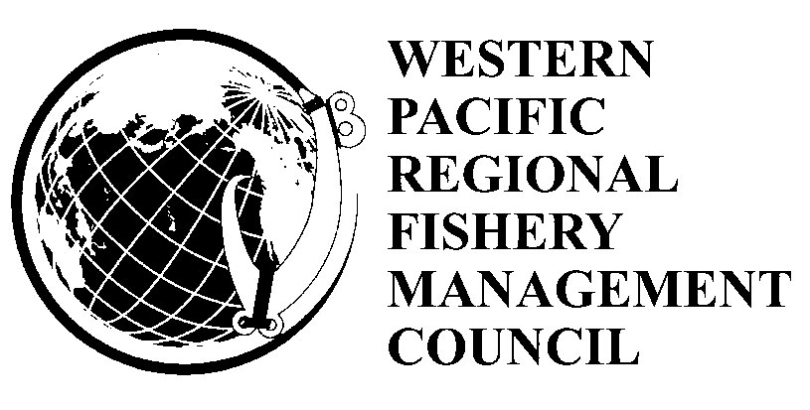
Agenda
Pelagics Plan Team Meeting
May 7 - 9, 2014
8.30 - 5.00 pm
1164 Bishop St., Suite 1400
Honolulu, Hawaii
Wednesday May 7, 2013 8.30 am

1. Introduction Keith Bigelow
2. Annual Report review Keith Bigelow
a. Review 2013 Annual Report modules and recommendations
i. CNMI Ray Roberto
- American Samoa Nonu Tuisamoa Serena Williams
- Guam Brent Tibbats
- Hawaii Russell Ito
- International Keith Bigelow
b. 2012 Annual Report region wide recommendations Keith Bigelow

Thursday – Friday May 8-9 2013 8.30 am

- WCPFC 10 Paul Dalzell/Tom Graham/Keith Bigelow
- South Pacific albacore and American Samoa longline Paul Dalzell/Minling Pan
- Biological Opinions for deep set tuna fishery
and American Samoa longline fishery Adam Bailey
- Outstanding FEP amendments Paul Dalzell/Eric Kingma
- Recreational Fisheries David Itano
- Hawaii yellowfin stock assessment Paul Dalzell
- Marianas shark survey Paul Dalzell
- Electronic monitoring and reporting Eric Kingma
- Seabird-longline fishery interactions Tom Graham
- Other business Keith Bigelow
- Public comment
- Pelagic Plan Team Recommendations Keith Bigelow

