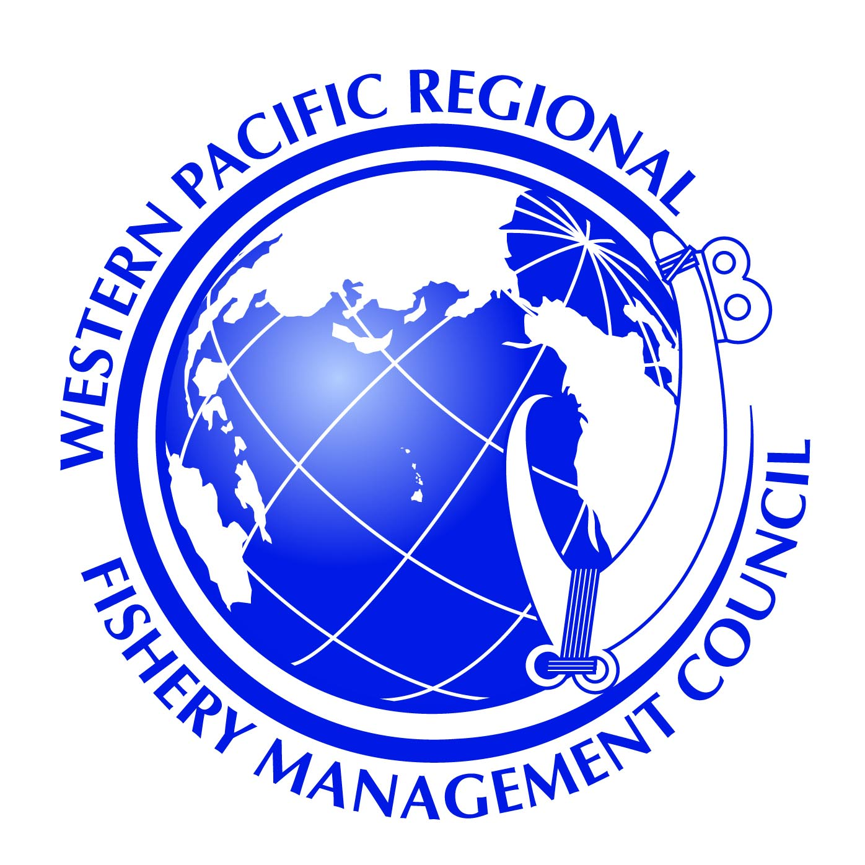

NOTICE OF PUBLIC MEETING

COMMONWEALTH OF NORTHERN MARIANAS

BOTTOMFISH MANAGEMENT

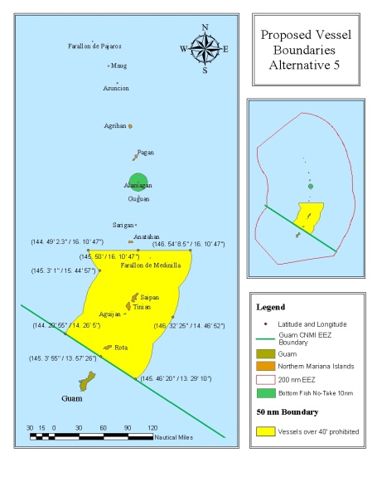

The Western Pacific Fishery Management Council (Council) will convene public informational scoping meetings in the Commonwealth of Northern Marianas Islands (CNMI) to solicit comments on the management of the bottomfish fishery in their Exclusive Economic Zones (EEZ. The scoping meeting will, among other things, describe existing federal management rules for bottomfish species, examine the current performance of the fishery and consider the need for potential rule changes.

Meetings will be held at the following locations, dates and times.

|  |  |  |
| --- | --- | --- |
| Date | Time | Location |
| Monday, April 28, 2014 | 6:00-9:00 p.m. | Rota – Sinapalo Youth Center |
| Wednesday, April 30, 2014 | 6:00-9:00 p.m. | Tinian- Tinian Elementary School Cafeteria |

For additional information or questions, please contact the Western Pacific Fishery Management Council at (808) 522-8220; on CNMI contact Jack Ogumoro at 670-287-9482 or 670-322-9834.

**Public Scoping Meetings on CNMI Bottomfish Fishery Rule Changes**

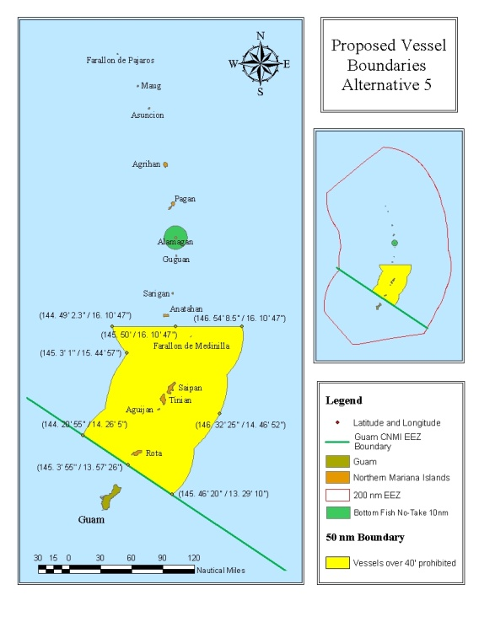

**Background Information**

In 2009, federal fishing rules were put in place to manage bottomfishing in the waters around CNMI’s southern islands. The rules included a 50 mile closure area for vessels larger than 40 feet prohibiting bottomfishing for Bottomfish Management Unit Species (BMUS) around the islands of the islands of Rota, Saipan, Tinian and FDM. In addition, a 10 mile closure was also created around the island of Alamagan. Other rules include federal permit and trip reporting and the use of a vessel monitoring system for fishermen harvesting BMUS in CNMI waters.

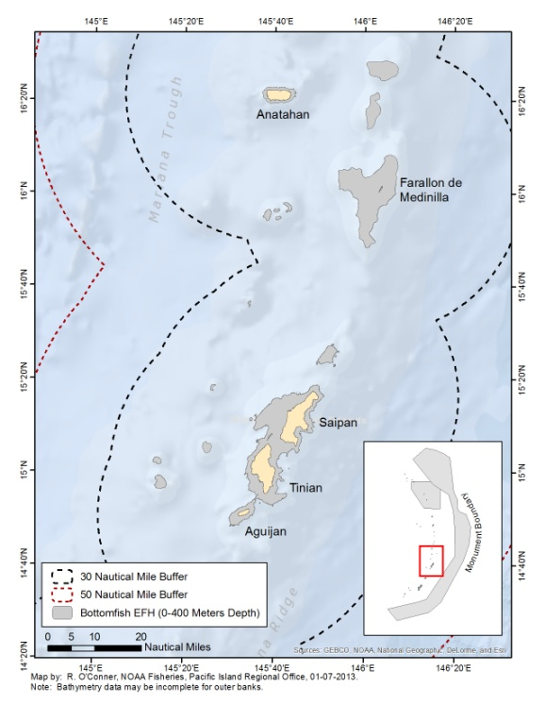Proposed rule changes to be discussed will include removing the 50 mile area closure for vessels larger than 40 feet. Also, being considered is a closure reduction from 50 miles to 30 miles around the Southern Islands. Finally, the option to retain or remove the 10 mile closure around Alamagan will also be discussed during these public meetings.

Federal Bottomfish Management Unit Species

|  |  |  |
| --- | --- | --- |
| **Species name** | **Common name** | **Deep or shallow** |
| *Aphareus rutilans* | Lehi | Deep |
| *Aprion virescens* | Uku | Shallow |
| *Caranx ignobilis* | Giant trevally | Shallow |
| *Caranx lugubris* | Black trevally | Deep |
| *Epinephelus fasciatus* | Blacktip grouper | Shallow |
| *Etelis carbunculus* | Ehu | Deep |
| *Etelis coruscans* | Onaga | Deep |
| *Lethrinus amboinensis* | Ambon emperor | Shallow |
| *Lethrinus rubrioperculatus* | Redgill emperor | Shallow |
| *Lutjanus kasmira* | Blueline snapper | Shallow |
| *Pristipomoides auricilla* | Yellowtail snapper | Deep |
| *Pristipomoides filamentosus* | Opakapaka | Deep |
| *Pristipomoides flavipinnis* | Yelloweye opakapaka | Deep |
| *Pristipomoides seiboldi* | Kalekale | Deep  Reduction of closure from 50 to 30 miles provides no additional bottomfishing habitat around the southern island of CNMI. |
| *Pristipomoides zonatus* | Gindai | Deep |
| *Seriola dumerili* | Amberjack | Shallow |
| *Variola louti* | Lunartail | Deep |

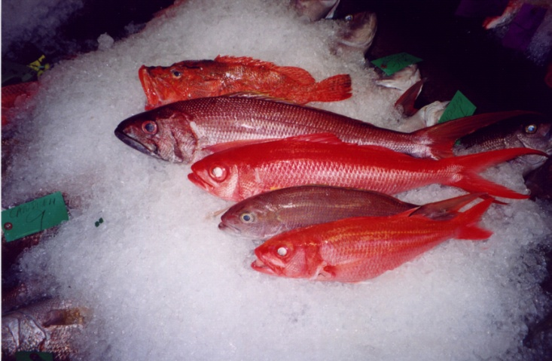

For more information regarding bottomfishing rules and regulations in CNMI, please visit [www.wpcouncil.org](http://www.wpcouncil.org) or call the Western Pacific Fishery Management Council Office at (808) 522-8220. On CNMI contact Jack Ogumoro at 670-287-9482 or 670-322-9834.