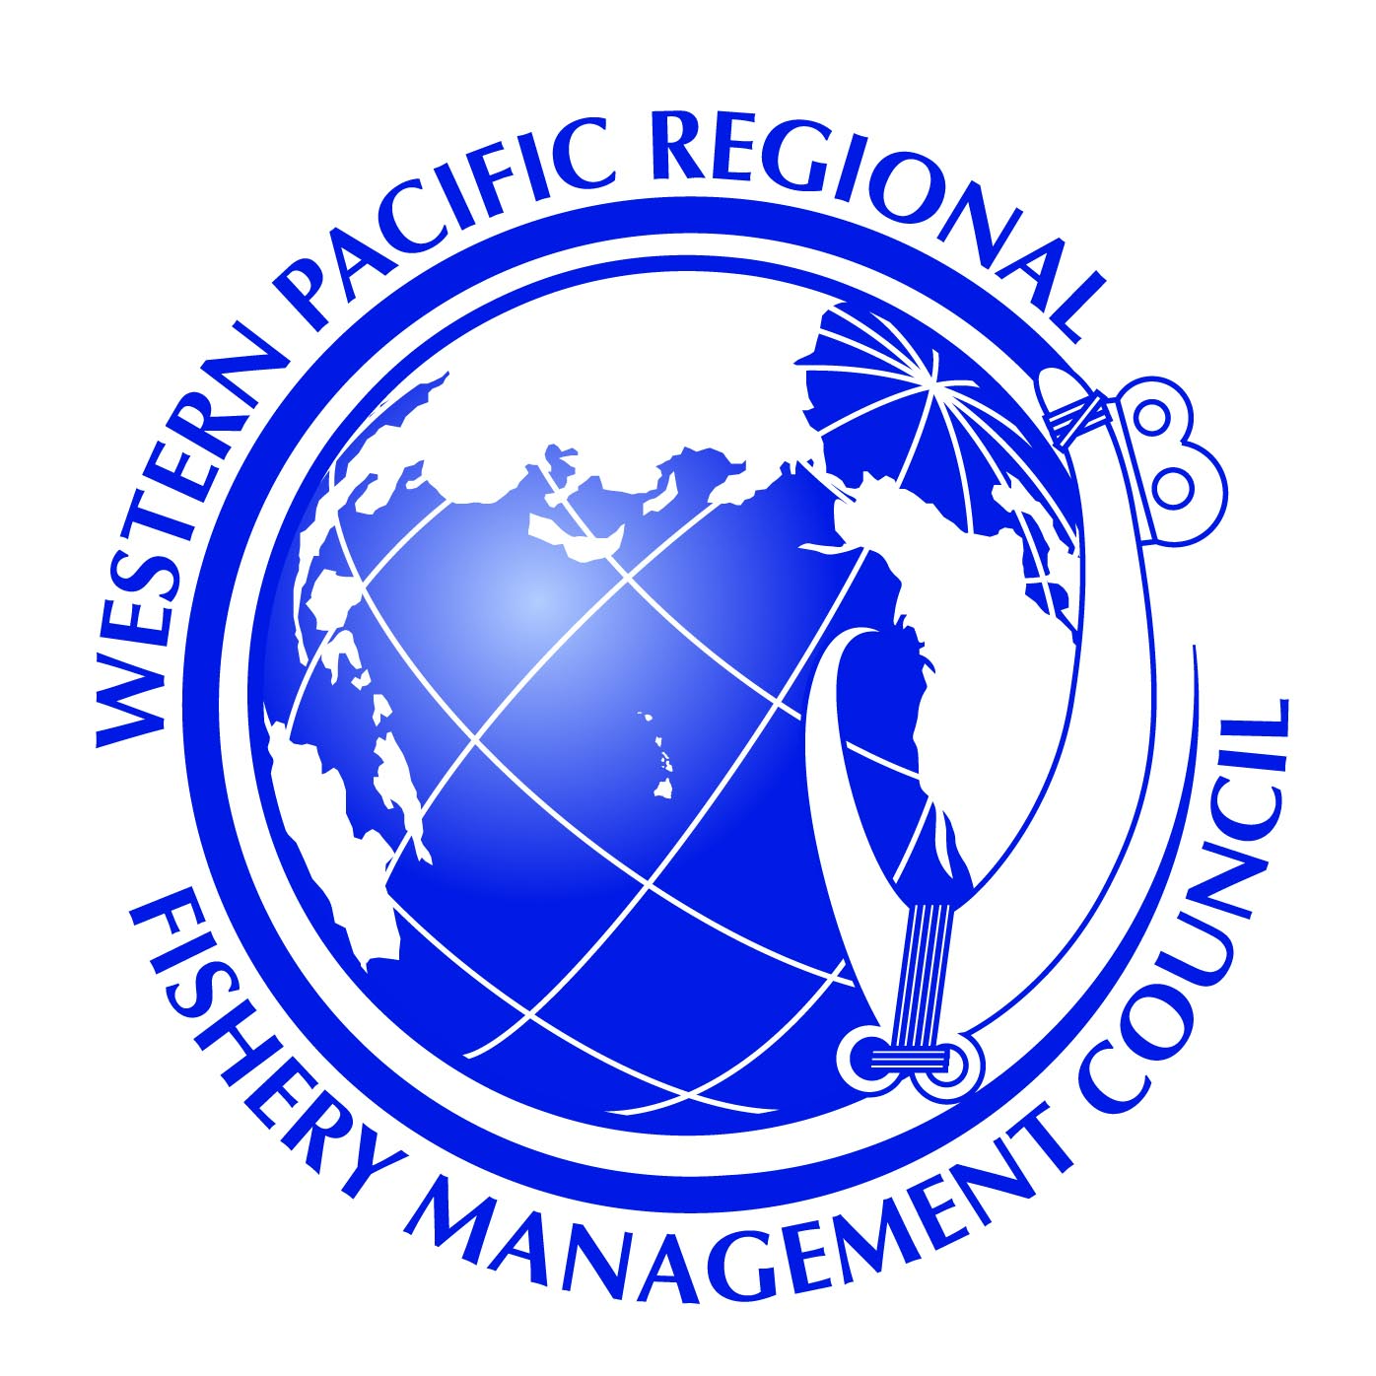

DRAFT

Agenda

Fishing Industry Advisory Panel

June 23, 2014

10:00 a.m. - 4:00 p.m.

1. Introduction and Welcome Chair
2. Overview of the Fishing Industry Advisory Panel role and responsibilities Staff
3. Council 5-Year Program Plan Mark
4. Magnuson Steven Act Reauthorization Staff
5. Round table discussion on fishing and seafood industry issues Participants
   1. American Samoa
   2. CNMI
   3. Guam
   4. Hawaii
6. Pelagic/International Management Issues
   1. International Management – IUU impact on domestic markets Eric
   2. Billfish Act Paul
   3. Shark Fisheries/Sharkfinning
7. Seafood Issues
   1. NOAA seafood Certification Mark
   2. 50% by 5 John
8. Bottomfish Management Mark
9. Protected Species Issues
   1. Marine Mammals Asuka
   2. Status of Humpback Whale and Green Sea Turtle delisting Asuka
10. Fisheries Development Eric
11. Other Issues
12. Public Comment
13. Discussion and Recommendations