Rep. Takai: A Friend and Supporter of Hawaii’s Fishing Community
HONOLULU (20 July 2016) Today’s passing of U.S. Rep. Mark Takai (D-Hawaii) brings much sadness to Hawaii’s fishing community. A strong supporter of local fishermen, Takai recently appeared in a short video celebrating the 40th anniversary of the Magnuson-Stevens Fishery Conservation and Management Act and Hawaii’s fishing industry.
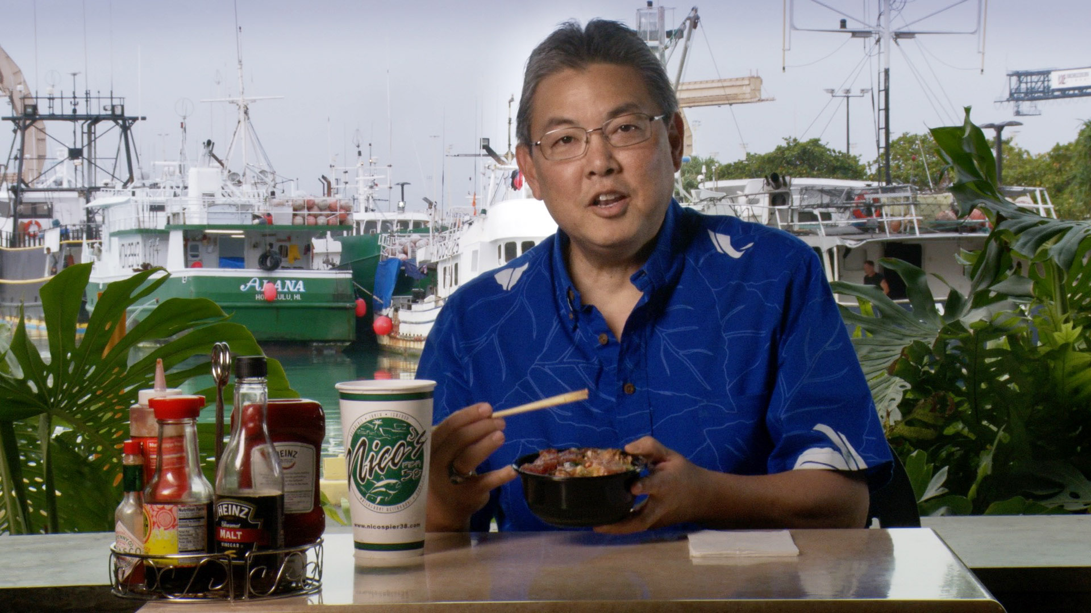
“Rep. Takai always welcomed members of the fishing community to meet with him, whether in D.C. or here in Hawai‘i,” reminisced Kitty M. Simonds, executive director of the Western Pacific Regional Fishery Management Council. “He listened to our concerns about the fisheries and helped spread the news about their importance to the state and the nation in regards to economics, food security and social and cultural cohesion.”

“Hawaii’s fishing community will miss his warmth and sincerity,” said Council Chair Edwin Ebisui Jr. “He understood the long hours and hardships, including the regulatory ones, that fishermen and others in the industry face. And he relished the fresh poke Hawaii enjoys as a result of those efforts.”

From the Boat to Plate, which features Rep. Takai, is scheduled to air on Olelo channel 55 on July 25 at 8:30 p.m., July 27 at 5:30 p.m., July 28 at 10:30 p.m. and July 30 at 8:00 a.m. It is also available on YouTube at https://www.youtube.com/watch?v=9M30Zy7LNsw.
The Western Pacific Regional Fishery Management Council, under the Magnuson-Stevens Fishery Conservation and Management Act of 1976, has authority over fisheries in the Pacific Ocean seaward of the State of Hawaii, the Territories of American Samoa and Guam, the Commonwealth of the Northern Mariana Islands and the U.S. Pacific remote island areas.

Western Pacific Regional Fishery Management Council: Appointees by the Secretary of Commerce from nominees selected by American Samoa, CNMI, Guam and Hawai`i governors: Michael Duenas, Guam Fishermen’s Cooperative Association (Guam) (vice chair); Edwin Ebisui Jr. (Hawaii) (chair); Michael Goto, United Fishing Agency Ltd. (Hawaii); John Gourley, Micronesian Environmental Services (CNMI) (vice chair); Julie Leialoha, biologist (Hawaii); Dr. Claire Tuia Poumele, Port Administration (American Samoa); McGrew Rice, commercial and charter fisherman (Hawaii) (vice chair); and William Sword, recreational fisherman (American Samoa) (vice chair). Designated state officials: Suzanne Case, Hawai`i Department of Land and Natural Resources; Dr. Ruth Matagi-Tofiga, American Samoa Department of Marine and Wildlife Resources; Richard Seman, CNMI Department of Lands and Natural Resources; and Matt Sablan, Guam Department of Agriculture. Designated federal officials: Matthew Brown, USFWS Pacific Islands Refuges and Monuments Office; Michael Brakke, US Department of State; RADM Vincent B. Atkins, US Coast Guard 14th District; and Michael Tosatto, NMFS Pacific Islands Regional Office.
– end –

