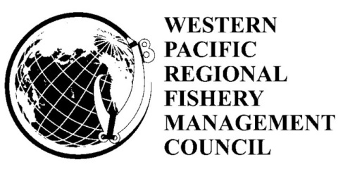

Draft Agenda
Social Science Planning Committee
Monday, March 5, 2018
1:00 p.m. - 5:00 p.m.

Conference Room
Western Pacific Fishery Management Council
1164 Bishop Street
Honolulu, Hawaii 96813

Teleconference
(888) 482-3560; Passcode: 5228220

- Welcome and Introductions
- New emerging Issues by Region
  - American Samoa
  - CNMI
  - Guam
  - Hawaii
- Review of the draft 2017 Socioeconomic Module of the Annual/Stock Assessment and Fisheries Evaluation (SAFE) Report
- Report on PIFSC Response to the External Review
- Review and Update of SSPC Research Priorities
- Recommendations
- Other Business
Pau

