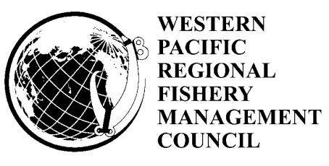

Fishery Ecosystem Plan Team Meeting
January 23, 2020
1:00 p.m. – 5:00 p.m.
Council Office Conference Room
Honolulu, Hawaii

Public Agenda

- Welcome and introductions
- Approval of draft agenda & assignment of rapporteurs
- Potential reclassification of the Territory Bottomfish Management Unit Species (BMUS) Complex
- Options to the BMUS in the American Samoa and Marianas Fishery Ecosystem Plan (Action Item)
- Revisions to the Archipelagic Stock Assessment and Fishery Evaluation Reports
- Updates to the Data Collection Projects
  - Marianas Shark Depredation
  - Small Boat Electronic Reporting
- Public Comment
- Other Business
- Plan Team Discussion and Recommendations

