## Climate and Oceanic Indicators

### Introduction

Over the past few years, the Council has incorporated climate change into the overall management of the fisheries over which it has jurisdiction. This 2018 Annual SAFE Report includes a now standard chapter on indicators of climate and oceanic conditions in the Western Pacific region. These indicators reflect global climate variability and change as well as trends in local oceanographic conditions.

The reasons for the Council’s decision to provide and maintain an evolving discussion of climate conditions as an integral and continuous consideration in their deliberations, decisions, and reports are numerous:

* Emerging scientific and community understanding of the impacts of changing climate conditions on fishery resources, the ecosystems that sustain those resources, and the communities that depend upon them;
* Recent Federal Directives including the 2010 implementation of a National Ocean Policy that identified Resiliency and Adaptation to Climate Change and Ocean Acidification as one of nine National priorities as well as the development of a Climate Science Strategy by NMFS in 2015 and the subsequent development of the Pacific Islands Regional Action Plan for climate science; and
* The Council’s own engagement with NOAA as well as jurisdictional fishery management agencies in American Samoa, CNMI, Guam, and Hawaii as well as fishing industry representatives and local communities in those jurisdictions.

In 2013, the Council began restructuring its Marine Protected Area/Coastal and Marine Spatial Planning Committee to include a focus on climate change, and the committee was renamed as the Marine Planning and Climate Change (MPCC) Committee. In 2015, based on recommendations from the committee, the Council adopted its Marine Planning and Climate Change Policy and Action Plan, which provided guidance to the Council on implementing climate change measures, including climate change research and data needs. The revised Pelagic FEP (February 2016) included a discussion on climate change data and research as well as a new objective (Objective 9) that states the Council should consider the implications of climate change in decision-making, with the following sub-objectives:

1. To identify and prioritize research that examines the effects of climate change on Council-managed fisheries and fishing communities.
2. To ensure climate change considerations are incorporated into the analysis of management alternatives.
3. To monitor climate change related variables via the Council’s Annual Reports.
4. To engage in climate change outreach with U.S. Pacific Islands communities.

Beginning with the 2015 report, the Council and its partners began providing continuing descriptions of changes in a series of climate and oceanic indicators.

This annual report focuses previous years’ efforts by refining existing indicators and improving communication of their relevance and status. Future reports will include additional indicators as the information becomes available and their relevance to the development, evaluation, and revision of the FEPs becomes clearer. Working with national and jurisdictional partners, the Council will make all datasets used in the preparation of this and future reports available and easily accessible.

### Response to Previous Plan Team and Council Recommendations

There were no Council recommendations relevant to the climate and oceanic indicators section of the Annual SAFE Report in 2019.

At its 170th meeting from June 20-22, 2017, the Council directed staff to support the development of community training and outreach materials and activities on climate change. In addition, the Council directed staff to coordinate a “train-the-trainers” workshop that includes NOAA scientists who presented at the 6th Marine Planning and Climate Change Committee (MPCCC) meeting and the MPCCC committee members in preparation for community workshops on climate and fisheries. The Council and NOAA partnered to deliver the workshops in the fall of 2017 to the MPCCC members in Hawaii (with the Hawaii Regional Ecosystem Advisory Committee), as well as American Samoa, Guam, and the CNMI (with their respective Advisory Panel groups). Feedback from workshop participants has been incorporated into this year’s climate and oceanic indicator section. To prepare for community outreach, Guam-based MPCCC members conducted a climate change survey and shared the results with the MPCCC at its 7th meeting on April 10th and 11th, 2018. The Council also directed staff to explore funding avenues to support the development of additional oceanic and climate indicators, such as wind and extratropical storms. These indicators were added to this module by corresponding Plan Team members in 2018.

Prior to holding its 8th meeting, the MPCCC was disbanded in early 2019, re-allocating its responsibilities among its members already on other committees or teams, such as the Fishery Ecosystem Plan Teams.

### Conceptual Model

In developing this chapter, the Council relied on a number of recent reports conducted in the context of the U.S. National Climate Assessment including, most notably, the 2012 Pacific Islands Regional Climate Assessment (PIRCA) and the Ocean and Coasts chapter of the 2014 report on a Pilot Indicator System prepared by the National Climate Assessment and Development Advisory Committee (NCADAC).

The Advisory Committee Report presented a possible conceptual framework designed to illustrate how climate factors can connect to and interact with other ecosystem components to impact ocean and coastal ecosystems and human communities. The Council adapted this model with considerations relevant to the fishery resources of the Western Pacific region:

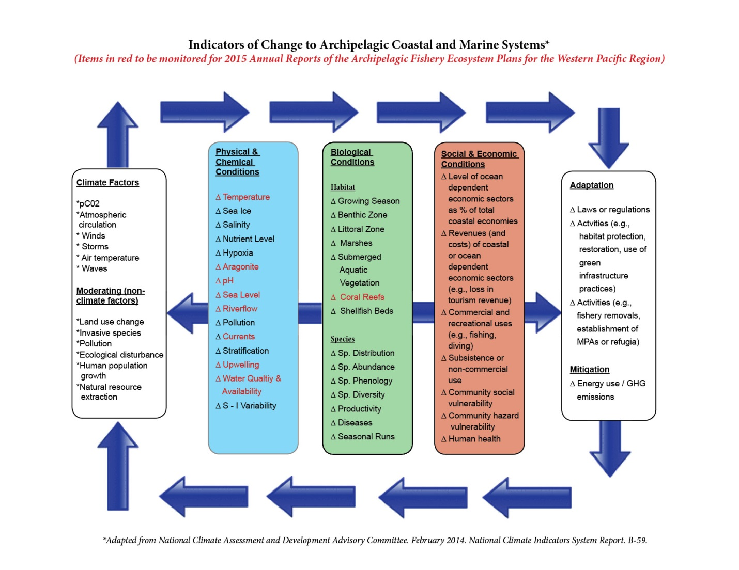

Figure 12. Schematic diagram illustrating how indicators are connected to one another and how they vary as a result of natural climate variability

As described in the 2014 NCADAC report, the conceptual model presents a “simplified representation of climate and non-climate stressors in coastal and marine ecosystems.” For the purposes of this Annual Report, the modified Conceptual Model allows the Council and its partners to identify indicators of interest to be monitored on a continuing basis in coming years. The indicators shown in red were considered for inclusion in the Annual SAFE Reports, though the final list of indicators varied somewhat. Other indicators will be added over time as data become available and an understanding of the causal chain from stressors to impacts emerges.

The Council also hopes that this Conceptual Model can provide a guide for future monitoring and research. This guide will ideally enable the Council and its partners to move forward from observations and correlations to understanding the specific nature of interactions, and to develop capabilities to predict future changes of importance in the developing, evaluating, and adapting of FEPs in the Western Pacific region.

### Selected Indicators

The primary goal for selecting the Indicators used in this (and future reports) is to provide fisheries-related communities, resource managers, and businesses with climate-related situational awareness. In this context, Indicators were selected to:

* Be fisheries relevant and informative;
* Build intuition about current conditions considering changing climate;
* Provide historical context; and
* Recognize patterns and trends.

In this context, this section includes the following climate and oceanic indicators:

* Atmospheric concentration of carbon dioxide (CO2)
* Oceanic pH at Station ALOHA;
* Oceanic Niño Index (ONI);
* Pacific Decadal Oscillation (PDO);
* Tropical cyclones;
* Sea surface temperature (SST);
* Coral Thermal Stress Exposure
* Chlorophyll-A
* Rainfall
* Sea Level (Sea Surface Height)

Figure 13 and Figure 14 provide a description of these indicators and illustrate how they are connected to each other in terms of natural climate variability and anthropogenic climate change.

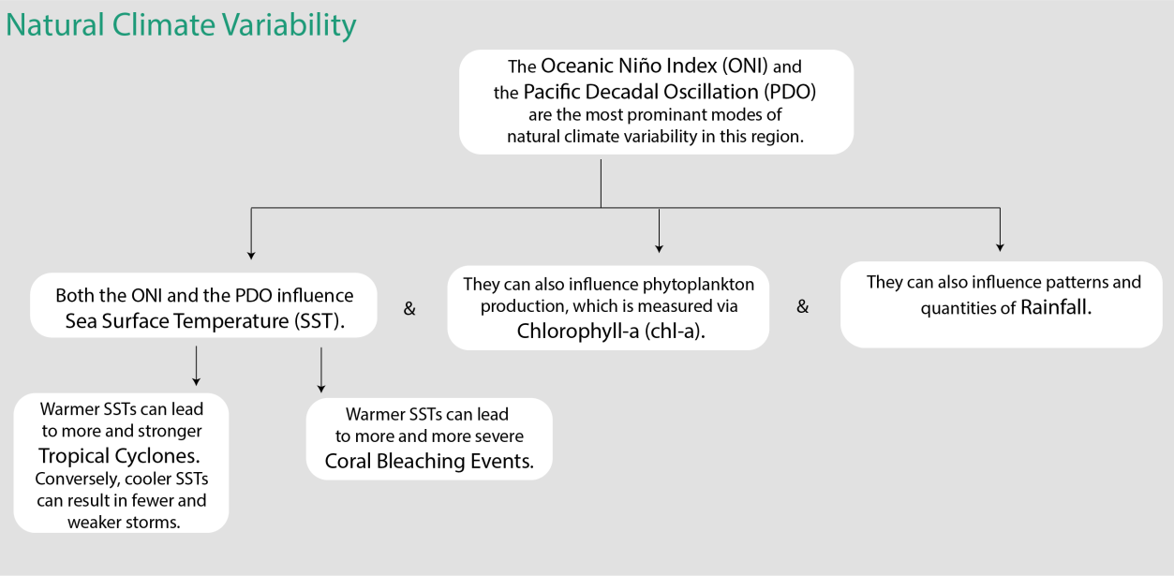

Figure . Schematic diagram illustrating how indicators are connected to one another and how they vary as a result of natural climate variability

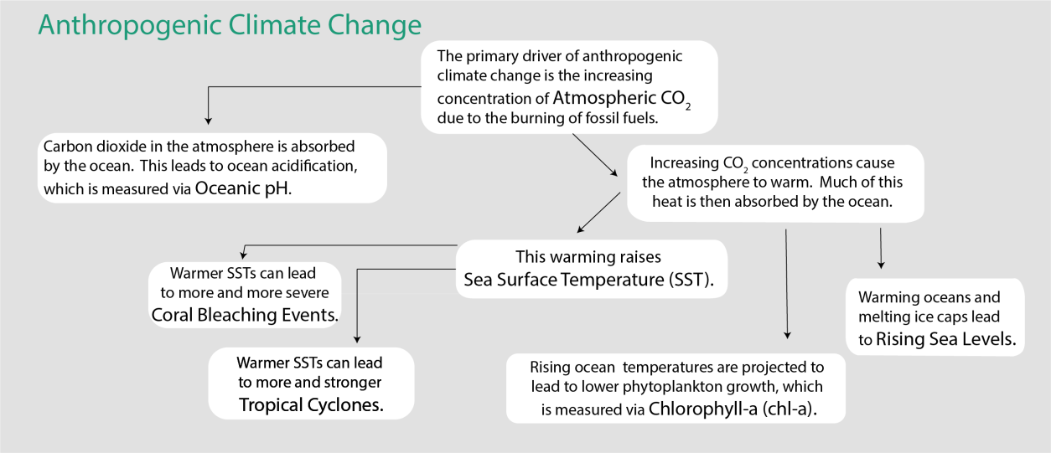

Figure Schematic diagram illustrating how indicators are connected to one another and how they vary as a result of anthropogenic climate change

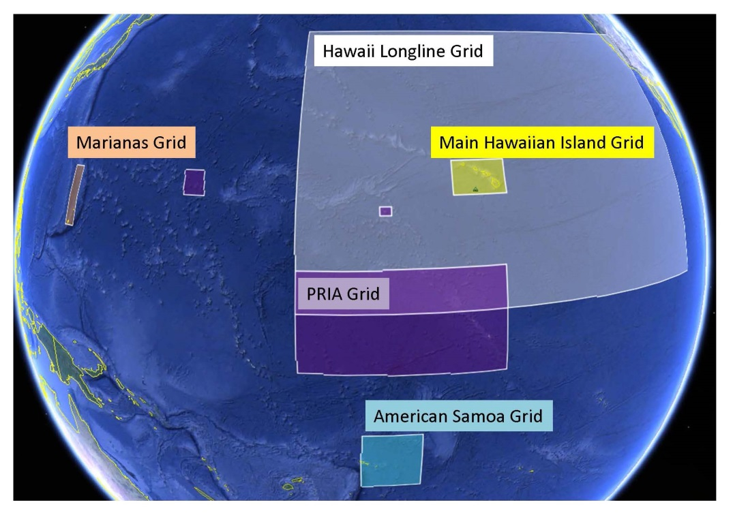

Figure 15. Regional spatial grids representing the scale of the climate change indicators being monitored

#### Atmospheric Concentration of Carbon Dioxide (CO2) at Mauna Loa

Rationale: Atmospheric carbon dioxide is a measure of what human activity has already done to affect the climate system through greenhouse gas emissions. It provides quantitative information in a simplified, standardized format that decision makers can easily understand. This indicator demonstrates that the concentration (and, in turn, warming influence) of greenhouse gases in the atmosphere has increased substantially over the last several decades*.*

Status: Atmospheric CO2 is increasing exponentially. This means that atmospheric CO2 is increasing at a faster rate each year. In 2019, the annual mean concentration of CO2 was 411 ppm. In 1959, the first year of the time series, it was 316 ppm. The annual mean passed 350 ppm in 1988 and 400 ppm in 2015 (NOAA 2019b).

Description: Monthly mean atmospheric carbon dioxide (CO2) at Mauna Loa Observatory, Hawaii in parts per million (ppm) from March 1958 to present. The observed increase in monthly average carbon dioxide concentration is primarily due to CO2 emissions from fossil fuel burning. Carbon dioxide remains in the atmosphere for a very long time, and emissions from any location mix throughout the atmosphere in about one year. The annual oscillations at Mauna Loa, Hawaii are due to the seasonal imbalance between the photosynthesis and respiration of plants on land. During the summer growing season photosynthesis exceeds respiration and CO2 is removed from the atmosphere, whereas outside the growing season respiration exceeds photosynthesis and CO2 is returned to the atmosphere*.* The seasonal cycle is strongest in the northern hemisphere because of this hemisphere’s larger land mass.

Timeframe: Annual, monthly.

Region/Location: Mauna Loa, Hawaii but representative of global atmospheric carbon dioxide concentration.

Measurement Platform: *In-situ* station.

Sourced from: Keeling et al. (1976), Thoning et al. (1989), and NOAA (2020b).

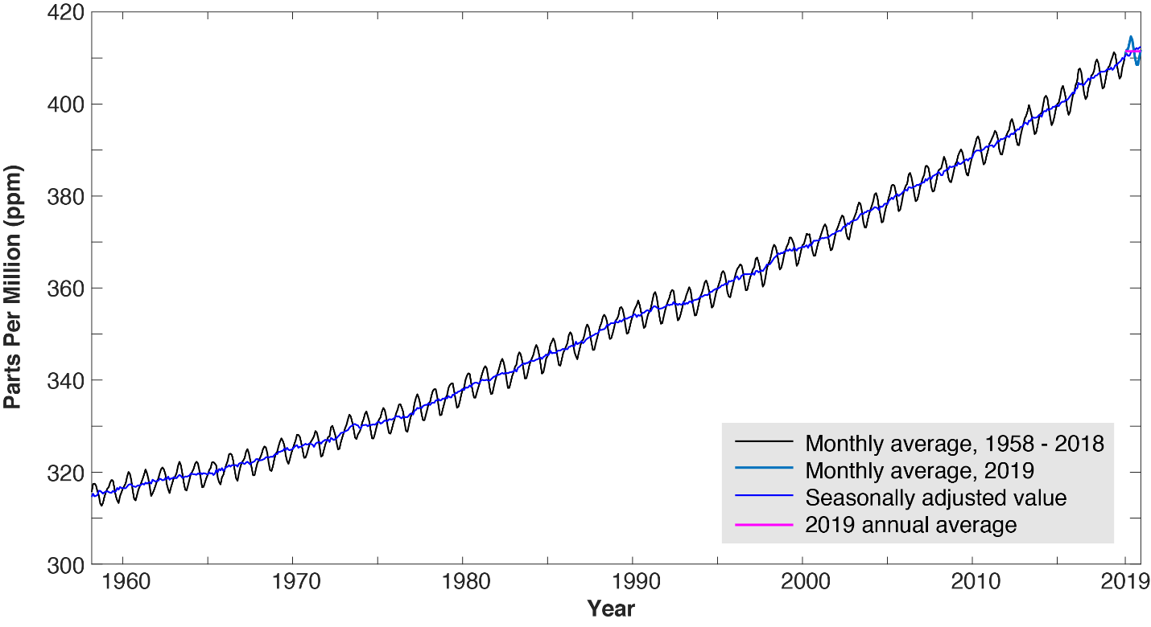

Figure . Monthly mean (black) and seasonally corrected (blue) atmospheric carbon dioxide at Mauna Loa Observatory, Hawaii

#### Oceanic pH

Rationale: Oceanic pH is a measure of how greenhouse gas emissions have already impacted the ocean. This indicator demonstrates that oceanic pH has decreased significantly over the past several decades (i.e. the ocean has become more acidic). Increasing ocean acidification limits the ability of marine organisms to build shells and other calcareous structures. Recent research has shown that pelagic organisms such as pteropods and other prey for commercially valuable fish species are already being negatively impacted by increasing acidification (Feely et al., 2016). The full impact of ocean acidification on the pelagic food web is an area of active research (Fabry et al., 2008).

Status: The ocean is roughly 9.7% more acidic than it was nearly 30 years ago at the start of this time series. Over this time, pH has declined by 0.0401 at a constant rate. In 2018, the most recent year for which data are available, the average pH was 8.07. Additionally, small variations seen over the course of the year are now outside the range seen in the first year of the time series. The highest pH value reported for the most recent year (8.0743, down from a high of 8.0830 in 2017) is lower than the lowest pH value reported in the first year of the time series (8.0845).

Description: Trends in surface (5 m) pH at Station ALOHA, north of Oahu (22.75°N, 158°W), collected by the Hawai`i Ocean Time Series (HOT) from October 1988 to 2018 (2019 data are not yet available). Oceanic pH is a measure of ocean acidity, which increases as the ocean absorbs carbon dioxide from the atmosphere. Lower pH values represent greater acidity. Oceanic pH is calculated from total alkalinity (TA) and dissolved inorganic carbon (DIC). Total alkalinity represents the ocean’s capacity to resist acidification as it absorbs CO2 and the amount of CO2 absorbed is captured through measurements of DIC. The multi-decadal time series at Station ALOHA represents the best available documentation of the significant downward trend in oceanic pH since the time series began in 1988. Oceanic pH varies over both time and space, though the conditions at Station ALOHA are considered broadly representative of those across the Western and Central Pacific’s pelagic fishing grounds.

Timeframe: Monthly.

Region/Location: Station ALOHA: 22.75°N, 158°W.

Measurement Platform: *In-situ* station.

Sourced from: Fabry et al. (2008), Feely et al. (2016). These data are based upon Hawaii Ocean Time-series observations supported by the U.S. National Science Foundation under Grant OCE-12-60164 a as described in Karl et al. (1996) and on its website (HOT, 2020).

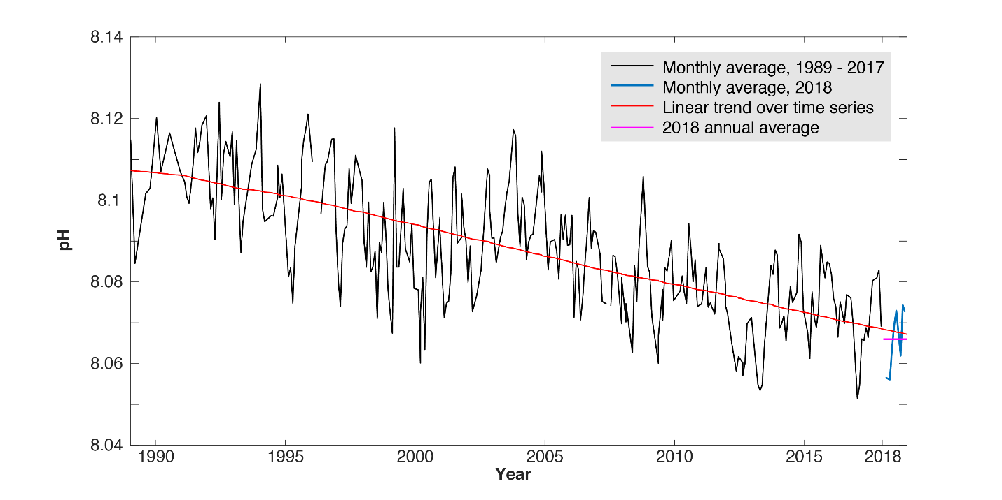

Figure . Oceanic pH (black) and its trend (red) at Station ALOHA from 1989 – 2018

#### Oceanic Niño Index

Rationale: The El Niño – Southern Oscillation (ENSO) cycle is known to have impacts on Pacific fisheries including tuna fisheries. The ONI focuses on ocean temperature, which has the most direct effect on these fisheries.

Status: In 2019, the ONI transitioned from a weak El Niño to neutral conditions.

Description: The three-month running mean of satellite remotely-sensed sea surface temperature (SST) anomalies in the Niño 3.4 region (5°S – 5°N, 120° – 170°W). The Oceanic Niño Index (ONI) is a measure of the El Niño – Southern Oscillation (ENSO) phase. Warm and cool phases, termed El Niño and La Niña respectively, are based in part on an ONI threshold of ± 0.5 °C being met for a minimum of five consecutive overlapping seasons. Additional atmospheric indices are needed to confirm an El Niño or La Niña event, as the ENSO is a coupled ocean-atmosphere phenomenon. The atmospheric half of ENSO is measured using the Southern Oscillation Index.

Timeframe: Every three months.

Region/Location: Niño 3.4 region, 5°S – 5°N, 120° – 170°W.

Measurement Platform: *In-situ* station, satellite, model.

Sourced from NOAA CPC (2020)

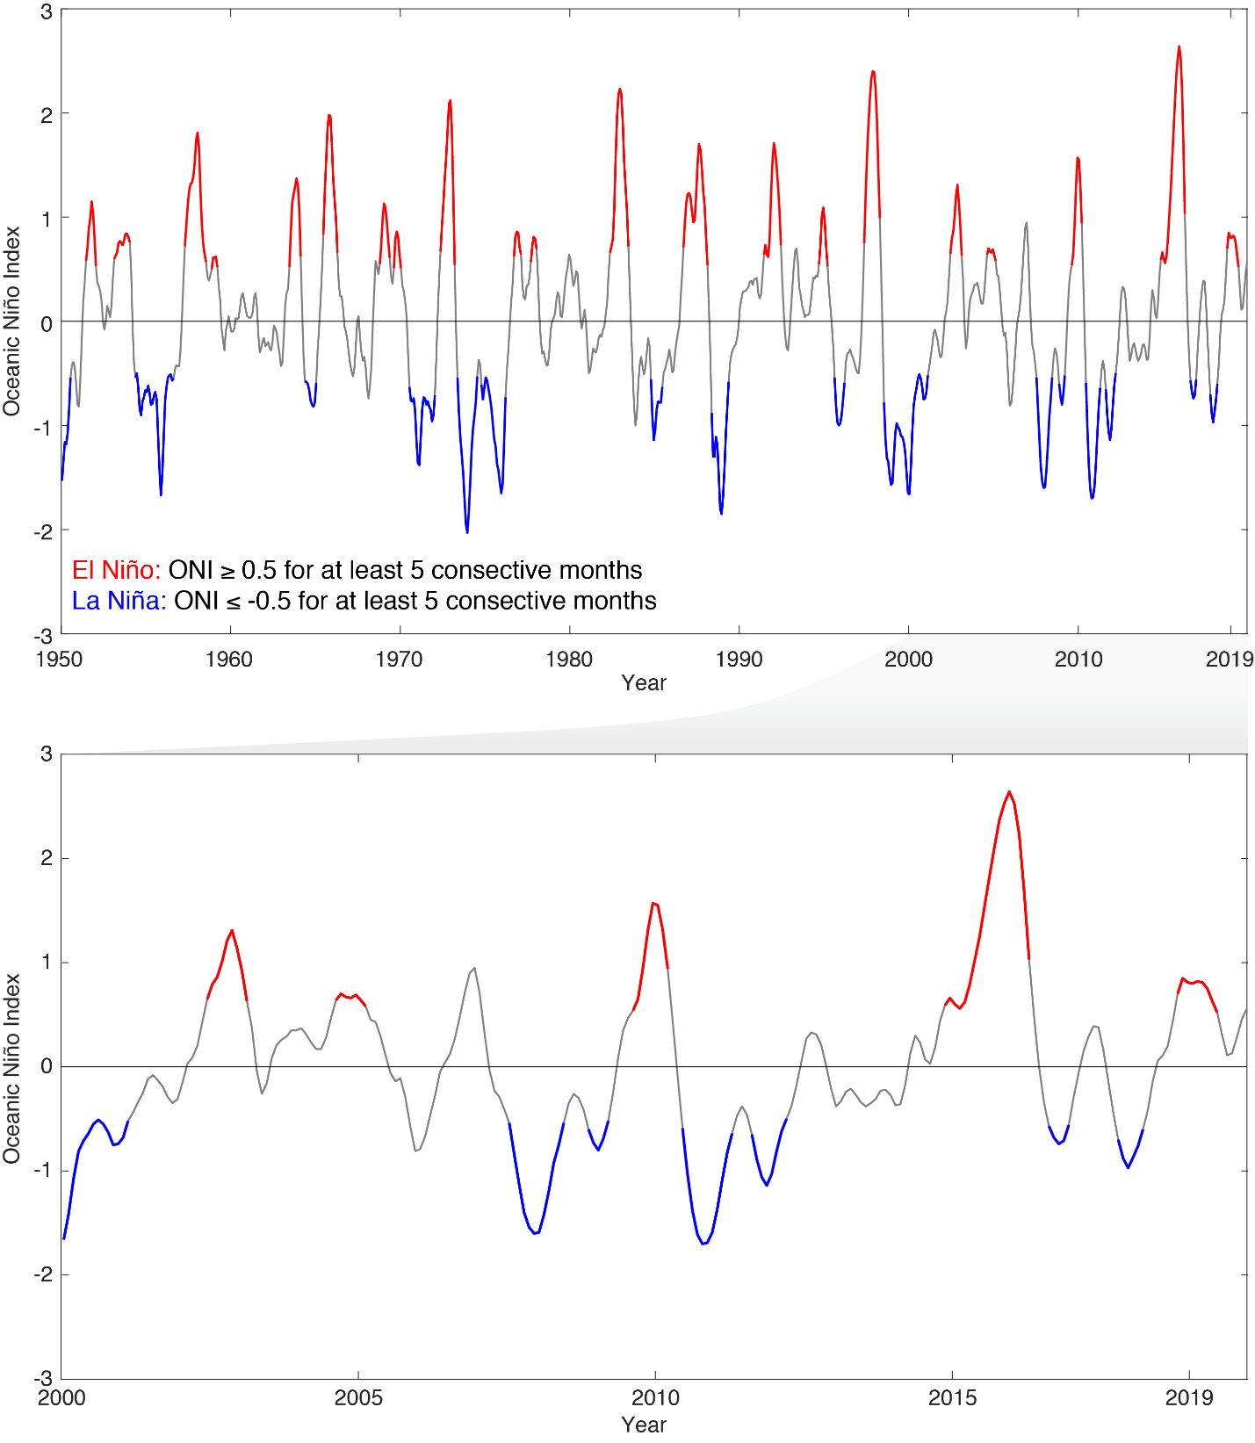

Figure . Oceanic Niño Index from 1950-2019 (top) and 2000–2019 (bottom) with El Niño periods in red and La Niña periods in blue

#### Pacific Decadal Oscillation

Rationale: The Pacific Decadal Oscillation (PDO) was initially named by fisheries scientist Steven Hare in 1996 while researching connections between Alaska salmon production cycles and Pacific climate. Like ENSO, the PDO reflects changes between periods of persistently warm or persistently cool ocean temperatures, but over a period of 20 to 30 years (versus six to 18 months for ENSO events). The climatic fingerprints of the PDO are most visible in the Northeastern Pacific, but secondary signatures exist in the tropics.

Status: The PDO hovered around zero in 2019. The year was nearly evenly split between values that were slightly negative (seven months) and values that were slightly positive (5 months).

Description: The PDO is often described as a long-lived El Niño-like pattern of Pacific climate variability. As seen with the better-known ENSO, extremes in the PDO pattern are marked by widespread variations in the Pacific Basin and the North American climate. In parallel with the ENSO phenomenon, the extreme cases of the PDO have been classified as either warm or cool, as defined by ocean temperature anomalies in the northeast and tropical Pacific Ocean. When SST is below average in the interior North Pacific and warm along the North American coast, and when sea level pressures are below average in the North Pacific, the PDO has a positive value. When the climate patterns are reversed, with warm SST anomalies in the interior and cool SST anomalies along the North American coast, or above average sea level pressures over the North Pacific, the PDO has a negative value NOAA (2019b).

Timeframe: Annual, monthly.

Region/Location: Pacific Basin north of 20°N.

Measurement Platform: *In-situ* station, satellite, model.

Sourced from: NOAA (2020b)

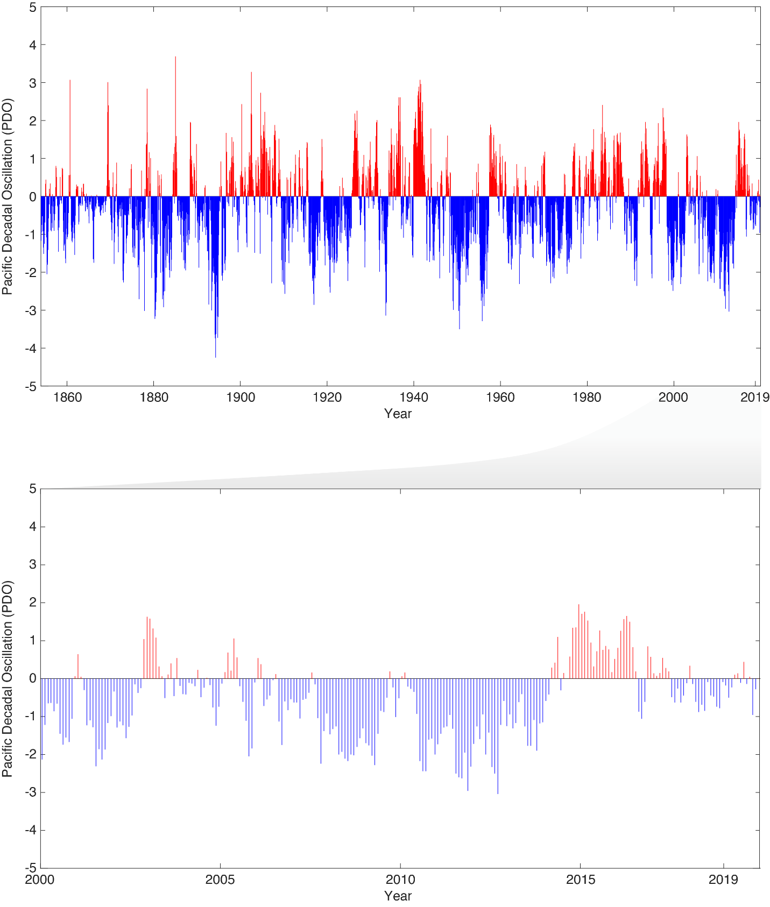

Figure 30. Pacific Decadal Oscillation from 1950–2019 (top) and 2000–2019 (bottom) with positive warm periods in red and negative cool periods in blue

#### Tropical Cyclones

Rationale: The effects of tropical cyclones are numerous and well known. At sea, storms disrupt and endanger shipping traffic as well as fishing effort and safety. The Hawai`i longline fishery, for example, has had serious problems with vessels dodging storms at sea, delayed departures, and inability to make it safely back to Honolulu because of bad weather. When cyclones encounter land, their intense rains and high winds can cause severe property damage, loss of life, soil erosion, and flooding. Associated storm surge, the large volume of ocean water pushed toward shore by cyclones’ strong winds, can cause severe flooding and destruction.

Status:

*Eastern North Pacific.* Overall, the 2019 eastern Pacific hurricane season featured near average activity. There were 17 named storms, of which seven became hurricanes and three became major hurricanes - category 3 or higher on the Saffir-Simpson Hurricane Wind Scale. This compares to the long-term averages of fifteen named storms, eight hurricanes, and four major hurricanes. There were also two tropical depressions that did not reach tropical storm strength. In terms of Accumulated Cyclone Energy (ACE), which measures the strength and duration of tropical storms and hurricanes, activity in the basin in 2019 was a little below the long-term mean. Summary inserted from <https://www.nhc.noaa.gov/text/MIATWSEP.shtml>.

*Central North Pacific.* Tropical cyclone activity in the central Pacific in 2019 was average. There were four named storms, of which one became a hurricane and one became a major hurricane. The ACE index was slightly below the 1981 – 2010 average of roughly 20 (x 104 knots2).

*Western North Pacific.* Tropical cyclone activity was roughly average in the western Pacific in 2019. There were 26 named storms. Sixteen of these storms developed into typhoons, and ten of these typhoons were major. The ACE Index was below the 1981 – 2010 average. Of note was Super typhoon Hagibis. Hagibis was just the third category 5 tropical cyclone globally in 2019 (Super Typhoon Wutip and Hurricane Dorian were the others). Hagibis weakened to a category 2 storm before making landfall in Japan, but was still one of the most damaging typhoons in history. The remnants of Hagibis transitioned to an extratropical cyclone that affected the Aleutian Islands and significantly altered the weather patterns over the North America in the subsequent days. Summary inserted from <https://www.ncdc.noaa.gov/sotc/tropical-cyclones/201910>.

*South Pacific.* Tropical cyclone activity was average in the south Pacific region in 2019. There were nine named storms, four of which developed into cyclones and one of which was a major cyclone. The ACE Index were below average in 2019.

Description: This indicator uses historical data from the NOAA National Climate Data Center (NCDC) International Best Track Archive for Climate Stewardship to track the number of tropical cyclones in the western, central, eastern, and southern Pacific basins. This indicator also monitors the Accumulated Cyclone Energy (ACE) Index and the Power Dissipation Index which are two ways of monitoring the frequency, strength, and duration of tropical cyclones based on wind speed measurements.

The annual frequency of storms passing through each basin is tracked and a stacked time series plot shows the representative breakdown of Saffir-Simpson hurricane categories.

Every cyclone has an ACE Index value, which is a number based on the maximum wind speed measured at six-hourly intervals over the entire time that the cyclone is classified as at least a tropical storm (wind speed of at least 34 knots; 39 mph). Therefore, a storm’s ACE Index value accounts for both strength and duration. This plot shows the historical ACE values for each hurricane/typhoon season and has a horizontal line representing the average annual ACE value.

Timeframe: Annual.

Region/Location:

Eastern North Pacific: east of 140° W, north of the equator.

Central North Pacific: 180° - 140° W, north of the equator.

Western North Pacific: west of 180°, north of the equator.

South Pacific: south of the equator.

Measurement Platform: Satellite.

Sourced from: Knapp et al. (2010), Knapp et al. (2018)

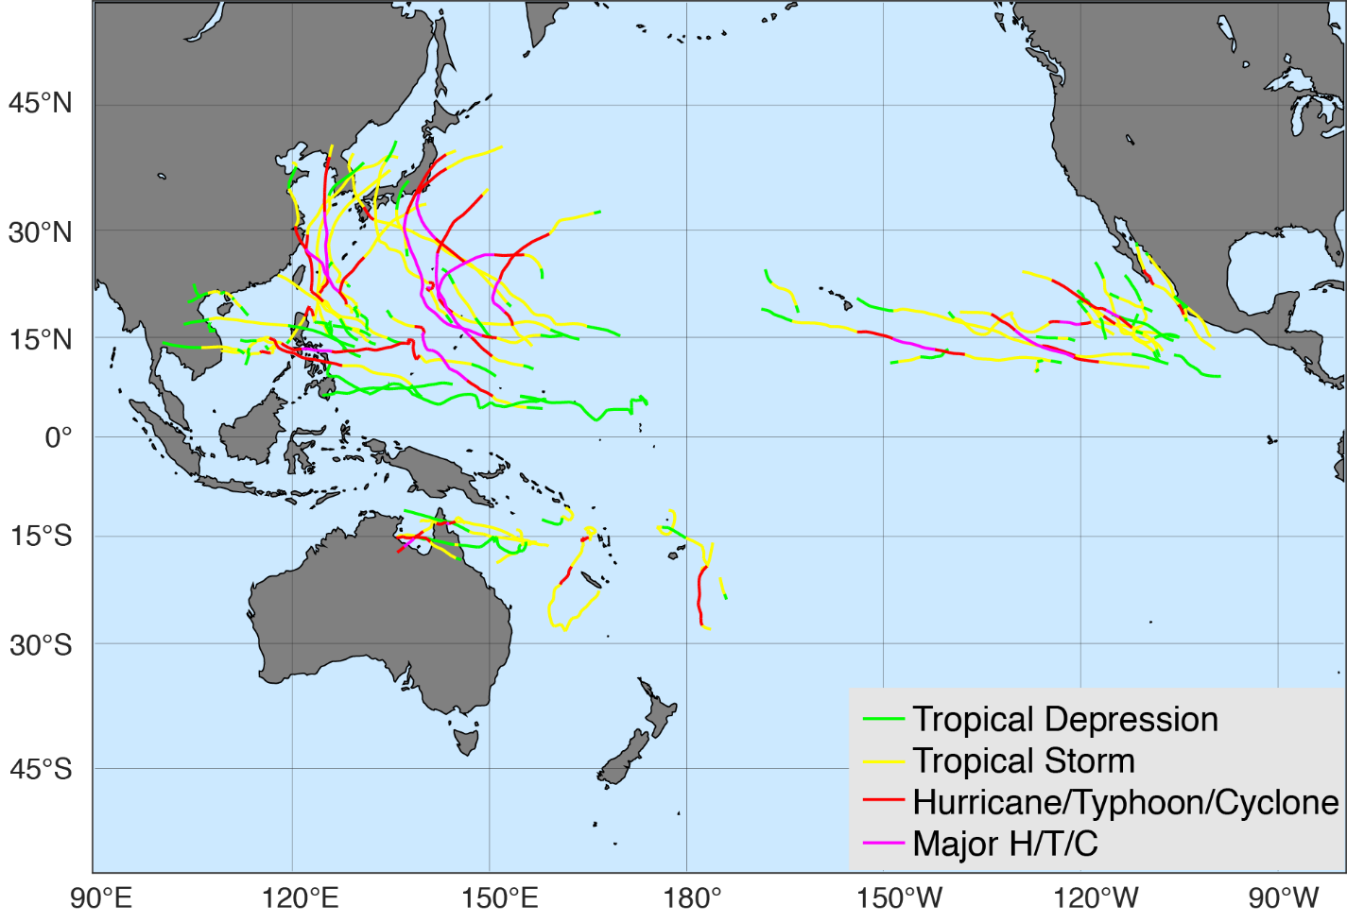

Figure 31. 2019 Pacific basin tropical cyclone tracks

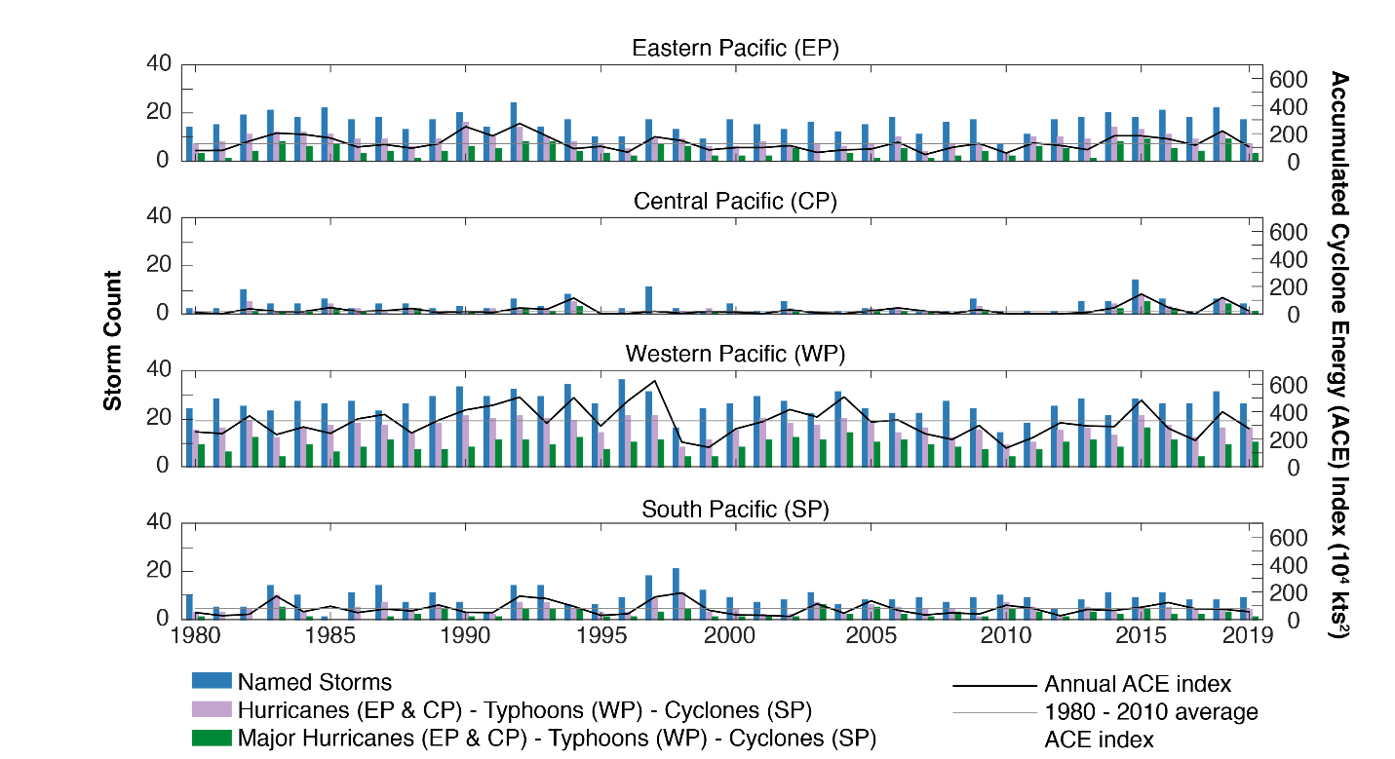

Figure 32. 2019 tropical storm totals by region

#### Sea Surface Temperature and Anomaly

Rationale: Sea surface temperature is one of the most directly observable existing measures for tracking increasing ocean temperatures. SST varies in response to natural climate cycles such as the El Niño – Southern Oscillation (ENSO) and is projected to rise as a result of anthropogenic climate change. Both short-term variability and long-term trends in SST impact the marine ecosystem. Understanding the mechanisms through which organisms are impacted and the time scales of these impacts is an area of active research.

Status*:* Annual mean SST was 29.08ºC in 2019. Over the period of record, annual SST has increased at a rate of 0.023ºC yr-1. Monthly SST values in 2019 ranged from 28.18 – 29.91 ºC, within the climatological range of 26.56 – 29.91 ºC. The annual anomaly was 0.54ºC hotter than average, with wide spatial variability.

Note that from the top to bottom in Figure 23, panels show climatological SST (1985-2018), 2019 SST anomaly, time series of monthly mean SST, and time series of monthly SST anomaly. The white box in the upper panels indicates the area over which SST is averaged for the time series plots.

Description: Satellite remotely-sensed monthly sea surface temperature (SST) is averaged across the American Samoa Grid (10° – 17.5°S, 165° – 172°W). A time series of monthly mean SST averaged over the American Samoa Grid Region is presented. Additionally, spatial climatology and anomalies are shown. Data from NOAA Coral Reef Watch CoralTemp (NOAA, 2019c).

Timeframe: Monthly.

Region/Location: American Samoa Grid (10° – 17.5°S, 165° – 172°W).

Measurement Platform: Satellite.

Sourced from: NOAA OceanWatch (2020)

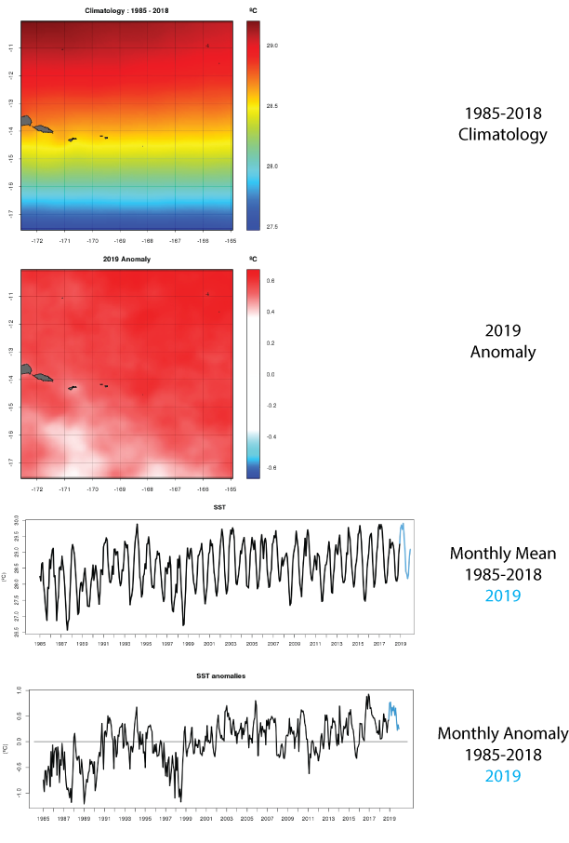

Figure . Sea surface temperature climatology and anomalies from 1985-2019

#### Coral Thermal Stress Exposure: Degree Heating Weeks

Rationale: Degree heating weeks are one of the most widely used metrics for assessing exposure to coral bleaching-relevant thermal stress.

Status: After a series of stress events in 2014, 2015, and 2017, the Samoas experienced a coral heat stress event that began early in 2019 and reached its maximum in April 2019.

Description:  Here we present a metric of exposure to thermal stress that is relevant to coral bleaching. Degree Heating Weeks (DHW) measure time and temperature above a reference ‘summer maximum’, presented as rolling sum weekly thermal anomalies over a 12-week period. Higher DHW measures imply a greater likelihood of mass coral bleaching or mortality from thermal stress.

The NOAA Coral Reef Watch program uses satellite data to provide current reef environmental conditions to quickly identify areas at risk for [coral bleaching](http://oceanservice.noaa.gov/facts/coral_bleach.html). Bleaching is the process by which corals lose the symbiotic algae that give them their distinctive colors. If a coral is severely bleached, disease and death become likely.

The NOAA Coral Reef Watch (CRW) daily 5-km satellite coral bleaching Degree Heating Week (DHW) product presented here shows accumulated heat stress, which can lead to coral bleaching and death. The scale goes from 0 to 20 °C-weeks. The DHW product accumulates the instantaneous bleaching heat stress (measured by Coral Bleaching HotSpots) during the most-recent 12-week period. It is directly related to the timing and intensity of coral bleaching. Significant coral bleaching usually occurs when DHW values reach 4 °C-weeks. By the time DHW values reach 8 °C-weeks, widespread bleaching is likely and significant mortality can be expected (NOAA Coral Reef Watch, 2019).

Timeframe: 2013-2018, Daily data.

Region/Location: Global.

Sourced from: NOAA Coral Reef Watch (2020) <https://coralreefwatch.noaa.gov/product/vs/timeseries/polynesia.php#samoas>

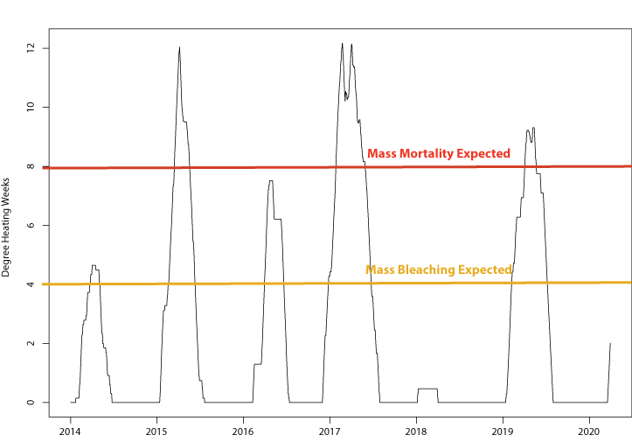

Figure 24. Coral Thermal Stress Exposure measured at Samoa Virtual Station 2014-2019 (Coral Reef Watch Degree Heating Weeks)

#### Chlorophyll-A and Anomaly

Rationale: Chlorophyll-A is one of the most directly observable measures we have for tracking increasing ocean productivity.

Status: Annual mean chlorophyll-A was 0.048 mg/m3 in 2019. Over the period of record, annual Chl-A has shown no significant temporal trend. Monthly chlorophyll-A values in 2019 ranged from 0.041-0.057 mg/m3, within the climatological range of 0.031 – 0.080 mg/m3. The annual anomaly was 0.0006 mg/m3 lower than average, with some intensification in the southern section of the region.

Description:  Chlorophyll-A Concentration from 1998-2019, derived from the ESA Ocean Color Climate Change Initiative dataset, v4.2. A monthly climatology was generated across the entire period (1982-2018) to provide both a 2019 spatial anomaly, and an anomaly time series.

ESA Ocean Color Climate Change Initiative dataset is a merged dataset, combining data from SeaWIFS, MODIS-Aqua, MERIS, and VIIRS to provide a homogeneous time-series of ocean color. Data was accessed from the OceanWatch Central Pacific portal.

Timeframe: 1998-2019, Daily data available, Monthly means shown.

Region/Location: Global.

Measurement Platform: SeaWIFS, MODIS-Aqua, MERIS, and VIIRS

Sourced from: NOAA OceanWatch (2020) <https://oceanwatch.pifsc.noaa.gov/>

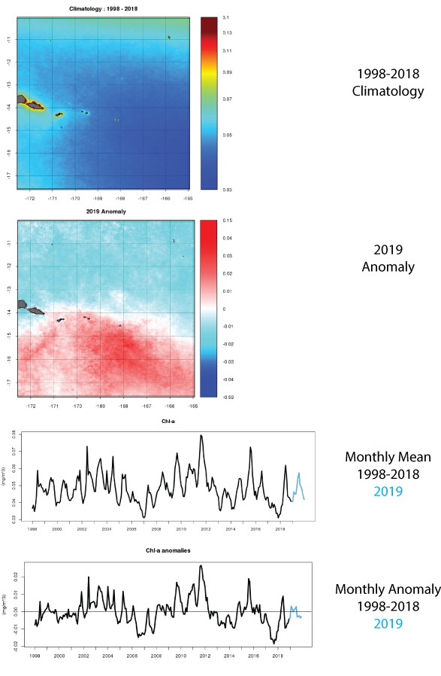

Figure . Chlorophyll-A (Chl-A) and Chl-A Anomaly from 1998-2019

#### Rainfall (CMAP Precipitation)

Rationale: Rainfall may have substantive effects on the nearshore environment and is a potentially important co-variate with the landings of stocks.

Description: The CPC Merged Analysis of Precipitation (CMAP) is a technique which produces pentad and monthly analyses of global precipitation in which observations from rain gauges are merged with precipitation estimates from several satellite-based algorithms, such as infrared and microwave (NOAA 2002). The analyses are on a 2.5 x 2.5-degree latitude/longitude grid and extend back to 1979.CMAP Precipitation data provided by the NOAA/OAR/ESRL PSD, Boulder, Colorado, USA, from their Web site at https://www.esrl.noaa.gov/psd/.The data are comparable (but should not be confused with) similarly combined analyses by the Global Precipitation Climatology Project described in Huffman et al. (1997).  
  
It is important to note that the input data sources to make these analyses are not constant throughout the period of record. For example, SSM/I (passive microwave - scattering and emission) data became available in July 1987; prior to that the only microwave-derived estimates available are from the MSU algorithm (Spencer1993) which is emission-based thus precipitation estimates are available only over oceanic areas. Furthermore, high temporal resolution IR data from geostationary satellites (every 3-hr) became available during 1986; prior to that, estimates from the OPI technique (Xie and Arkin 1997) are used based on OLR from orbiting satellites.  
  
The merging technique is thoroughly described in Xie and Arkin (1997). Briefly, the methodology is a two-step process. First, the random error is reduced by linearly combining the satellite estimates using the maximum likelihood method, in which case the linear combination coefficients are inversely proportional to the square of the local random error of the individual data sources. Over global land areas the random error is defined for each time period and grid location by comparing the data source with the rain gauge analysis over the surrounding area. Over oceans, the random error is defined by comparing the data sources with the rain gauge observations over the Pacific atolls. Bias is reduced when the data sources are blended in the second step using the blending technique of Reynolds (1988).

Timeframe: Monthly.

Region/Location: Global.

Measurement Platform: *In-situ* station gauges and satellite data.

Sourced from: CMAP Precipitation data provided by the NOAA/OAR/ESRL PSD, Boulder, Colorado, USA, from their Web site at <https://www.esrl.noaa.gov/psd/>. <http://apdrc.soest.hawaii.edu/datadoc/cmap_month.php>

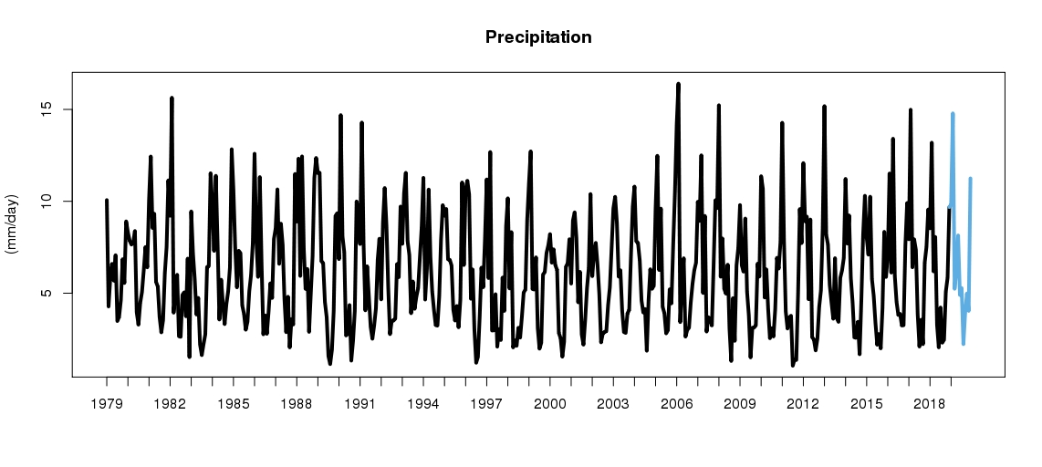

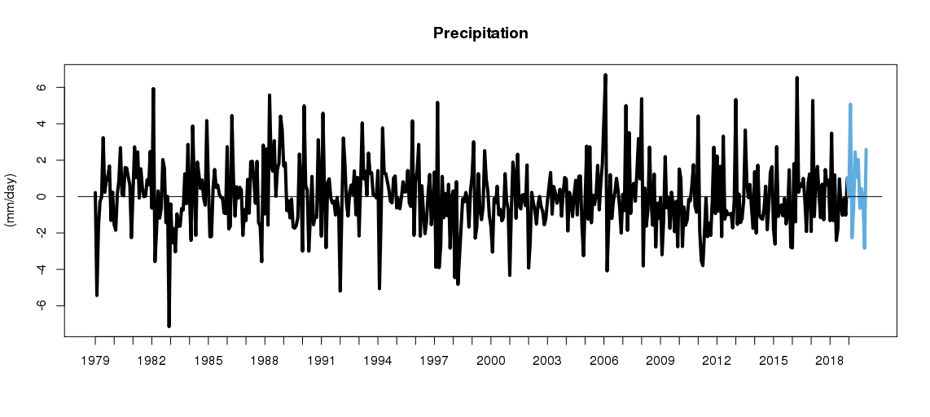

Figure . CMAP precipitation across the American Samoa Longline Grid with 2019 values in blue

#### Sea Level (Sea Surface Height and Anomaly)

Rationale: Coastal: Rising sea levels can result in several coastal impacts, including inundation of infrastructure, increased damage resulting from storm-driven waves and flooding, and saltwater intrusion into freshwater supplies.

Description: Monthly mean sea level time series of local and basin-wide sea surface height and sea surface height anomalies, including extremes.

Timeframe: Monthly.

Region/Location: Observations from selected sites within the Samoan Archipelago.

Measurement Platform:  Satellite and *in situ* tide gauges.

Sourced from: Aviso (2020) and <https://tidesandcurrents.noaa.gov/datum_options.html>

##### Basin-Wide Perspective

This image of the mean sea level anomaly for March 2019 compared to 1993-2013 climatology from satellite altimetry provides a glimpse into how the current weak El Niño continues to affect sea level across the Pacific Basin. The image captures the fact that sea level continues to be lower in the Western Pacific and higher in the Central and Eastern Pacific (a standard pattern during El Niño events - this basin-wide perspective provides a context for the location-specific sea level/sea surface height images that follow).

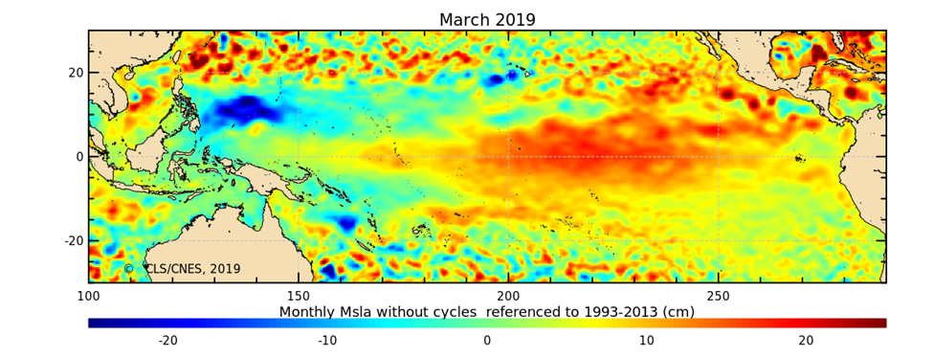

Figure 27a. Sea surface height and anomaly

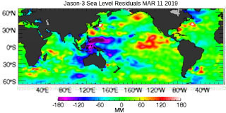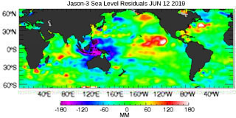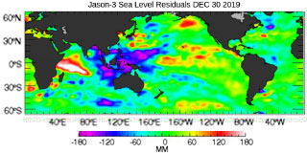

**Figure 27b.** Quarterly time series of mean sea level anomalies during 2019 show no pattern of El Niño throughout the year according to satellite altimetry measurements of sea level height (unlike 2015).

http://sealevel.jpl.nasa.gov/layout/ostm/images/color-bar.jpg

##### Local Sea Level

These time-series from *in situ* tide gauges provide a perspective on sea level trends within each Archipelago (Tide Station Time Series from NOAA/COOPS).

The following figures and descriptive paragraphs were inserted from NOAA (2018). Figure 28 shows the monthly mean sea level without the regular seasonal fluctuations due to coastal ocean temperatures, salinities, winds, atmospheric pressures, and ocean currents. The long-term linear trend is also shown, including its 95% confidence interval. The plotted values are relative to the most recent [Mean Sea Level datum established by CO-OPS](http://tidesandcurrents.noaa.gov/datum_options.html). The calculated trends for all stations are available as a table in millimeters/year and in feet/century. If present, solid vertical lines indicate times of any major earthquakes in the vicinity of the station and dashed vertical lines bracket any periods of questionable data or datum shift.

The monthly extreme water levels include a Mean Sea Level (MSL) trend of 2.21 millimeters/year with a 95% confidence interval of +/- 0.81 millimeters/year based on monthly MSL data from 1948 to 2019, which is equivalent to a change of 0.73 feet in 100 years.

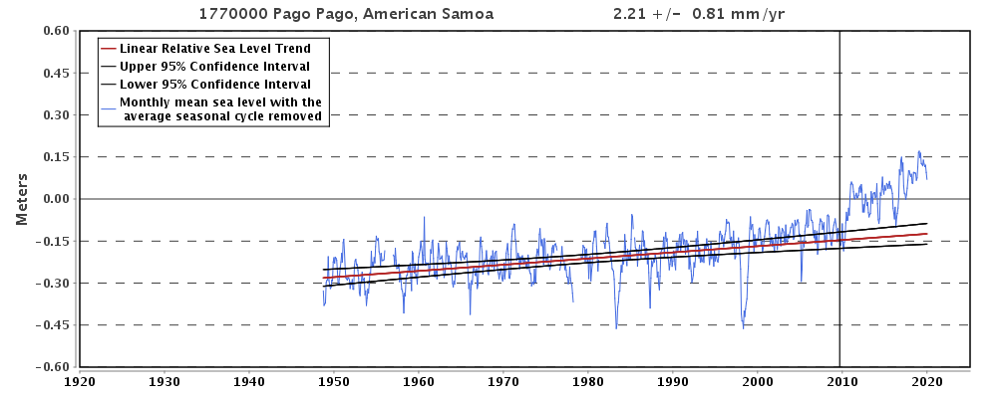

Figure . Monthly mean sea level without regular seasonal variability due to coastal ocean temperatures, salinities, winds, atmospheric pressures, and ocean currents