## CORAL REEF FISH ECOSYSTEM PARAMETERS

### Regional Reef Fish Biomass & Habitat Condition

**Description:** ‘Reef fish biomass’ is mean biomass of reef fishes per unit area derived from visual survey data between 2010 and 2019. Hard Coral cover is mean cover derived from visual estimates by divers of sites where reef fish surveys occurred.

**Rationale:** Reef fish biomass has been widely used as an indicator of relative ecosystem status and has repeatedly been shown to be sensitive to changes in fishing pressure, habitat quality, and oceanographic regime. Hard coral cover is an indicator of relative status of the organisms that build coral reef habitat, and has been shown to be sensitive to changes in oceanographic regime, and a range of direct and indirect anthropogenic impacts. Most fundamentally, cover of hard corals has been increasingly impacted by temperature stress as a result of global heating.

**Data Category:** Fishery-independent

**Timeframe:** Triennial

**Jurisdiction:** American Samoa, Guam, CNMI, Main Hawaiian Islands (MHI), Northwestern Hawaiian Islands (NWHI), and Pacific Remote Island Areas (PRIAs)

**Spatial Scale:** Regional

**Data Source:** Data used to generate cover and biomass estimates come from visual surveys conducted by NOAA PIFSC Coral Reef Ecosystem and their partners as part of the Pacific Reef Assessment and Monitoring Program (RAMP; <http://www.pifsc.noaa.gov/cred/pacific_ramp.php>). Survey methods are described in detail at [http://www.pifsc.noaa.gov/library/pubs/admin/PIFSC_Admin_ Rep_15-07.pdf](http://www.pifsc.noaa.gov/library/pubs/admin/PIFSC_Admin_%20Rep_15-07.pdf). In brief, they involve teams of divers conducting stationary point count cylinder (SPC) surveys within a target domain of < 30 meter hard-bottom habitat at each island, stratified by depth zone and, for larger islands, by section of coastline. For consistency among islands, only data from forereef habitats are used. At each SPC, divers record the number, size, and species of all fishes within or passing through paired 15 meter-diameter cylinders over the course of a standard count procedure.

Fish sizes and abundance are converted to biomass using standard length-to-weight conversion parameters, taken largely from FishBase (<http://www.fishbase.org>) and converted to biomass per unit area by dividing by the area sampled per survey. Site-level data were pooled into island-scale values by first calculating mean and variance within strata, and then calculating weighted island-scale mean and variance using the formulas given in Smith et al. (2011) with strata weighted by their respective sizes.

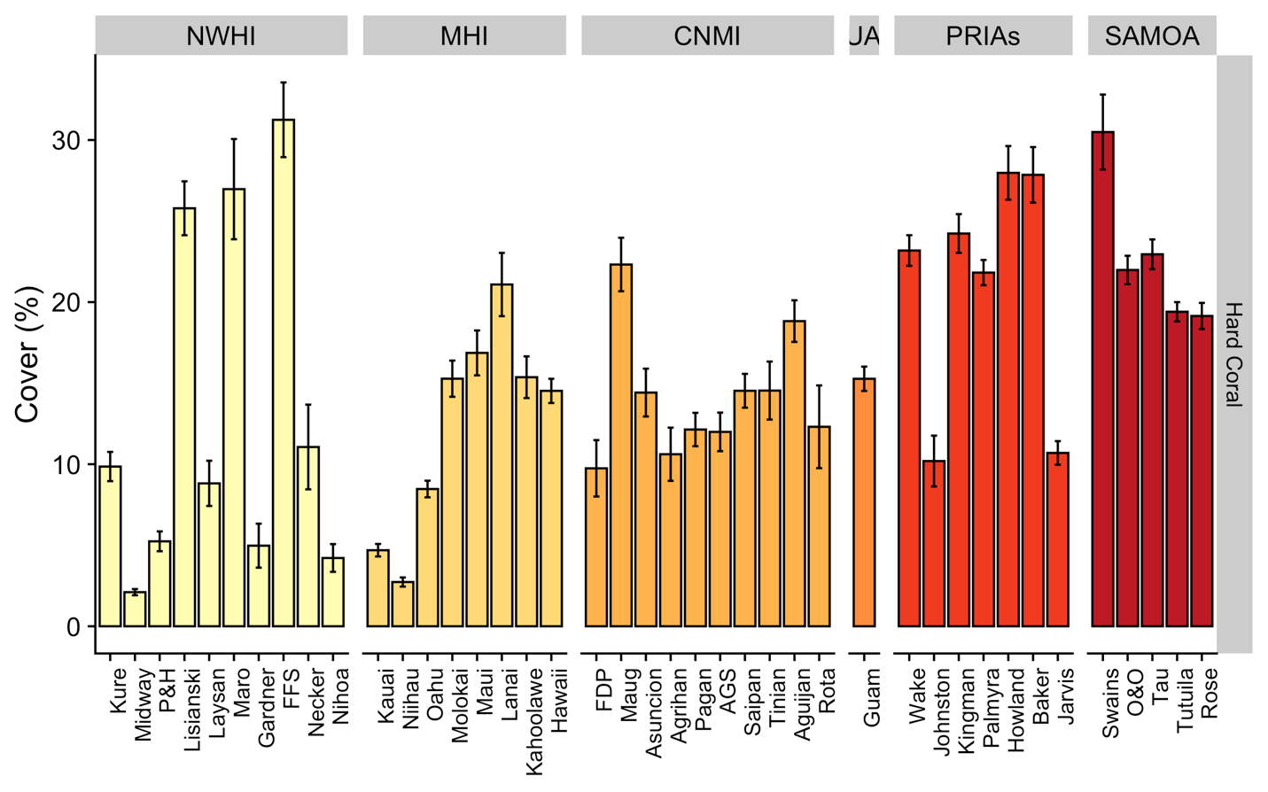

**Figure 1. Mean coral cover (%) per U.S. Pacific island averaged over the years 2010-2019 by latitude**

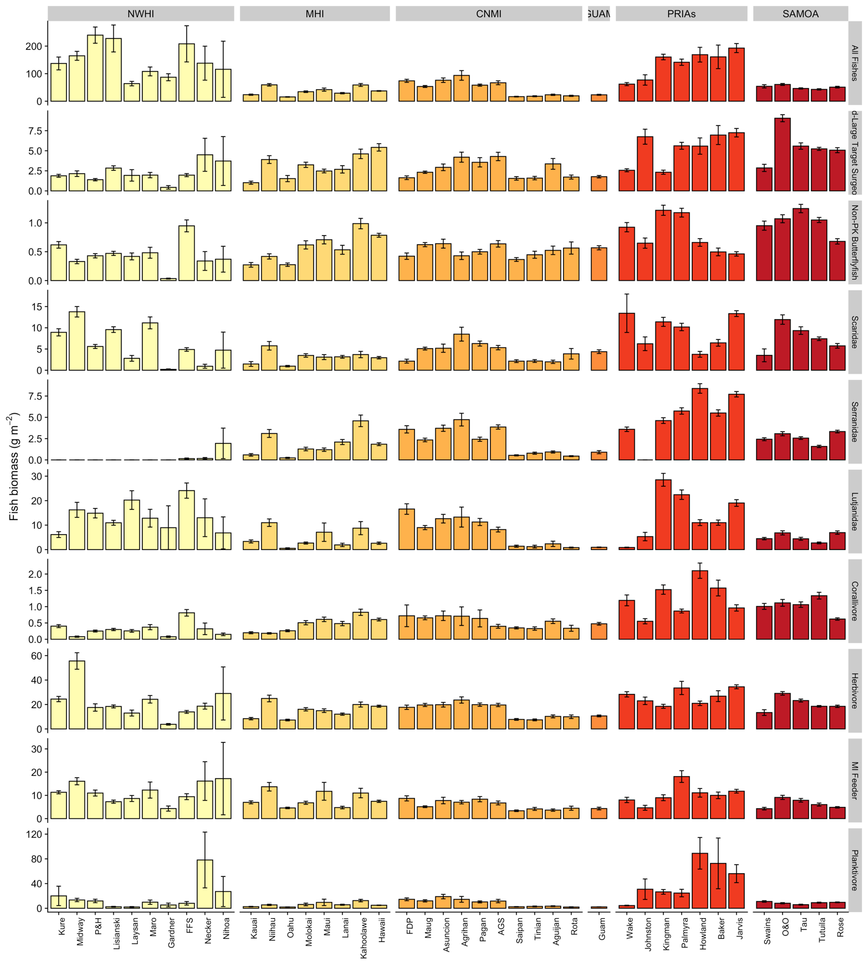Figure 2. Mean fish biomass (g/m2 ± standard error) of functional, taxonomic and trophic groups by U.S. Pacific reef area from the years 2010-2019 by latitude. The group Serranidae excludes planktivorous members of that family – i.e. anthias, which can by hyper-abundant in some regions. Similarly the bumphead parrotfish, *Bolbometopon muricatum*, has been excluded from the corallivore group – as high biomass of that species at Wake overwhelms corallivore biomass at all other locations. The group ‘MI Feeder’ consists of fishes that primarily feed on mobile invertebrates.

### CNMI Fish Biomass & Habitat Condition

**Description:** ‘Reef fish biomass’ is mean biomass of reef fishes per unit area derived from visual survey data between 2010 and 2019. Hard Coral cover is mean cover derived from visual estimates by divers of sites where reef fish surveys occurred.

**Rationale:** Reef fish biomass has been widely used as an indicator of relative ecosystem status and has repeatedly been shown to be sensitive to changes in fishing pressure, habitat quality, and oceanographic regime. Hard coral cover is an indicator of relative status of the organisms that build coral reef habitat, and has been shown to be sensitive to changes in oceanographic regime, and a range of direct and indirect anthropogenic impacts. Most fundamentally, cover of hard corals has been increasingly impacted by temperature stress as a result of global heating.

**Data Category:** Fishery-independent

**Timeframe:** Triennial

**Jurisdiction:** CNMI

**Spatial Scale:** Island

**Data Source:** Data used to generate biomass and cover estimates comes from visual surveys conducted by NOAA PIFSC Coral Reef Ecosystem and partners, as part of the Pacific Reef Assessment and Monitoring Program. Survey methods and sampling design, and methods to generate reef fish biomass are described above (Section 2.1.1).

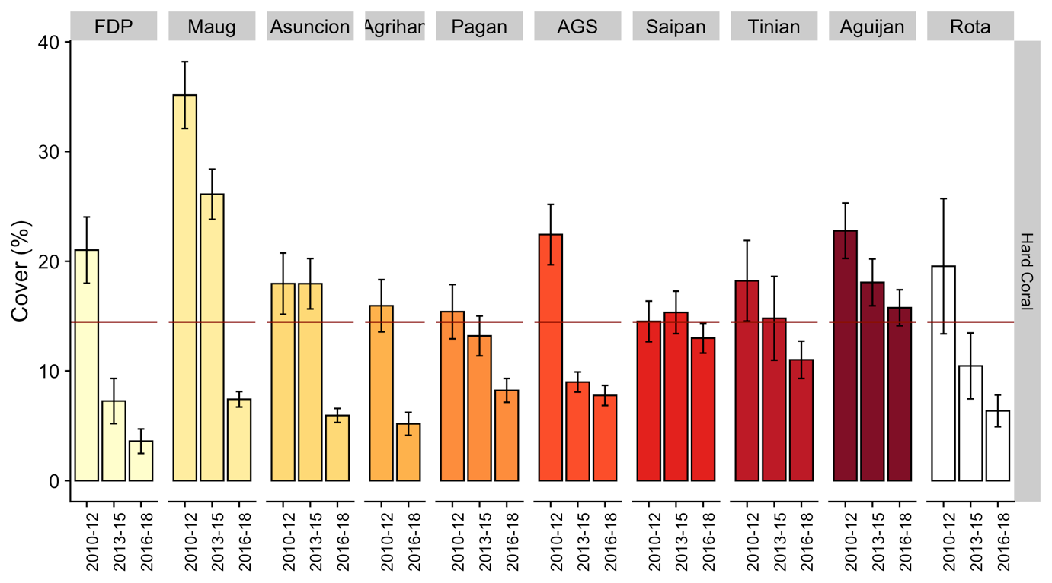

Figure 3. Mean coral cover (%) per island averaged over the years 2010-2019 by latitude with CNMI mean estimates plotted for reference (red line).

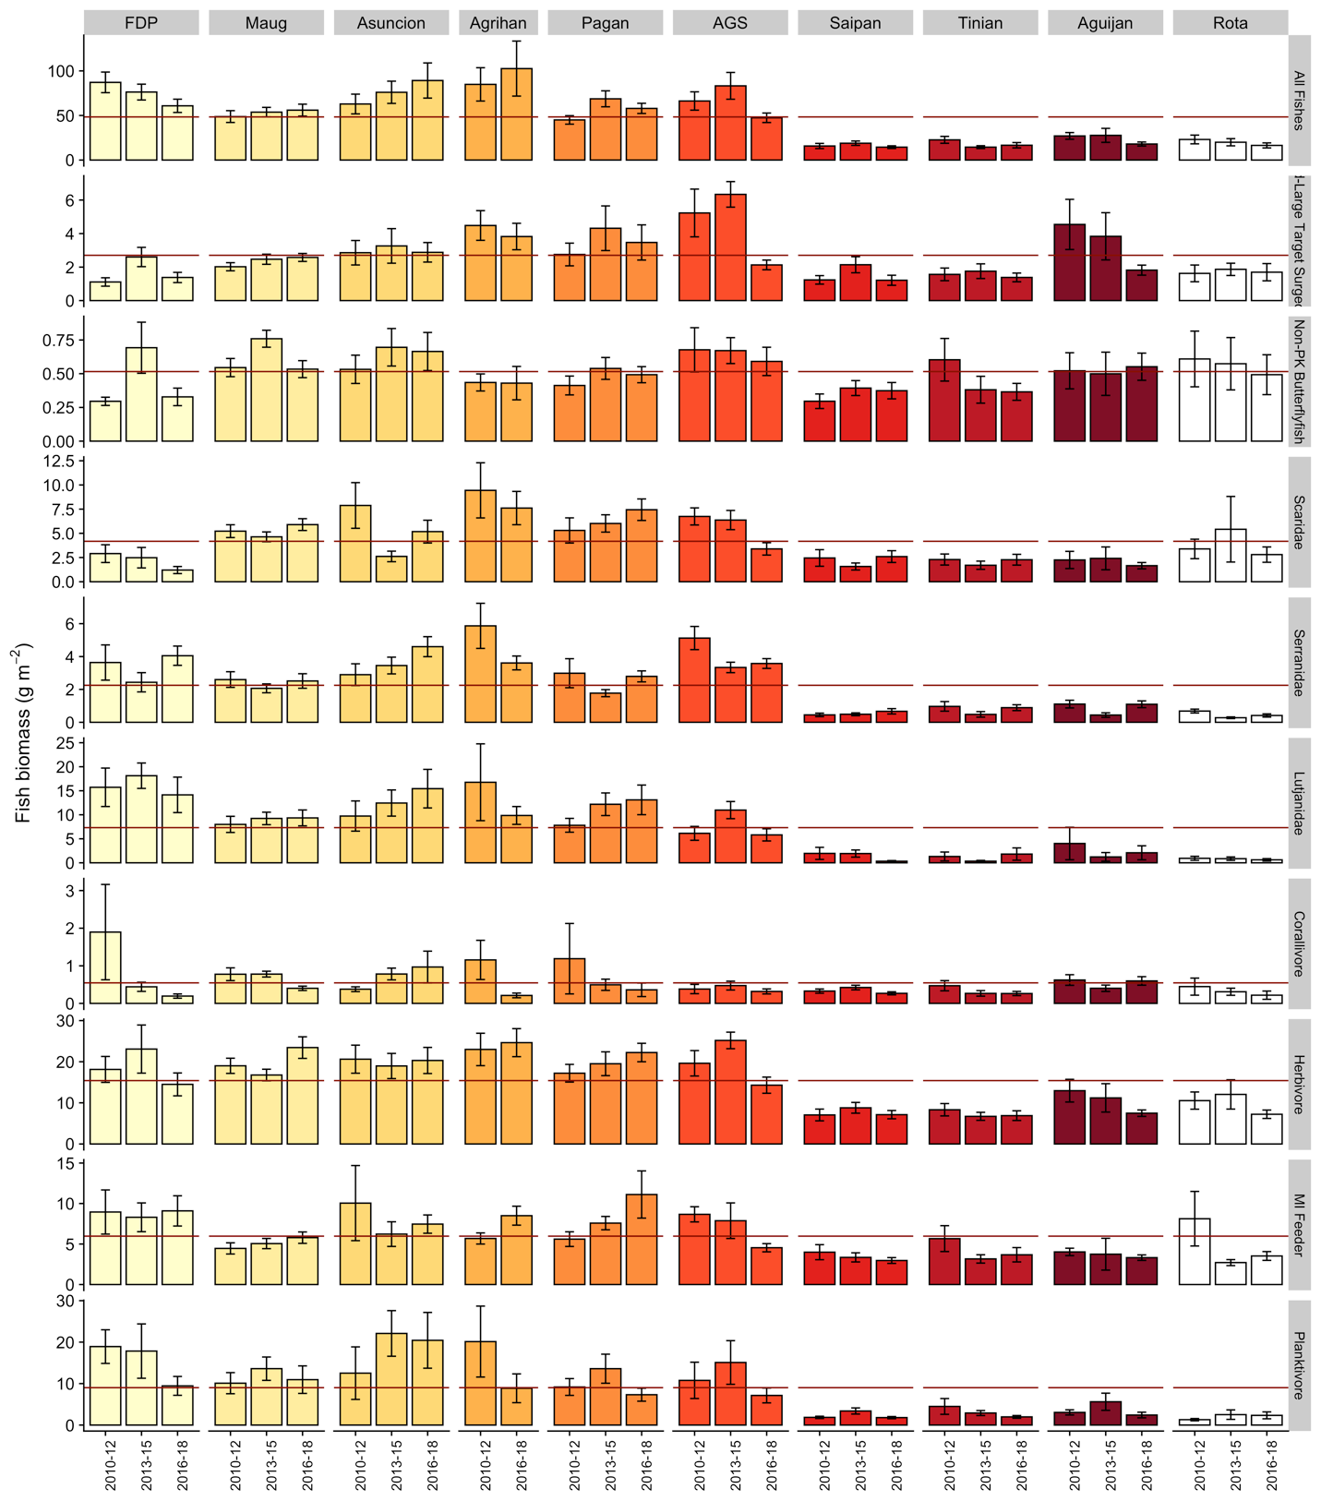Figure 4. Mean fish biomass (g/m2 ± standard error) of CNMI functional, taxonomic and trophic groups from the years 2010-2019 by island. The group Serranidae excludes planktivorous members of that family – i.e. anthias, which can by hyper-abundant in some regions. Similarly the bumphead parrotfish, *Bolbometopon muricatum*, has been excluded from the corallivore group. The group ‘MI Feeder’ consists of fishes that primarily feed on mobile invertebrates; with CNMI mean estimates plotted for reference (red line).

### Guam Fish Biomass & Habitat Condition

**Description:** ‘Reef fish biomass’ is mean biomass of reef fishes per unit area derived from visual survey data between 2010 and 2019. Hard Coral cover is mean cover derived from visual estimates by divers of sites where reef fish surveys occurred.

**Rationale:** Reef fish biomass has been widely used as an indicator of relative ecosystem status and has repeatedly been shown to be sensitive to changes in fishing pressure, habitat quality, and oceanographic regime. Hard coral cover is an indicator of relative status of the organisms that build coral reef habitat, and has been shown to be sensitive to changes in oceanographic regime, and a range of direct and indirect anthropogenic impacts. Most fundamentally, cover of hard corals has been increasingly impacted by temperature stress as a result of global heating.

**Data Category:** Fishery-independent

**Timeframe:** Triennial

**Jurisdiction:** Guam

**Spatial Scale:** Island

**Data Source:** Data used to generate biomass and cover estimates comes from visual surveys conducted by NOAA PIFSC Coral Reef Ecosystem and partners, as part of the Pacific Reef Assessment and Monitoring Program. Survey methods and sampling design, and methods to generate reef fish biomass are described above (Section 2.1.1).

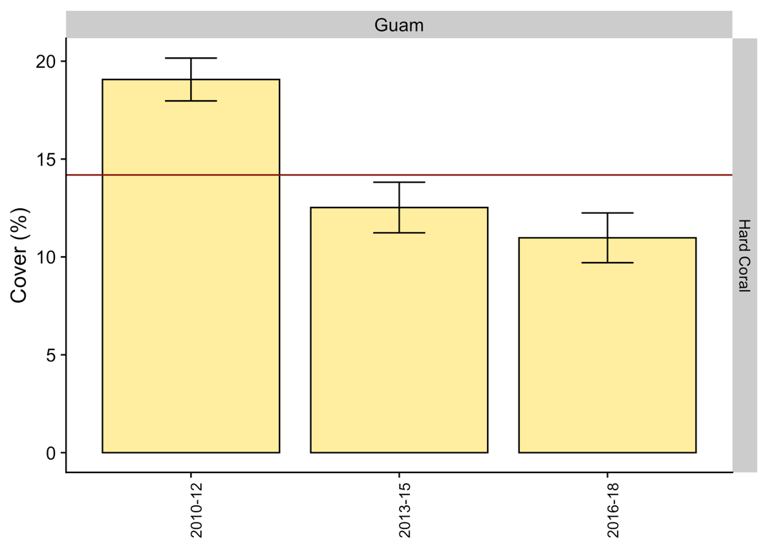

Figure 5. Mean coral cover (%) over the years 2010-2019 with mean for the entire time period plotted for reference (red line).

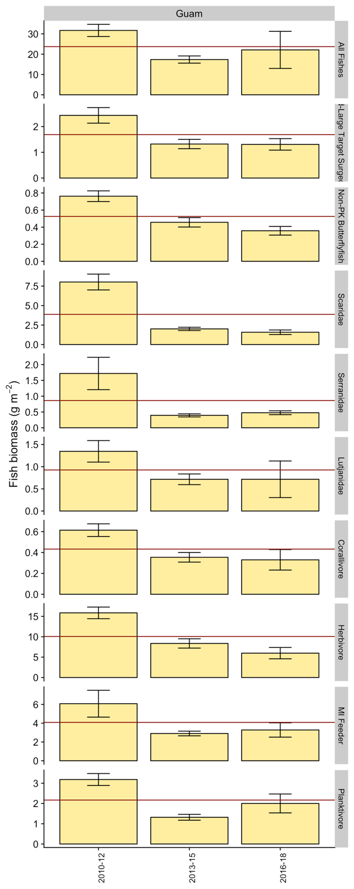

Figure 6. Mean fish biomass (g/m2 ± standard error) of Guam functional, taxonomic and trophic groups from the years 2010-2019. The group Serranidae excludes planktivorous members of that family – i.e. anthias, which can by hyper-abundant in some regions. Similarly the bumphead parrotfish, *Bolbometopon muricatum*, has been excluded from the corallivore group. The group ‘MI Feeder’ consists of fishes that primarily feed on mobile invertebrates; with Guam mean estimates plotted for reference (red line).