## Essential Fish Habitat

### Introduction

The Magnuson-Stevens Fishery Conservation and Management Act (MSA) includes provisions concerning the identification and conservation of essential fish habitat (EFH) and, under the EFH final rule, habitat areas of particular concern (HAPC) (50 Code of Federal Regulations [CFR] 600.815). The MSA defines EFH as “those waters and substrate necessary to fish for spawning, breeding, feeding, or growth to maturity.” HAPC are those areas of EFH identified pursuant to 50 CFR 600.815(a)(8), and meeting one or more of the following considerations: (1) ecological function provided by the habitat is important; (2) habitat is sensitive to human-induced environmental degradation; (3) development activities are, or will be, stressing the habitat type; or (4) the habitat type is rare.

NMFS and the regional fishery management councils must describe and identify EFH in fishery management plans (FMPs) or fishery ecosystem plans (FEPs), minimize to the extent practicable the adverse effects of fishing on EFH, and identify other actions to encourage the conservation and enhancement of EFH. Federal agencies that authorize, fund, or undertake actions that may adversely affect EFH must consult with NMFS, and NMFS must provide conservation recommendations to federal and state agencies regarding actions that would adversely affect EFH. Councils also have the authority to comment on federal or state agency actions that would adversely affect the habitat, including EFH, of managed species.

The EFH Final Rule strongly recommends regional fishery management councils and NMFS to conduct a review and revision of the EFH components of FMPs every five years (600.815(a)(10)). The Council’s FEPs state that new EFH information should be reviewed, as necessary, during preparation of the annual reports by the Plan Teams. Additionally, the EFH Final Rule states “Councils should report on their review of EFH information as part of the annual Stock Assessment and Fishery Evaluation (SAFE) report prepared pursuant to §600.315(e).” The habitat portion of the annual SAFE report is designed to meet the FEP requirements and EFH Final Rule guidelines regarding EFH reviews.

National Standard 2 guidelines recommend that the SAFE report summarize the best scientific information available concerning the past, present, and possible future condition of EFH described by the FEPs.

#### EFH Information

The EFH components of FMPs include the description and identification of EFH, lists of prey species and locations for each managed species, and optionally, HAPC. Impact-oriented components of FMPs include federal fishing activities that may adversely affect EFH, non-federal fishing activities that may adversely affect EFH, non-fishing activities that may adversely affect EFH, conservation and enhancement recommendations, and a cumulative impacts analysis on EFH. The last two components include the research and information needs section, which feeds into the Council’s Five-Year Research Priorities, and the EFH update procedure, which is described in the FEP but implemented in the annual SAFE report.

The Council has described EFH for five management unit species (MUS) under its management authority, some of which are no longer MUS: pelagic (PMUS), bottomfish (BMUS), crustaceans (CMUS), former coral reef ecosystem (CREMUS), and precious corals (PCMUS). The Hawaii FEP describes EFH for the BMUS, CMUS, and PCMUS.

EFH reviews of the biological components, including the description and identification of EFH, lists of prey species and locations, and HAPC, consist of three to four parts:

* Updated species descriptions, which can be found appended to the SAFE report. These can be used to directly update the FEP;
* Updated EFH levels of information tables, which can be found in this Section 2.6.4;
* Updated research and information needs, which can be found in Section 2.6.5. These can be used to directly update the FEP; and
* An analysis that distinguishes EFH from all potential habitats used by the species, which is the basis for an options paper for the Council. This part is developed if enough information exists to refine EFH.

#### Habitat Objectives of FEP

The habitat objective of the FEP is to refine EFH and minimize impacts to EFH, with the following sub-objectives:

* Review EFH and HAPC designations every five years based on the best available scientific information and update such designations based on the best available scientific information, when available; and
* Identify and prioritize research to assess adverse impacts to EFH and HAPC from fishing (including aquaculture) and non-fishing activities, including, but not limited to, activities that introduce land-based pollution into the marine environment.

The annual report has reviewed the precious coral EFH components, crustacean EFH components, and non-fishing impacts components, resetting the five-year timeline for review. The Council’s support of non-fishing activities research is monitored through the program plan and five-year research priorities, not the annual report.

#### Response to Previous Council Recommendations

At its 172nd meeting in March 2018, the Council recommended that staff develop an omnibus amendment updating the non-fishing impact to EFH sections of the FEPs, incorporating the non-fishing impacts EFH review report by Minton (2017) by reference. An options paper has been developed.

At its 173rd meeting in June 2018, the Council directed staff to develop options to redefine EFH precious corals in Hawaii for Council consideration for an FEP amendment. An options paper was developed and presented to the Council.

At its 174th meeting in October 2018, the Council directed staff to prepare an amendment to the Hawaii FEP to revise EFH for precious corals and selected the following preliminarily preferred options for the staff to further analyze: revise existing beds and designate new beds as EFH, update geographic extent and habitat characteristics, and update the FEPs.

At its 178th meeting in July 2019, the Council approved the draft amendment to the Hawaii FEP to revise precious coral EFH and directed staff to send the document to NMFS PIRO for completion, however, there were issues during the final transmittal associated with the designations of the new precious coral beds. The Council will decide how to proceed at its 181st meeting in March 2020.

### Habitat Use by MUS and Trends in Habitat Condition

The Hawaiian Archipelago is an island chain in the central North Pacific Ocean. It runs for approximately 1,500 miles in a northwest direction, from Hawaii Island in the southeast to Kure Atoll in the northwest and is among the most isolated island areas in the world. The chain can be divided according to the large and mountainous Main Hawaiian Islands (MHI; Hawaii, Maui, Lanai, Molokai, Kahoolawe, Oahu, Kauai, and Niihau) and the small, low-lying Northwest Hawaiian Islands (NWHI), which include Necker, French Frigate Shoals, Laysan, and Midway atoll. The largest of the MHI is Hawaii Island at just over 4,000 square miles – the largest in Polynesia, while Kahoolawe is the smallest at 44.6 square miles.

The archipelago developed as the Pacific plate moved slowly over a hotspot in the Earth's mantle. Thus, the islands on the northwest end of the archipelago are older; it is estimated that Kure Atoll is approximately 28 million years old while Hawaii Island is approximately 400,000 years old. The highest point in Hawaii is Mauna Kea, at approximately 13,800 feet.

The MHI are all in tropical latitudes. The archipelago becomes subtropical at about French Frigate Shoals (23°46’ N). The climate of the Hawaiian Islands is generally tropical, but there is great climactic variation, due primarily to elevation and leeward versus windward areas. Easterly trade winds bring much of the rain, and so the windward sides of all the islands are typically wetter. The south and west (leeward) sides of the islands tend to be drier. Hawaii receives the majority of its precipitation from October to April, while drier conditions generally prevail from May to September. Tropical storms and hurricanes occur in the northern hemisphere hurricane and typhoon season, which runs from June through November.

There is fairly little shallow water habitat in Hawaii, owing to the islands’ steep rise from the abyssal deep. However, there are some larger areas, such as Penguin Bank between Oahu and Molokai, which are relatively shallow. Hawaii has extensive coral reef habitat throughout the MHI as they are much younger and have more fringing reef habitat than the NWHI, which has shallower reef habitat overall.

EFH in the Hawaiian Archipelago for the MUS comprises all substrate from the shoreline to the 700 m isobath. The entire water column is described as EFH from the shoreline to the 700 m isobath, and the water column to a depth of 400 m is described as EFH from the 700 m isobath to the limit or boundary of the EEZ. While the coral reef ecosystems surrounding the islands in the MHI and NWHI have been the subject of a comprehensive monitoring program through the PIFSC Coral Reef Ecosystem Division (CRED) biennially since 2002, surveys are focused on the nearshore environments surrounding the islands, atolls, and reefs .

PIFSC CRED is now the Coral Reef Ecosystem Program (CREP) within the PIFSC Ecosystem Sciences Division (ESD) whose mission is to conduct multidisciplinary research, monitoring, and analysis of integrated environmental and living resource systems in coastal and offshore waters of the Pacific Ocean. This mission includes field research activities that cover near-shore island ecosystems such as coral reefs to open ocean ecosystems on the high seas. The ESD research focus includes oceanography, coral reef ecosystem assessment and monitoring, benthic habitat mapping, and marine debris surveys and removal. This broad focus enables ESD to analyze not only the current structure and dynamics of marine environments, but also to examine potential projections of future conditions such as those resulting from climate change impacts. Because humans are a key part of the ecosystem, our research includes the social, cultural, and economic aspects of fishery and resource management decisions. (PIFSC, 2020. https://www.fisheries.noaa.gov/about/pacific-islands-fisheries-science-center) The CREP continues to “provide high-quality, scientific information about the status of coral reef ecosystems of the U.S. Pacific islands to the public, resource managers, and policymakers on local, regional, national, and international levels” (PIFSC, 2011). CREP conducts comprehensive ecosystem monitoring surveys at about 50 islands, atolls, and shallow bank sites in the Western Pacific Region on a rotating schedule, based on operational capabilities. CREP coral reef monitoring reports provide the most comprehensive description of nearshore habitat quality in the region.

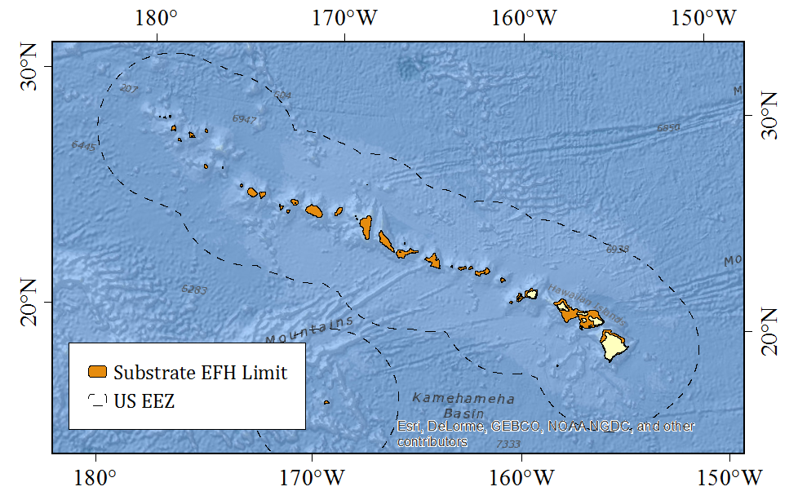

Figure 41. Substrate EFH limit of 700 m isobath around the Hawaiian Archipelago (from GMRT; Ryan et al., 2009)

#### Habitat Mapping

Interpreted IKONOS benthic habitat maps in the 0 – 30 m depth range have been completed for all islands in the MHI and NWHI (Miller et al., 2011). While there are gaps in multibeam coverage in the MHI (Miller et al., 2011), 60 m resolution bathymetry and backscatter are available from the Falkor for much of the NWHI (Hawaii Mapping Research Group, 2014).

Table 52. Summary of habitat mapping in the MHI

|  |  |  |  |
| --- | --- | --- | --- |
| **Depth Range** | **Timeline/Mapping Product** | **Progress** | **Source** |
| 0-30 m | IKONOS Benthic Habitat Maps | All islands complete | Miller et al. (2011) |
|  | 2000-2010 Bathymetry | 84% | DesRochers (2016) |
|  | 2011-2015 Multibeam Bathymetry | 4% | DesRochers (2016) |
|  | 2011-2015 Satellite WorldView 2 Bathymetry | 5% | DesRochers (2016) |
| 0-150 m | Multibeam Bathymetry | Gaps exist around Maui, Lanai, and Kahoolawe. Access restricted at Kahoolawe. | Miller et al. (2011) |
| 30-150 m | 2000-2010 Bathymetry | 86% | DesRochers (2016) |
|  | 2011-2015 Multibeam Bathymetry | 2% | DesRochers (2016) |
| Overall multibeam depths | Derived Products | Few exist | Miller et al. (2011) |

Table 53. Summary of habitat mapping in the NWHI

|  |  |  |  |
| --- | --- | --- | --- |
| **Depth Range** | **Timeline/Mapping Product** | **Progress** | **Source** |
| 0-30 m | IKONOS Benthic Habitat Maps | All islands complete | Miller et al. (2011) |
|  | 2000-2010 Bathymetry | 6% | DesRochers (2016) |
|  | 2011-2015 Multibeam Bathymetry | - | DesRochers (2016) |
|  | 2011-2015 Satellite WorldView 2 Bathymetry | - | DesRochers (2016) |
| 30-150 m | 2000-2010 Bathymetry | 49% | DesRochers (2016) |
|  | 2011-2015 Multibeam Bathymetry | 4% | DesRochers (2016) |

The land and seafloor area surrounding the islands of the MHI as well as primary data coverage are reproduced from Miller et al. (2011) in Figure 42. The land and seafloor area surrounding the islands of the NWHI as well as primary data coverage are similarly reproduced in Figure 43.

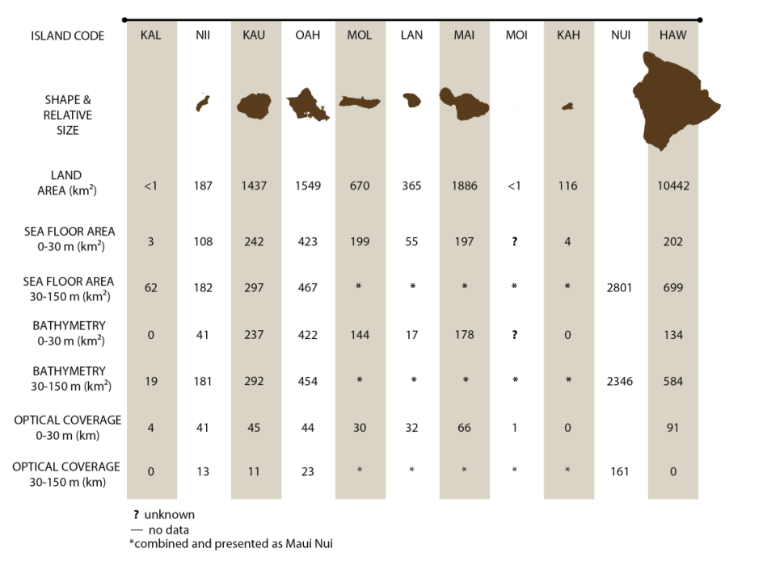

Figure 42. MHI land and seafloor with primary data coverage

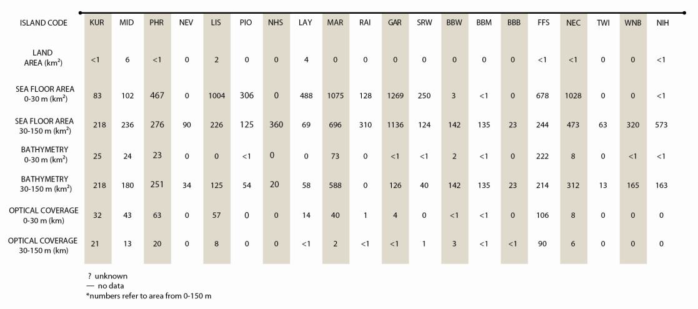

Figure 43. NWHI land and seafloor with primary data coverage

#### Benthic Habitat

Juvenile and adult life stages of former CREMUS and crustaceans including spiny and slipper lobsters and Kona crab extends from the shoreline to the 100 m isobath (64 FR 19067, April 19, 1999). All benthic habitat is considered EFH for crustacean species (64 FR 19067, April 19, 1999), while the type of bottom habitat varies by family for coral reef species (69 FR 8336, February 24, 2004). Juvenile and adult bottomfish EFH extends from the shoreline to the 400 m isobath (64 FR 19067, April 19, 1999), and juvenile and adult deepwater shrimp habitat extends from the 300m isobath to the 700 m isobath (73 FR 70603, November 21, 2008).

##### RAMP Indicators

Benthic percent cover of coral, macroalgae, and crustose coralline algae are surveyed as a part of the Pacific Reef Assessment and Monitoring Program (RAMP) led by the PIFSC Ecosystem Sciences Division (ESD). Previously, Pacific RAMP surveys had benthic cover data summarized by island; these data are shown in Table 54 through Table 59. The benthic towed-diver survey method was used to monitor change in benthic communities. In this method, a pair of scuba divers (one collecting fish data, the other collecting benthic data) would be towed about one meter above the reef roughly 60 m behind a small boat at a constant speed of about 1.5 kt. Each diver maneuvers a tow board platform, which is connected to the boat by a bridle and towline and outfitted with a communications telegraph and various survey equipment including a downward-facing digital SLR camera. The benthic towed diver records general habitat complexity and type (e.g., spur and groove, pavement), percent cover by functional-group (hard corals, stressed corals, soft corals, macroalgae, crustose coralline algae, sand, and rubble) and for macroinvertebrates (crown-of-thorns sea stars, sea cucumbers, free and boring urchins, and giant clams). The surveys are typically 50 minutes long and cover about two to three kilometers of habitat (PIFSC, 2016). However, this method was retired in 2016, and no new data will be appended to the time series.

More recently, the surveys began focusing on geographic sub-regions of islands for a more fine-scale summary of benthic cover; these data are shown in Table 60 through Table 62. A stratified random sampling design is used to determine status, trends, and variability of benthic communities at Rapid Ecological Assessment (REA) sites. In 2018, surveys at each REA site were conducted with one 10-meter squared belt transects, whereas two belt transects were used from 2013 to 2017. The survey domain encompasses the majority of the mapped area of reef and hard bottom habitats from 0 to 30 m depth. The stratification scheme includes (1) three depth categories (shallow: 0 to 6 m; mid-depth: >6 to 18 m; and deep: >18 to 30 m); (2) regional sub-island sectors; (3) reef zone components, including back reef, lagoon, and fore reef.

Coral colonies and their morphology are identified before measuring the colony size and assessing colony condition. Photoquadrats are used to derive estimates of benthic cover. The photoquadrat consists of a high-resolution digital camera mounted on a photoquadrat pole. Photoquadrat images are collected along the same two transects used for coral surveys at one-meter intervals, starting at 1 m and progressing to the 15-meter mark (images are not collected at the 0 m mark). This provides a total of 15 images per transect and 30 per site. In 2018, a single stage sampling scheme was implemented, which designates primary sample units (referred to sites) as grid cells containing >10% hard-bottom reef habitats. Also in 2018, a new method of determining survey effort was used by first determining the number of days spent at each island then by strata area and variance of target species at the island level (Swanson et al, 2018; Winston et al., 2019).

Table 54. Mean percent cover of live coral at RAMP sites collected from towed-diver surveys using previous methodology in the MHI

|  |  |  |  |  |  |
| --- | --- | --- | --- | --- | --- |
| **Island** | **2005** | **2006** | **2008** | **2010** | **2016** |
| Hawaii |  | 18.38 | 17.11 | 22.1 | 25.65 |
| Kauai | 6.06 | 12.27 | 7.04 | 6.04 | 6.99 |
| Kaula |  | 6.9 |  |  |  |
| Lanai | 30.48 | 26.61 | 22.42 | 23.34 | 30.42 |
| Maui | 18.99 | 20.33 | 12.06 | 14.62 | 11.91 |
| Molokai | 35.66 | 6.96 | 6.92 | 52.17 | 18.85 |
| Niihau | 5.03 | 2.39 | 2.29 | 2.26 | 3.44 |
| Oahu | 9.36 | 12.21 | 9.45 | 8.19 |  |

Table 55. Mean percent cover of macroalgae at RAMP sites collected from towed-diver surveys using previous methodology in the MHI

|  |  |  |  |  |  |
| --- | --- | --- | --- | --- | --- |
| **Island** | **2005** | **2006** | **2008** | **2010** | **2016** |
| Hawaii |  | 5.46 | 1.01 | 1.05 | 0.29 |
| Kauai | 35.67 | 27.92 | 16.45 | 16.25 | 9.61 |
| Kaula |  | 5.94 |  |  |  |
| Lanai | 7.38 | 13.18 | 17.13 | 11.14 | 2.69 |
| Maui | 17.84 | 16.24 | 12.04 | 2.13 | 12.12 |
| Molokai | 23.31 | 24.22 | 12.71 | 4.75 | 9.47 |
| Niihau | 41.30 | 14.57 | 2.58 | 2.22 | 0.03 |
| Oahu | 37.03 | 27.41 | 12.58 | 13.03 |  |

Table 56. Mean percent cover of crustose coralline algae from RAMP sites collected from towed-diver surveys using previous methodology in the MHI

|  |  |  |  |  |  |
| --- | --- | --- | --- | --- | --- |
| **Island** | **2005** | **2006** | **2008** | **2010** | **2016** |
| Hawaii |  | 14.82 | 16.09 | 6.94 | 5.97 |
| Kauai | 3.67 | 2.94 | 4.14 | 1.71 | 2.70 |
| Kaula |  | 7.40 |  |  |  |
| Lanai | 2.42 | 1.31 | 3.72 | 2.82 | 0.03 |
| Maui | 4.37 | 4.83 | 6.82 | 4.31 | 1.22 |
| Molokai | 3.71 | 3.79 | 5.24 | 4.19 | 0.65 |
| Niihau | 10.87 | 6.68 | 8.05 | 1.88 | 0.28 |
| Oahu | 13.95 | 2.74 | 4.28 | 2.42 |  |

Table 57. Mean percent cover of live coral at RAMP sites collected from towed-diver surveys using previous methodology in the NWHI

| **Island** | **2000** | **2001** | **2002** | **2003** | **2004** | **2006** | **2008** | **2010** | **2016** |
| --- | --- | --- | --- | --- | --- | --- | --- | --- | --- |
| French Frigate | 27.23 | 5.00 | 14.22 | 13.47 | 11.29 | 18.25 | 15.23 | 13.28 | 17.53 |
| Gardner | 3.00 |  |  | 2.50 | 1.65 |  |  |  |  |
| Kure | 7.3 |  | 9.61 | 12.34 | 12.63 | 17.2 | 17.6 | 14.57 | 13.08 |
| Laysan | 9.96 |  | 9.76 | 4.00 | 7.33 | 6.96 | 8.43 |  |  |
| Lisianski | 28.17 |  | 24.29 | 15.2 | 26.81 | 27.22 | 25.69 | 27.56 | 26.96 |
| Maro | 27.38 | 18.31 | 13.77 | 16.54 | 25.59 | 22.67 | 19.78 |  |  |
| Midway |  |  | 5.58 | 3.06 | 1.24 | 3.91 | 2.66 |  |  |
| Necker | 6.50 |  |  | 14.52 |  | 14.92 |  |  |  |
| Nihoa | 3.89 |  |  |  |  |  |  |  |  |
| Pearl & Hermes | 15.82 |  | 10.71 | 6.47 | 9.45 | 11.64 | 10.79 | 8.25 | 7.91 |
| Raita |  | 2.50 |  |  |  |  |  |  |  |

Table 58. Mean percent cover of macroalgae at RAMP sites collected from towed-diver surveys using previous methodology in the NWHI

|  |  |  |  |  |  |  |  |  |  |
| --- | --- | --- | --- | --- | --- | --- | --- | --- | --- |
| **Island** | **2000** | **2001** | **2002** | **2003** | **2004** | **2006** | **2008** | **2010** | **2016** |
| French Frigate | 0.00 | 10.50 | 30.13 | 29.05 | 23.15 | 17.33 | 17.81 | 18.42 | 9.60 |
| Gardner | 0.00 |  |  | 73.63 | 26.94 |  |  |  |  |
| Kure | 0.00 |  | 38.84 | 42.79 | 29.84 | 23.14 | 26.22 | 12.99 | 11.00 |
| Laysan | 0.00 |  | 26.90 | 47.03 | 30.63 | 28.66 | 25.70 |  |  |
| Lisianski | 0.00 |  | 20.04 | 24.61 | 17.14 | 21.46 | 20.83 | 13.85 | 10.92 |
| Maro | 0.00 | 17.01 | 20.39 | 17.69 | 30.01 | 20.79 | 18.19 |  |  |
| Midway |  |  | 42.28 | 44.90 | 24.86 | 11.02 | 19.93 |  |  |
| Necker | 0.00 |  |  | 23.39 |  | 33.51 |  |  |  |
| Nihoa | 0.00 |  |  |  |  |  |  |  |  |
| Pearl & Hermes | 0.00 |  | 36.94 | 41.51 | 114.87 | 33.56 | 33.79 | 36.96 | 39.84 |
| Raita |  | 68.83 |  |  |  |  |  |  |  |

Table 59. Mean percent cover of crustose coralline algae at RAMP sites collected from towed-diver surveys using previous methodology in the NWHI

| **Island** | **2000** | **2001** | **2002** | **2003** | **2004** | **2006** | **2008** | **2010** | **2016** |
| --- | --- | --- | --- | --- | --- | --- | --- | --- | --- |
| French Frigate | 0.00 | 0.00 | 8.55 | 8.56 | 2.52 | 9.46 | 8.55 | 1.87 | 4.21 |
| Gardner | 0.00 |  |  | 9.13 | 1.50 |  |  |  |  |
| Kure | 0.00 |  | 3.38 | 7.65 | 5.87 | 7.31 | 6.91 | 4.11 | 7.18 |
| Laysan | 0.00 |  | 3.95 | 11.17 | 5.11 | 10.21 | 7.93 |  |  |
| Lisianski | 0.00 |  | 14.21 | 7.97 | 12.11 | 17.19 | 17.42 | 11.78 | 13.29 |
| Maro | 0.00 | 13.95 | 15.17 | 12.89 | 4.36 | 16.54 | 15.29 |  |  |
| Midway |  |  | 7.58 | 3.69 | 7.17 | 5.80 | 5.62 |  |  |
| Necker | 0.00 |  |  | 7.86 |  | 1.48 |  |  |  |
| Nihoa | 0.00 |  |  |  |  |  |  |  |  |
| Pearl & Hermes | 0.00 |  | 14.13 | 14.38 | 11.84 | 10.07 | 12.43 | 7.61 | 14.44 |
| Raita |  | 0.42 |  |  |  |  |  |  |  |

Table 60. Mean percent cover of live coral at RAMP sites collected from belt transect surveys using updated methodology in the MHI

|  |  |  |  |  |  |
| --- | --- | --- | --- | --- | --- |
| **Island** | **Island Area** | **2010-12** | **2013-15** | **2016** | **2019** |
| Hawaii | Hamakua | 8.49 | 6.83 |  | 4.55 |
| Hawaii | Kona | 27.59 | 26.87 | 15.84 | 13.80 |
| Hawaii | Puna | 13.87 | 16.88 | 9.00 | 5.03 |
| Hawaii | Southeast |  | 23.33 | 16.19 |  |
| Kahoolawe | North |  |  | 32.67 | 27.64 |
| Kahoolawe | South |  |  | 5.04 | 4.40 |
| Kauai | East | 8.01 | 6.10 | 3.23 | 3.40 |
| Kauai | Nā Pali | 4.50 | 3.55 | 0.92 | 1.25 |
| Lanai | North | 26.99 | 12.62 | 20.59 | 39.07 |
| Lanai | South | 20.61 | 17.55 | 26.67 | 16.39 |
| Maui | Hana | 4.45 |  |  |  |
| Maui | Kahului |  | 25.22 |  |  |
| Maui | Kihei | 36.06 | 42.28 | 29.48 | 25.48 |
| Maui | Lahaina | 13.20 | 12.27 | 7.89 | 15.49 |
| Maui | Northeast | 3.03 | 5.37 | 5.63 | 2.03 |
| Maui | Northwest | 5.26 |  |  |  |
| Maui | Southeast |  |  |  | 11.92 |
| Molokai | Northwest |  | 4.67 |  |  |
| Molokai | Pali | 3.57 | 1.98 | 3.17 | 2.54 |
| Molokai | South | 38.13 | 30.47 | 31.18 | 17.40 |
| Molokai | West | 5.28 | 6.98 | 3.14 | 5.76 |
| Niihau | East | 1.81 | 2.38 |  | 0.67 |
| Niihau | Lehua |  | 3.19 | 2.88 | 2.67 |
| Niihau | West | 0.95 | 1.42 | 0.84 | 0.41 |
| Oahu | East | 8.29 | 13.51 | 17.07 |  |
| Oahu | Kaʻena | 24.05 | 9.17 | 5.28 | 2.90 |
| Oahu | Northeast | 11.68 | 12.94 | 16.08 | 14.85 |
| Oahu | North | 7.25 | 8.31 | 2.87 | 2.75 |
| Oahu | South | 4.64 | 4.36 | 3.37 | 4.54 |

Table 61. Mean percent cover of macroalgae at RAMP sites collected from belt transect surveys using updated methodology in the MHI

| **Island** | **Island Area** | **2010-12** | **2013-15** | **2016** | **2019** |
| --- | --- | --- | --- | --- | --- |
| Hawaii | Hamakua | 5.40 | 0.84 |  | 1.24 |
| Hawaii | Kona | 1.36 | 0.52 | 0.89 | 0.36 |
| Hawaii | Puna | 1.98 | 0.59 | 0.43 | 0.21 |
| Hawaii | Southeast |  | 0.81 | 0.11 |  |
| Kahoolawe | North |  |  | 1.64 | 0.35 |
| Kahoolawe | South |  |  | 2.69 | 2.14 |
| Kauai | East | 5.37 | 1.38 | 2.29 | 0.50 |
| Kauai | Nā Pali | 5.97 | 1.91 | 2.49 | 4.62 |
| Lanai | North | 9.33 | 10.54 | 1.21 | 1.03 |
| Lanai | South | 2.94 | 2.54 | 0.29 | 0.80 |
| Maui | Hana | 6.69 |  |  |  |
| Maui | Kahului |  | 3.66 |  |  |
| Maui | Kihei | 1.50 | 0.71 | 2.14 | 2.51 |
| Maui | Lahaina | 4.76 | 0.95 | 0.27 | 1.68 |
| Maui | Northeast | 7.28 | 3.96 | 1.68 | 1.91 |
| Maui | Northwest | 3.60 |  |  |  |
| Maui | Southeast |  |  |  | 0.21 |
| Molokai | Northwest |  | 0.96 |  |  |
| Molokai | Pali | 1.31 | 5.88 | 0.53 | 1.06 |
| Molokai | South | 1.78 | 0.73 | 0.87 | 1.94 |
| Molokai | West | 5.23 | 3.32 | 3.15 | 8.68 |
| Niihau | East | 13.59 | 0.78 |  | 0.00 |
| Niihau | Lehua |  | 1.22 | 2.05 | 0.60 |
| Niihau | West | 5.27 | 3.35 | 2.24 | 4.00 |
| Oahu | East | 10.48 | 4.21 | 2.72 |  |
| Oahu | Kaʻena | 2.64 | 3.72 | 2.01 | 1.05 |
| Oahu | Northeast | 9.53 | 6.29 | 3.24 | 0.93 |
| Oahu | North | 0.31 | 1.92 | 3.45 | 1.30 |
| Oahu | South | 5.55 | 4.88 | 1.41 | 1.47 |

Table 62. Mean percent cover of crustose coralline algae at RAMP sites collected from belt transect surveys using updated methodology in the MHI

| **Island** | **Island Area** | **2010-12** | **2013-15** | **2016** | **2019** |
| --- | --- | --- | --- | --- | --- |
| Hawaii | Hamakua | 5.91 | 2.51 |  | 3.99 |
| Hawaii | Kona | 9.02 | 9.91 | 7.61 | 7.58 |
| Hawaii | Puna | 16.4 | 9.93 | 5.97 | 4.25 |
| Hawaii | Southeast |  | 10.53 | 7.3 |  |
| Kahoolawe | North |  |  | 2.36 | 0.98 |
| Kahoolawe | South |  |  | 2.64 | 3.56 |
| Kauai | East | 9.75 | 2.47 | 4.98 | 1.92 |
| Kauai | Nā Pali | 2.63 | 1.16 | 1.26 | 1.43 |
| Lanai | North | 5.45 | 1.94 | 0.36 | 0.81 |
| Lanai | South | 3.16 | 1.98 | 1.59 | 1.95 |
| Maui | Hana | 8.02 |  |  |  |
| Maui | Kahului |  | 6.8 |  |  |
| Maui | Kihei | 6.48 | 2.41 | 3.83 | 4.1 |
| Maui | Lahaina | 1.53 | 0.43 | 0.8 | 0.77 |
| Maui | Northeast | 5.05 | 2.19 | 3.96 | 5.73 |
| Maui | Northwest | 5.09 |  |  |  |
| Maui | Southeast |  |  |  | 3.71 |
| Molokai | Northwest |  | 1.14 |  |  |
| Molokai | Pali | 5.58 | 3.88 | 2.41 | 4.02 |
| Molokai | South | 2.04 | 2.82 | 3.22 | 6.71 |
| Molokai | West | 1.58 | 0.79 | 0.87 | 3.3 |
| Niihau | East | 2.84 | 0.83 |  | 1.34 |
| Niihau | Lehua |  | 4.62 | 2.75 | 2.97 |
| Niihau | West | 4.86 | 1.76 | 1.39 | 0.86 |
| Oahu | East | 3.55 | 1.6 | 2.7 |  |
| Oahu | Kaʻena | 0.74 | 2.79 | 0.74 | 2.04 |
| Oahu | Northeast | 10.43 | 2.38 | 7.13 | 1.68 |
| Oahu | North | 1.58 | 1.32 | 1.51 | 1.55 |
| Oahu | South | 2.12 | 0.91 | 3.24 | 0.67 |

#### Oceanography and Water Quality

The water column is also designated as EFH for selected MUS life stages at various depths. For larval stages of all species except deepwater shrimp, the water column is EFH from the shoreline to the EEZ. Coral reef species egg and larval EFH is to a depth of 100 m; crustaceans, 150m; and bottomfish, 400 m. Please see the Ecosystem and Climate Change section (Section 2.5) for information related to oceanography and water quality.

### Report on Review of EFH Information

A review of the biological components of crustacean EFH in Guam and Hawaii was finalized in 2019. This review can be found in Appendix C of this report. The non-fishing impacts and cumulative impacts components were reviewed in 2016 through 2017, which can be found in Minton (2017).

### EFH Levels

NMFS guidelines codified at 50 C.F.R. § 600.815 recommend Councils organize data used to describe and identify EFH into the following four levels:

* Level 1: Distribution data are available for some or all portions of the geographic range of the species.
* Level 2: Habitat-related densities of the species are available.
* Level 3: Growth, reproduction, or survival rates within habitats are available.
* Level 4: Production rates by habitat are available.

The Council adopted a fifth level, denoted Level 0, for situations in which there is no information available about the geographic extent of a particular managed species’ life stage. The existing level of data for individual MUS in each fishery are presented in tables per fishery.

The Hawai‘i Undersea Research Laboratory (HURL) is a center operating under the School of Ocean and Earth Sciences and Technology (SOEST) at the University of Hawai‘i (UH) and NOAA’s Office of Ocean Exploration and Research. The unique deep-sea research operation runs the Pisces IV and V manned submersibles and remotely operated vehicles (ROVs) for investigating the undersea environment through hypothesis driven projects that address gaps in knowledge or scientific needs. HURL maintains a comprehensive video database, which includes biological and substrate data extracted from their dive video archives. Submersible and ROV data are collected from depths deeper than 40 m. Observations from the HURL video archives are considered Level 1 EFH information for deeper bottomfish and precious coral species which exist in the database though cannot be considered to observe absence of species. Survey effort is low compared to the range of species observed.

#### Precious Corals

EFH for precious corals was originally designated in Amendment 4 to the Precious Corals FMP (64 FR 19067, April 19, 1999), using the level of data found in Table 60.

Table 63. Level of EFH available for Hawaii former and current precious corals MUS

| **Species** | **Pelagic Phase (Larval Stage)** | **Benthic Phase** | **Source(s)** |
| --- | --- | --- | --- |
| **Pink Coral (*Corallium)*** | | | |
| *Pleurocorallium secundum* (prev. *Corallium secundum)* | 0 | 1 | Figueroa and Baco (2014);  HURL Database |
| *C. regale* | 0 | 1 | HURL Database |
| *Hemicorallium laauense (*prev*. C. laauense)* | 0 | 1 | HURL Database |
| **Gold Coral** | | | |
| *Kulamanamana haumeaae (prev. Gerardia* spp.) | 0 | 1 | Sinniger et al. (2013);  HURL Database |
| *Callogorgia gilberti* | 0 | 1 | HURL Database |
| *Narella* spp. | 0 | 1 | HURL Database |
| **Bamboo Coral** | | | |
| *Lepidisis olapa* | 0 | 1 | HURL Database |
| *Acanella* spp. | 0 | 1 | HURL Database |
| **Black Coral** | | | |
| *Antipathes griggi* (prev. *Antipathes dichotoma)* | 0 | 1 | Opresko (2009); HURL Database |
| *A. grandis* | 0 | 1 | HURL Database |
| *Myriopathes ulex* (prev. *A. ulex)* | 0 | 1 | Opresko (2009); HURL Database |

#### Bottomfish and Seamount Groundfish

EFH for bottomfish and seamount groundfish was originally designated in Amendment 6 to the Bottomfish and Seamount Groundfish FMP (64 FR 19067, April 19, 1999).

Table 64. Level of EFH information available for Hawaii bottomfish and seamount groundfish former and current MUS

| **Life History Stage** | **Eggs** | **Larvae** | **Juvenile** | **Adult** |
| --- | --- | --- | --- | --- |
| *Aphareus rutilans* (red snapper/silvermouth) | 0 | 0 | 0 | 1 |
| *Aprion virescens* (gray snapper/jobfish) | 0 | 0 | 1 | 1 |
| *Caranx ignoblis* (giant trevally/jack) | 0 | 0 | 1 | 1 |
| *C. lugubris* (black trevally/jack) | 0 | 0 | 0 | 1 |
| *Epinephelus faciatus* (blacktip grouper) | 0 | 0 | 0 | 1 |
| *E quernus* (sea bass) | 0 | 0 | 1 | 1 |
| *Etelis carbunculus* (red snapper) | 0 | 0 | 1 | 1 |
| *E. coruscans* (red snapper) | 0 | 0 | 1 | 1 |
| *Lethrinus amboinensis* (ambon emperor) | 0 | 0 | 0 | 1 |
| *L. rubrioperculatus* (redgill emperor) | 0 | 0 | 0 | 1 |
| *Lutjanus kasmira* (blueline snapper) | 0 | 0 | 1 | 1 |
| *Pristipomoides auricilla* (yellowtail snapper) | 0 | 0 | 0 | 1 |
| *P. filamentosus* (pink snapper) | 0 | 0 | 1 | 1 |
| *P. flavipinnis* (yelloweye snapper) | 0 | 0 | 0 | 1 |
| *P. seiboldi* (pink snapper) | 0 | 0 | 1 | 1 |
| *P. zonatus* (snapper) | 0 | 0 | 0 | 1 |
| *Pseudocaranx dentex* (thicklip trevally) | 0 | 0 | 1 | 1 |
| *Seriola dumerili* (amberjack) | 0 | 0 | 0 | 1 |
| *Variola louti* (lunartail grouper) | 0 | 0 | 0 | 1 |
| *Beryx splendens* (alfonsin) | 0 | 1 | 2 | 2 |
| *Hyperoglyphe japonica* (ratfish/butterfish) | 0 | 0 | 0 | 1 |
| *Pseudopentaceros richardsoni* (armorhead) | 0 | 1 | 1 | 3 |

#### Crustaceans

EFH for crustaceans was originally designated in Amendment 10 to the Crustaceans FMP (64 FR 19067, April 19, 1999). EFH definitions were also approved for deepwater shrimp through an amendment to the Crustaceans FMP in 2008 (73 FR 70603, November 21, 2008).

Table 65. Level of EFH information available for former and current Hawaii CMUS

| **Life History Stage** | **Eggs** | **Larvae** | **Juvenile** | **Adult** |
| --- | --- | --- | --- | --- |
| Spiny lobster (*Panulirus marginatus*) | 2 | 1 | 1-2 | 2-3 |
| Spiny lobster (*Panulirus pencillatus*) | 1 | 1 | 1 | 2 |
| Common slipper lobster (*Scyllarides squammosus*) | 2 | 1 | 1 | 2-3 |
| Ridgeback slipper lobster (*Scyllarides haanii*) | 2 | 0 | 1 | 2-3 |
| Chinese slipper lobster (*Parribacus antarcticus*) | 2 | 0 | 1 | 2-3 |
| Kona crab (*Ranina ranina*) | 1 | 0 | 1 | 1-2 |

### Research and Information Needs

Based, in part, on the information provided in the tables above the Council identified the followingscientific data which are needed to more effectively address the EFH provisions:

#### All FMP Fisheries

* Distribution of early life history stages (eggs and larvae) of MUS by habitat.
* Juvenile habitat (including physical, chemical, and biological features that determine suitable juvenile habitat).
* Food habits (feeding depth, major prey species etc.).
* Habitat-related densities for all MUS life history stages.
* Growth, reproduction, and survival rates for MUS within habitats.

#### Bottomfish Fishery

* Inventory of marine habitats in the EEZ of the Western Pacific region.
* Data to obtain a better SPR estimate for American Samoa’s bottomfish complex.
* Baseline (virgin stock) parameters (CPUE, percent immature) for the Guam/NMI deep-water and shallow water bottomfish complexes.
* High resolution maps of bottom topography/currents/water masses/primary productivity.
* Habitat utilization patterns for different life history stages and species.

#### Crustaceans Fishery

* Identification of post-larval settlement habitat of all CMUS.
* Identification of “source/sink” relationships in the NWHI and other regions (i.e. relationships between spawning sites settlement using circulation models, genetic techniques, etc.).
* Establish baseline parameters (CPUE) for the Guam/Northern Marinas crustacean populations.
* Research to determine habitat related densities for all CMUS life history stages in American Samoa, Guam, Hawaii, and CNMI.
* High resolution mapping of bottom topography, bathymetry, currents, substrate types, algal beds, and habitat relief.

#### Precious Coral Fishery

* Statistically sound estimates of distribution, abundance, and condition of precious corals throughout the MHI. Targeted surveys of areas that meet the depth and hardness criteria could provide very accurate estimates.
* Environmental conditions necessary for precious coral settlement, growth, and reproduction. The same surveys used for abundance and distribution could collect these data as well.
* Quantitative measures of growth and productivity.
* Taxonomic investigations to ascertain if the *H. laauense* that is commonly observed between 200- and 600-meters depth is the same species as those *H. laauense* observed below 1,000 meters in depth.
* Continuous backscatter or LIDAR data in depths shallower than 60 m.