## Essential Fish Habitat

### Introduction

The Magnuson-Stevens Fishery Conservation and Management Act (MSA) includes provisions concerning the identification and conservation of essential fish habitat (EFH) and, under the EFH final rule, habitat areas of particular concern (HAPC) (50 Code of Federal Regulations [CFR] 600.815). The MSA defines EFH as “those waters and substrate necessary to fish for spawning, breeding, feeding, or growth to maturity.” HAPC are those areas of EFH identified pursuant to 50 CFR 600.815(a)(8), and meeting one or more of the following considerations: (1) ecological function provided by the habitat is important; (2) habitat is sensitive to human-induced environmental degradation; (3) development activities are, or will be, stressing the habitat type; or (4) the habitat type is rare.

NMFS and the regional fishery management councils must describe and identify EFH in fishery management plans (FMPs) or fishery ecosystem plans (FEPs), minimize to the extent practicable the adverse effects of fishing on EFH, and identify other actions to encourage the conservation and enhancement of EFH. Federal agencies that authorize, fund, or undertake actions that may adversely affect EFH must consult with NMFS, and NMFS must provide conservation recommendations to federal and state agencies regarding actions that would adversely affect EFH. Councils also have the authority to comment on federal or state agency actions that would adversely affect the habitat, including EFH, of managed species.

The EFH Final Rule strongly recommends regional fishery management councils and NMFS to conduct a review and revision of the EFH components of FMPs every five years (600.815(a)(10)). The council’s FEPs state that new EFH information should be reviewed, as necessary, during preparation of the annual reports by the Plan Teams. Additionally, the EFH Final Rule states “Councils should report on their review of EFH information as part of the annual Stock Assessment and Fishery Evaluation (SAFE) report prepared pursuant to §600.315(e).” The habitat portion of the annual SAFE report is designed to meet the FEP requirements and EFH Final Rule guidelines regarding EFH reviews.

National Standard 2 guidelines recommend that the SAFE report summarize the best scientific information available concerning the past, present, and possible future condition of EFH described by the FEPs.

#### EFH Information

The EFH components of FMPs include the description and identification of EFH, lists of prey species and locations for each managed species, and optionally, HAPC. Impact-oriented components of FMPs include federal fishing activities that may adversely affect EFH, non-federal fishing activities that may adversely affect EFH; non-fishing activities that may adversely affect EFH, conservation and enhancement recommendations, and a cumulative impacts analysis on EFH. The last two components include the research and information needs section, which feeds into the Council’s Five-Year Research Priorities, and the EFH update procedure, which is described in the FEP but implemented in the annual SAFE report.

The Council has described EFH for five management unit species (MUS) under its management authority, some of which are no longer MUS: pelagic (PMUS), bottomfish (BMUS), crustaceans (CMUS), former coral reef ecosystem species (CREMUS), and precious corals (PCMUS).

EFH reviews of the biological components, including the description and identification of EFH, lists of prey species and locations, and HAPC, consist of three to four parts:

* Updated species descriptions, which can be found appended to previous SAFE reports and can be used to directly update the FEP;
* Updated EFH levels of information tables, which can be found in Section 2.5.5;
* Updated research and information needs, which can be found in Section 2.5.6 and can be used to directly update the FEP; and
* An analysis that distinguishes EFH from all potential habitats used by the species, which is the basis for an options paper for the Council and can be developed if enough information exists to refine EFH.

#### Habitat Objectives of FEP

The habitat objective of the FEP is to refine EFH and minimize impacts to EFH, with the following sub-objectives:

* Review EFH and HAPC designations every five years based on the best available scientific information and update such designations based on the best available scientific information, when available.
* Identify and prioritize research to assess adverse impacts to EFH and HAPC from fishing (including aquaculture) and non-fishing activities, including, but not limited to, activities that introduce land-based pollution into the marine environment.

The annual reports have reviewed the precious coral EFH components, crustacean EFH component, and non-fishing impacts components. The Council’s support of non-fishing activities research is monitored through the program plan and Five-Year Research Priorities, not the annual report.

#### Response to Previous Council Recommendations

At its 172nd meeting in March 2018, the Council recommended that staff develop an omnibus amendment updating the non-fishing impact to EFH sections of the FEPs, incorporating the non-fishing impacts EFH review report by Minton (2017) by reference. An options paper has been developed.

### Habitat Use by MUS and Trends in Habitat Condition

The PRIAs comprise the U.S. possessions of Baker Island, Howland Island, Jarvis Island, Johnston Atoll, Kingman Reef, Wake Island, Palmyra Atoll, and Midway Atoll (Figure 32). However, because Midway is located in the Hawaiian archipelago, it is included in the Hawaii Archipelago FEP[1]. Therefore, neither the “Pacific Remote Island Areas” nor “PRIA” include Midway Atoll, for the purpose of federal fisheries management.

Baker Island is part of the Phoenix Islands archipelago. It is located approximately 1,600 nautical miles (nm) to the southwest of Honolulu at 0° 13' N and 176° 38' W. Baker is a coral-topped seamount surrounded by a narrow-fringing reef that drops steeply very close to the shore. The total amount of emergent land area of Baker Island is 1.4 square kilometers.

Howland Island lies approximately 35 miles due north of Baker Island and is also part of the Phoenix Islands archipelago. The island, which is the emergent top of a seamount, is fringed by a relatively flat coral reef that drops off sharply. Howland Island is approximately 1.5 miles long and 0.5 miles wide. The island is flat and supports some grasses and small shrubs. The total land area is 1.6 square kilometers.

Jarvis Island, which is part of the Line Island archipelago, is located approximately 1,300 miles south of Honolulu and 1,000 miles east of Baker Island. It sits 23 miles south of the Equator at 160° 01' W. Jarvis Island is a relatively flat, sandy coral island with a 15–20-ft beach rise. Its total land area is 4.5 square kilometers. It experiences a very dry climate.

Palmyra Atoll is a low-lying coral atoll system comprised of approximately 52 islets surrounding three central lagoons. It is approximately 1,050 nm south of Honolulu and is located at 5° 53' N and 162° 05' W. It is situated about halfway between Hawaii and American Samoa. Palmyra Atoll is located in the intertropical convergence zone, an area of high rainfall.

Kingman Reef is located 33 nm northwest of Palmyra Atoll at 6° 23' N and 162° 24' W. Along with Palmyra, it is at the northern end of the Line Island archipelago. Kingman is actually a series of fringing reefs around a central lagoon with no emergent islets that support vegetation.

Wake Island is located at 19° 18' N and 166° 35' E and is the northernmost atoll of the Marshall Islands group, located approximately 2,100 miles west of Hawaii. Wake Island has a total land area of 6.5 square kilometers and comprises three islets: Wake, Peale, and Wilkes.

Johnston Atoll is located at 16° 44' N and 169° 31' W and is approximately 720 nm southwest of Honolulu. French Frigate Shoals in the NWHI, about 450 nm to the northwest, is the nearest land mass. Johnston Atoll is an egg-shaped coral reef and lagoon complex comprised of four small islands totaling 2.8 square kilometers. The complex resides on a relatively flat, shallow platform approximately 34 kilometers in circumference. Johnston Island, the largest and main island, is natural, but has been enlarged by dredge-and-fill operations. Sand Island is composed of a naturally formed island on its eastern portion and is connected by a narrow, man-made causeway to a dredged coral island at its western portion. The remaining two islands, North Island and East Island, are completely man-made from dredged coral.

All commercial activity is prohibited within the Pacific Remote Island Area Marine National Monument, which is 50 nm surrounding Palmyra Atoll and Kingman Reef and Howland and Baker Islands, and the entire US EEZ surrounding Johnston Atoll, Wake, and Jarvis Island.

Essential fish habitat in the PRIA for the four MUS comprises all substrate from the shoreline to the 700 m isobath (Figure 33). The entire water column is described as EFH from the shoreline to the 700 m isobath, and the water column to a depth of 400 m is described as EFH from the 700 m isobath to the limit or boundary of the exclusive economic zone (EEZ). While the coral reef ecosystems surrounding the islands in the PRIAs have been the subject of a comprehensive monitoring program through the PIFSC Coral Reef Ecosystem Division (CRED) biennially since 2002, surveys are focused on the nearshore environments surrounding the islands, atolls, and reefs.

PIFSC CRED is now the Coral Reef Ecosystem Program (CREP) within the PIFSC Ecosystem Sciences Division (ESD) whose mission is to conduct multidisciplinary research, monitoring, and analysis of integrated environmental and living resource systems in coastal and offshore waters of the Pacific Ocean. This mission includes field research activities that cover near-shore island ecosystems such as coral reefs to open ocean ecosystems on the high seas. The ESD research focus includes oceanography, coral reef ecosystem assessment and monitoring, benthic habitat mapping, and marine debris surveys and removal. This broad focus enables ESD to analyze not only the current structure and dynamics of marine environments, but also to examine

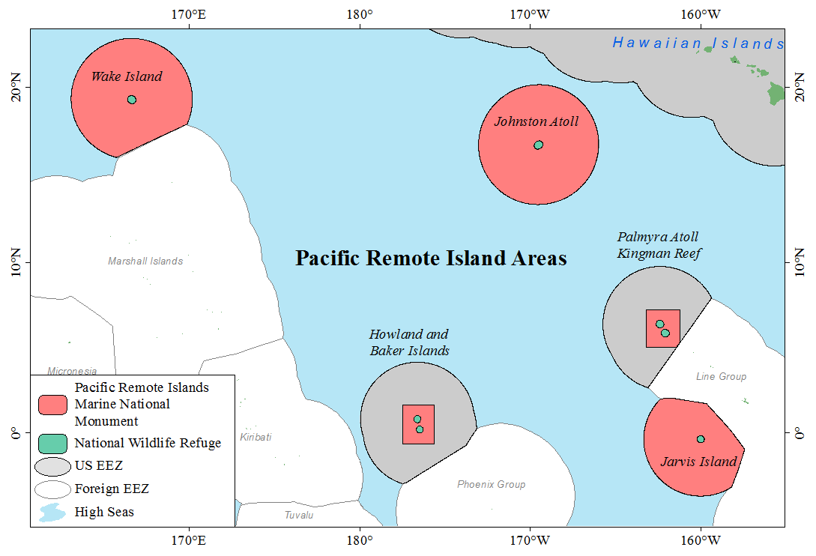

Figure 32. Pacific Remote Island Areas and the associated Pacific Remote Islands Marine National Monument

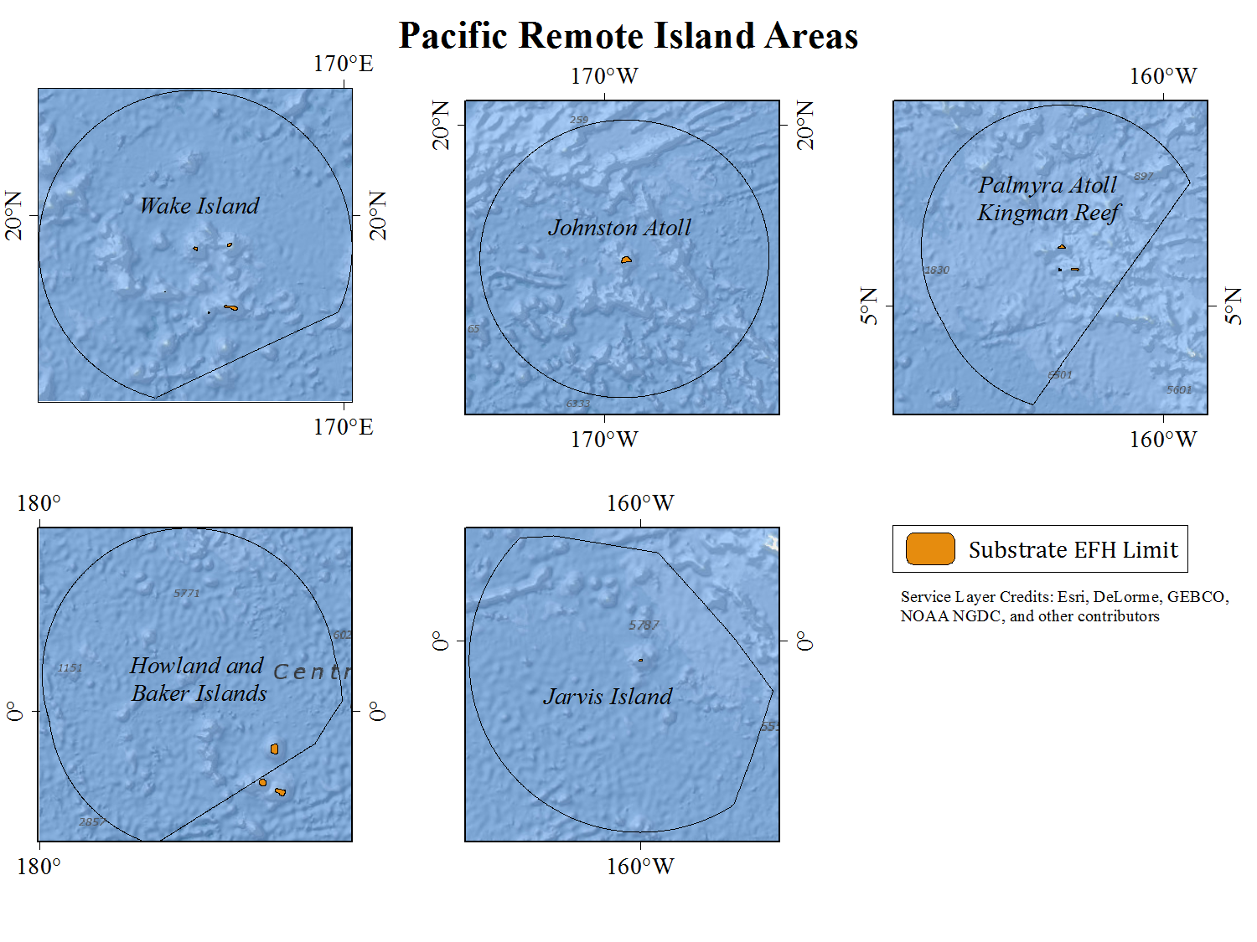

Figure 33. The Substrate EFH Limit and 700-meter isobath around the PRIAs (from Ryan et al. 2009)

#### Habitat Mapping

Mapping products for the PRIA are available from the Pacific Islands Benthic Habitat Mapping Center and are listed in Table 5.

Table 5. Summary of habitat mapping in the PRIA

|  |  |  |  |
| --- | --- | --- | --- |
| **Depth Range** | **Timeline/Mapping Product** | **Progress** | **Source** |
| 0-30 m | IKONOS Benthic Habitat Maps | Palmyra only | Miller et al. (2011) |
|  | 2000-2010 Bathymetry | 67% | DesRochers (2016) |
|  | 2011-2015 Multibeam Bathymetry |  | DesRochers (2016) |
|  | 2011-2015 Satellite Worldview 2 Bathymetry | Wake, Baker, and Howland Islands, Johnston and Palmyra Atolls, and Kingman Reef | Pers. Comm. DesRochers, March 19, 2018 |
| 30-150 m | 2000-2010 Bathymetry | 79% | DesRochers (2016) |
|  | 2011-2015 Multibeam Bathymetry | Howland and Baker updated with data collected in a few small areas in 2015 | Pers. Comm., DesRochers, March 19, 2018 |
| 15 to 2500 m | Multibeam bathymetry | Complete at Jarvis, Howland, and Baker Islands | [Pacific Islands Benthic Habitat Mapping Center](http://www.soest.hawaii.edu/pibhmc/pibhmc_pria.htm) |
|  | Derived Products | Backscatter available for all  Geomorphology products for Johnston, Howland, Baker, Wake | [Pacific Islands Benthic Habitat Mapping Center](http://www.soest.hawaii.edu/pibhmc/pibhmc_pria.htm) |

The land and seafloor area surrounding the islands and atolls of the PRIA are reproduced from Miller et al. (2011) and shown in Figure 34 alongside other physical data.

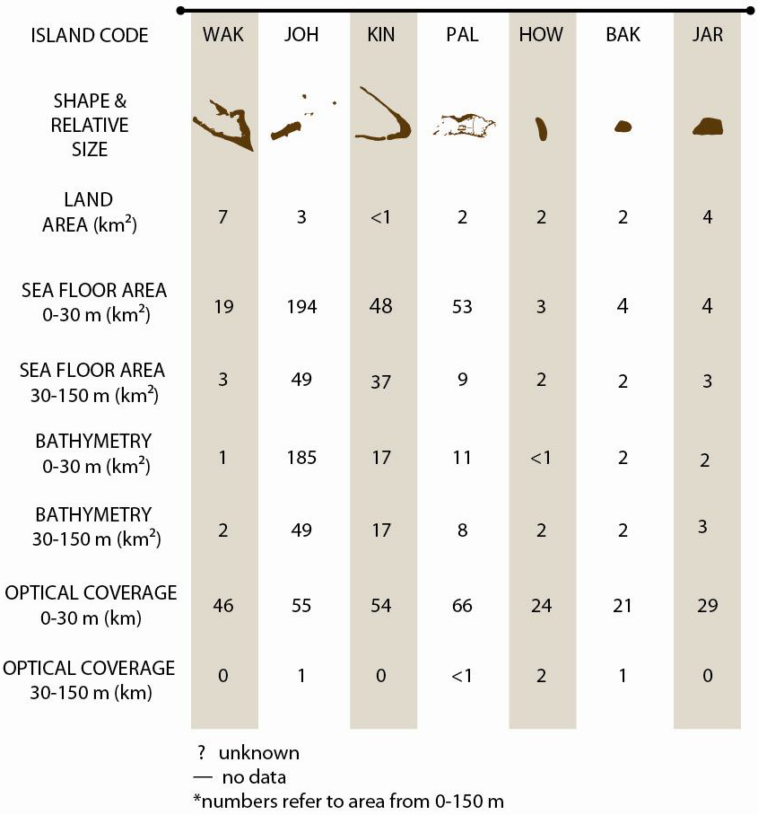

Figure 34. PRIA Land and Seafloor Primary Data Coverage (from Miller et al., 2011)

#### Benthic Habitat

Juvenile and adult life stages of coral reef MUS and crustaceans including spiny and slipper lobsters and Kona crab extends from the shoreline to the 100 m isobath (64 FR 19067, 19 April 1999). All benthic habitat is considered EFH for crustacean species (64 FR 19067, 19 April 1999), while the type of bottom habitat varies by family for coral reef species (69 FR 8336, 24 February 2004). Juvenile and adult bottomfish EFH extends from the shoreline to the 400 m isobath (64 FR 19067, 19 April 1999), and juvenile and adult deepwater shrimp habitat extends from the 300 m isobath to the 700 m isobath (73 FR 70603, 21 November 2008). Table 6 shows the depths of geologic features, the occurrence of MUS EFH at that feature, and the availability of long-term monitoring data at diving depths.

Table 6. Occurrence of EFH by feature in the PRIAs

|  |  |  |  |  |  |
| --- | --- | --- | --- | --- | --- |
| **Feature** | **Summit Minimum Depth** | **Coral Reef/Crustaceans (w/o Deepwater Shrimp)** | **Bottomfish** | **Deepwater Shrimp** | **CRED Long Term Monitoring** |
| Johnston Atoll | Emergent | ✓ | ✓ | ✓ | ✓ |
| Palmyra | Emergent | ✓ | ✓ | ✓ | ✓ |
| Kingman Reef | Emergent | ✓ | ✓ | ✓ | ✓ |
| Extensive banks 80 km SW of Kingman |  | ? | ? | ? |  |
| Jarvis Island | Emergent | ✓ | ✓ | ✓ | ✓ |
| Howland Island | Emergent | ✓ | ✓ | ✓ | ✓ |
| Baker Island | Emergent | ✓ | ✓ | ✓ | ✓ |
| Southeast of Baker | ? | ? | ? | ✓ |  |
| Wake Island | Emergent | ✓ | ✓ | ✓ | ✓ |
| South of Wake | ? | ? | ? | ✓ |  |

##### RAMP Indicators

Benthic percent cover of coral, macroalgae, and crustose coralline algae from PIFSC are found in the following tables. PIFSC has used the benthic towed-diver survey method to monitor changes in benthic composition. In this method, a pair of scuba divers (one collecting fish data, the other collecting benthic data) is towed about one m above the reef roughly 60 m behind a small boat at a constant speed of about 1.5 kt. Each diver maneuvers a tow board platform, which is connected to the boat by a bridle and towline and is outfitted with a communications telegraph and various survey equipment, including a downward-facing digital SLR camera. The benthic towed diver records general habitat complexity and type (e.g., spur and groove, pavement), percent cover by functional-group (hard corals, stressed corals, soft corals, macroalgae, crustose coralline algae, sand, and rubble) and for macroinvertebrates (crown-of-thorns sea stars, sea cucumbers, free and boring urchins, and giant clams; PIFSC, 2016).

Towed-diver surveys are typically 50 minutes long and cover about two to three kilometers of habitat. Each survey is divided into five-minute segments, with data recorded separately per segment to allow for later location of observations within the ~200-300 m length of each segment. Throughout each survey, latitude and longitude of the survey track are recorded on the small boat using a GPS; and after the survey, diver tracks are generated with the GPS data and a layback algorithm that accounts for position of the diver relative to the boat” (McCoy et al., 2017). The most recent data collected were in 2016 and described by McCoy et al. (2017), however the method was retired in 2016 and no new data will be appended to the time series.

**Table 7. Mean percent cover of live coral from RAMP sites collected from towed-diver surveys in the PRIA**

|  |  |  |  |  |  |  |  |  |  |  |  |  |  |  |
| --- | --- | --- | --- | --- | --- | --- | --- | --- | --- | --- | --- | --- | --- | --- |
| **Year** | **2001** | **2002** | **2004** | **2005** | **2006** | **2007** | **2008** | **2009** | **2010** | **2011** | **2012** | **2014** | **2015** | **2016** |
| Baker | 35.37 | 49.47 | 38.78 |  | 32.95 |  | 41.20 |  | 47.44 |  | 42.10 |  | 34.48 |  |
| Howland | 29.06 | 42.53 | 36.75 |  | 34.69 |  | 44.47 |  | 50.74 |  | 43.26 |  | 23.20 |  |
| Jarvis | 24.22 | 26.19 | 30.63 |  | 28.54 |  | 27.70 |  | 26.92 |  | 25.38 |  | 39.75 |  |
| Johnston |  |  | 5.01 |  | 22.95 |  | 18.38 |  | 7.94 |  | 10.89 |  | 7.46 |  |
| Kingman | 39.77 | 49.51 | 38.35 |  | 24.59 |  | 33.13 |  | 35.56 |  | 37.11 |  | 41.92 |  |
| Palmyra | 24.95 | 31.99 | 35.07 |  | 22.66 |  | 25.02 |  | 35.35 |  | 31.11 |  | 42.77 |  |
| Wake |  |  |  | 31.98 |  | 19.29 |  | 22.56 |  | 31.40 |  | 32.34 |  |  |

Table 8. Mean percent cover of macroalgae from RAMP sites collected from towed-diver surveys in the PRIA

|  |  |  |  |  |  |  |  |  |  |  |  |  |  |  |
| --- | --- | --- | --- | --- | --- | --- | --- | --- | --- | --- | --- | --- | --- | --- |
| **Year** | **2001** | **2002** | **2004** | **2005** | **2006** | **2007** | **2008** | **2009** | **2010** | **2011** | **2012** | **2014** | **2015** | **2016** |
| Baker | 12.33 | 2.11 | 12.63 |  | 9.29 |  | 8.09 |  | 1.60 |  | 8.05 |  | 2.15 |  |
| Howland | 2.58 | 5.34 | 13.01 |  | 3.57 |  | 6.14 |  | 0.64 |  | 6.07 |  | 1.08 |  |
| Jarvis | 28.75 | 10.88 | 25.03 |  | 38.14 |  | 24.01 |  | 7.35 |  | 7.58 |  | 3.94 |  |
| Johnston |  |  | 25.06 |  | 6.90 |  | 8.82 |  | 1.57 |  | 8.49 |  | 2.49 |  |
| Kingman | 4.36 | 5.36 | 27.04 |  | 7.81 |  | 7.31 |  | 3.97 |  | 5.05 |  | 2.04 |  |
| Palmyra | 13.28 | 10.45 | 23.14 |  | 15.17 |  | 11.98 |  | 4.76 |  | 8.94 |  | 4.35 |  |
| Wake |  |  |  | 22.88 |  | 18.74 |  | 12.00 |  | 8.30 |  | 6.80 |  |  |

Table 9. Mean percent cover of crustose coralline algae from RAMP sites collected from towed-diver surveys in the PRIA

|  |  |  |  |  |  |  |  |  |  |  |  |  |  |  |
| --- | --- | --- | --- | --- | --- | --- | --- | --- | --- | --- | --- | --- | --- | --- |
| **Year** | **2001** | **2002** | **2004** | **2005** | **2006** | **2007** | **2008** | **2009** | **2010** | **2011** | **2012** | **2014** | **2015** | **2016** |
| Baker | 31.66 | 37.57 | 39.61 |  | 33.43 |  | 23.09 |  | 23.40 |  | 24.03 |  | 32.80 |  |
| Howland | 36.60 | 27.40 | 34.26 |  | 22.60 |  | 22.59 |  | 15.73 |  | 18.12 |  | 21.25 |  |
| Jarvis | 29.11 | 29.56 | 34.76 |  | 24.23 |  | 11.82 |  | 30.29 |  | 24.20 |  | 27.48 |  |
| Johnston |  |  | 30.54 |  | 19.50 |  | 16.07 |  | 17.13 |  | 17.49 |  | 17.45 |  |
| Kingman | 33.04 | 16.4 | 17.49 |  | 23.50 |  | 13.45 |  | 9.20 |  | 8.45 |  | 9.64 |  |
| Palmyra | 38.46 | 24.46 | 27.26 |  | 26.30 |  | 18.02 |  | 13.87 |  | 17.09 |  | 10.28 |  |
| Wake |  |  |  | 1.01 |  | 6.43 |  | 3.87 |  | 4.15 |  | 1.13 |  |  |

#### Oceanography and Water Quality

The water column is also designated as EFH for selected MUS life stages at various depths. For larval stages of all species except deepwater shrimp, the water column is EFH from the shoreline to the EEZ. Coral reef species egg and larval EFH is to a depth of 100 m; crustaceans, 150m; and bottomfish, 400 m. Please see the Climate and Oceanic Indicators section (Section 2.4) for information related to oceanography and water quality.

### Report on Review of EFH Information

There were no EFH reviews completed in 2019 for the PRIAs, however a review of the biological components of crustacean EFH in Guam and Hawaii was finalized in 2019. This review can be found in the 2019 Archipelagic SAFE Reports for the Mariana and Hawaii Archipelagos. The non-fishing impacts and cumulative impacts components were reviewed in 2016 through 2017, which can be found in Minton (2017).

### EFH Levels

NMFS guidelines codified at 50 C.F.R. § 600.815 recommend Councils organize data used to describe and identify EFH into the following four levels:

* Level 1: Distribution data are available for some or all portions of the geographic range of the species.
* Level 2: Habitat-related densities of the species are available.
* Level 3: Growth, reproduction, or survival rates within habitats are available.
* Level 4: Production rates by habitat are available.

The Council adopted a fifth level, denoted Level 0, for situations in which there is no information available about the geographic extent of a managed species’ life stage. The existing level of data for individual MUS in each fishery are presented in tables per fishery. In subsequent SAFE reports, each fishery section will include the description of EFH method used to assess the value of the habitat to the species, description of data sources used if there was analysis, and description of method for analysis.

Levels of EFH Information are presented in this section first with databases that include observations of multiple species, separated by depth, and then by current or former MUS grouping.

The Hawaii Undersea Research Laboratory (HURL) is a center operating under the School of Ocean and Earth Sciences and Technology at the University of Hawaii and NOAA’s Office of Ocean Exploration and Research. The unique deep-sea research operation runs the Pisces IV and V manned submersibles and remotely operated vehicles for investigating the undersea environment through hypothesis driven projects that address gaps in knowledge or scientific needs. HURL maintains a comprehensive video database, which includes biological and substrate data extracted from their dive video archives. Submersible and ROV data are collected from depths deeper than 40 m. Observations from the HURL video archives are considered Level 1 EFH information for deeper bottomfish and precious coral species which exist in the database though cannot be considered to observe absence of species. Survey effort is low compared to the range of species observed.

#### Precious Corals

EFH for precious corals was originally designated in Amendment 4 to the Precious Corals Fishery Management Plan (64 FR 19067, 19 April 1999) using the level of data found in Table 10.

Table 10. Level of EFH information available for the Western Pacific precious coral MUS

| **Species** | **Pelagic Phase (Larval Stage)** | **Benthic Phase** | **Source(s)** |
| --- | --- | --- | --- |
| **Pink Coral (*Corallium*)** |  |  |  |
| *Pleurocorallium secundum* (prev. *Corallium secundum*) | 0 | 1 | Figueroa and Baco (2014);  HURL database |
| *C. regale* | 0 | 1 | HURL database |
| *Hemicorallium laauense (*prev. *C*. *laauense)* | 0 | 1 | HURL database |
| **Gold Coral** |  |  |  |
| *Kulamanamana haumeaae* | 0 | 1 | Sinniger et al. (2013);  HURL database |
| *Callogorgia gilberti* | 0 | 1 | HURL database |
| *Narella* spp. | 0 | 1 | HURL database |
| **Bamboo Coral** |  |  |  |
| *Lepidisis olapa* | 0 | 1 | HURL database |
| *Acanella* spp. | 0 | 1 | HURL database |
| **Black Coral** |  |  |  |
| *Antipathes griggi* (prev. *Antipathes dichotoma*) | 0 | 1 | Opresko (2009); HURL database |
| *A. grandis* | 0 | 1 | HURL database |
| *Myriopathes ulex* (prev. *A. ulex*) | 0 | 1 | Opresko (2009); HURL database |

#### Bottomfish and Seamount Groundfish

EFH for bottomfish and seamount groundfish was originally designated in Amendment 6 to the Bottomfish and Seamount Groundfish FMP (64 FR 19067, 19 April 1999) using the level of data found in Table 11.

Table 11. Level of EFH information available for the Western Pacific BMUS and seamount groundfish MUS complex

| **Life History Stage** | **Eggs** | **Larvae** | **Juvenile** | **Adult** |
| --- | --- | --- | --- | --- |
| *Aphareus rutilans* (red snapper/silvermouth) | 0 | 0 | 0 | 1 |
| *Aprion virescens* (gray snapper/jobfish) | 0 | 0 | 1 | 1 |
| *Caranx ignoblis* (giant trevally/jack) | 0 | 0 | 1 | 1 |
| *C. lugubris* (black trevally/jack) | 0 | 0 | 0 | 1 |
| *Epinephelus faciatus* (blacktip grouper) | 0 | 0 | 0 | 1 |
| *E. quernus* (sea bass) | 0 | 0 | 1 | 1 |
| *Etelis carbunculus* (red snapper) | 0 | 0 | 1 | 1 |
| *E. coruscans* (red snapper) | 0 | 0 | 1 | 1 |
| *Lethrinus amboinensis* (ambon emperor) | 0 | 0 | 0 | 1 |
| *L. rubrioperculatus* (redgill emperor) | 0 | 0 | 0 | 1 |
| *Lutjanus kasmira* (blueline snapper) | 0 | 0 | 1 | 1 |
| *Pristipomoides auricilla* (yellowtail snapper) | 0 | 0 | 0 | 1 |
| *P. filamentosus* (pink snapper) | 0 | 0 | 1 | 1 |
| *P. flavipinnis* (yelloweye snapper) | 0 | 0 | 0 | 1 |
| *P. seiboldi* (pink snapper) | 0 | 0 | 1 | 1 |
| *P. zonatus* (snapper) | 0 | 0 | 0 | 1 |
| *Pseudocaranx dentex* (thicklip trevally) | 0 | 0 | 1 | 1 |
| *Seriola dumerili* (amberjack) | 0 | 0 | 0 | 1 |
| *Variola louti* (lunartail grouper) | 0 | 0 | 0 | 1 |
| *Beryx splendens* (alfonsin) | 0 | 1 | 2 | 2 |
| *Hyperoglyphe japonica* (ratfish/butterfish) | 0 | 0 | 0 | 1 |
| *Pseudopentaceros richardsoni* (armorhead) | 0 | 1 | 1 | 3 |

#### Crustaceans

EFH for crustaceans MUS was originally designated in Amendment 10 to the Crustaceans FMP (64 FR 19067, 19 April 1999) using the level of data found in Table 12. EFH definitions were also approved for deepwater shrimp through an amendment to the Crustaceans FMP in 2008 (73 FR 70603, 21 November 2008).

Table 12. Level of EFH information available for the Western Pacific CMUS complex

| **Life History Stage** | **Eggs** | **Larvae** | **Juvenile** | **Adult** |
| --- | --- | --- | --- | --- |
| Spiny lobster (*Panulirus marginatus*) | 2 | 1 | 1-2 | 2-3 |
| Spiny lobster (*Panulirus pencillatus*) | 1 | 1 | 1 | 2 |
| Common slipper lobster (*Scyllarides squammosus*) | 2 | 1 | 1 | 2-3 |
| Ridgeback slipper lobster (*Scyllarides haanii*) | 2 | 0 | 1 | 2-3 |
| Chinese slipper lobster (*Parribacus antarcticus*) | 2 | 0 | 1 | 2-3 |
| Kona crab (*Ranina ranina*) | 1 | 0 | 1 | 1-2 |

### Research and Information Needs

The Council has identified the followingscientific data needs to more effectively address the EFH provisions:

#### All FMP Fisheries

* Distribution of early life history stages (eggs and larvae) of management unit species by habitat.
* Juvenile habitat (including physical, chemical, and biological features that determine suitable juvenile habitat);
* Food habits (feeding depth, major prey species etc.).
* Habitat-related densities for all MUS life history stages.
* Growth, reproduction, and survival rates for MUS within habitats.

#### Bottomfish Fishery

* Inventory of marine habitats in the EEZ of the Western Pacific region.
* Data to obtain a better SPR estimate for American Samoa’s bottomfish complex.
* Baseline (virgin stock) parameters (CPUE, percent immature) for the Guam/CNMI deep-water and shallow water bottomfish complexes.
* High resolution maps of bottom topography/currents/water masses/primary productivity.
* Habitat utilization patterns for different life history stages and species.

#### Crustaceans Fishery

* Identification of post-larval settlement habitat of all CMUS.
* Identification of “source/sink” relationships in the NWHI and other regions (i.e. relationships between spawning sites settlement using circulation models, genetic techniques, etc.).
* Establish baseline parameters (e.g., CPUE) for the Guam and Northern Marinas crustacean populations.
* Research to determine habitat-related densities for all CMUS life history stages in American Samoa, Guam, Hawaii, and CNMI.
* High resolution mapping of bottom topography, bathymetry, currents, substrate types, algal beds, habitat relief.

#### Precious Corals Fishery

* Distribution, abundance, and status of precious corals in the PRIAs.

1. Midway is not administered civilly by the State of Hawaii.