**Date:** February 3, 2020

**Project:** Assessing and Tracking Coral Reef Habitat Condition  
**Contract #:** 19-Coral-05  
  
**Update:** Deliverable #5 due February 3, 2020. Draft Habitat Module

**Personnel:**  Darla White and Christopher Hawkins

**Submitted to:** Joshua DeMello, WPFMC  
 Joshua.DeMello@wpcouncil.org

**Submitted by:** Lynker, LLC

**Coral Reef Ecosystem Project:**

**Assessing and Tracking Coral Reef Habitat Condition**

**Progress Report #5: Draft Habitat Module**

**for the**

**Stock Assessment and Fisheries Evaluation (SAFE) Annual Report**

**Western Pacific Regional Fisheries Management Council (WPRFMC)**

By Darla White and Chris Hawkins

Lynker Technologies

**HABITAT SECTION OUTLINE - original proposal**

SAFE Reports are organized by region, and as such each region (Hawaii, AS, CNMI, Guam).

Region

Introduction – Essential Fish Habitat

Background – Literature and Discussion

Available Data – Current Monitoring Programs and Research

Habitat Indicators, Definitions and Rationale

* Fish
* Benthic
* Anthropogenic
* Climate and Oceanographic

Discussion – Implications and Outlook

Management Needs

Implementation / Adaptive Management Course

Summary

**Template: Hawaii as a model - for your consideration and comments**

The goal of this section is to be able to update the habitat indicators annually, or more realistically, as data becomes available, to assess the cumulative impact of stressors to EFH. Past and current benthic habitat data from NOAA has been benthic cover at an island scale, which relates to fish at an island scale. The indicators and data streams in this draft are site/isobath/habitat specific, and as such should be considered and analyzed in the context of the scale that it was collected to portray.

Due to the patchy nature of benthic habitats and environmental and social indicators, as well as scale considerations, a method of classification or analysis grain appears necessary for this exercise. All of the data have location information, and any changes to the habitat will be local or sub-regional. Most of the in-situ data collected will be site specific, and other environmental information, especially buoy or other remotely sensed data, will mostly be reginal or sub-regional. Wave energy is a significant contributor to habitat morphology, and in Hawaii it is an accessibility factor, so this is recommended as a consideration when choosing a classification scheme. For example, quadrants could be chosen - windward, leeward, - subdivided into north and south by natural landmass formations, as a coarse but simple grain to elucidate areas of further investigation.

It is my recommendation that this section be based in a geospatial map format and database. All of the in situ data have location information which can be layered with the other indicators. The benthic habitat maps and topography of the substrate relate directly to the habitat complexity which is a good indicator of fish biomass (Wedding et al, 2008; 2019). When fish surveys are overlaid the habitat and the distance from population is considered, in addition to the environmental indicators, more holistic information about EFH condition and stressors can be gleaned. A geodatabase can be updated as data become available for each region. Analyses can be programmed in R for ease of computation in a geospatial platform such as ESRI's ArcMap Desktop which will only be around for a few more years, or ArcPro & ArcGIS online. ArcPro is the best choice for longevity at this point.

Recent work in Hawai‘i compiled in situ monitoring data from a consortium of organizations and through a suite of multivariate analyses found multiple major reef habitats or regimes (Jouffray et al, 2015, 2019; Donovan et al, 2018). For Hawai‘i, it seems appropriate to use this most recent information as a basis of classification, and the maps already exist (Figure 1). The regimes, however, do change over time. This is the type of change that you would want to compare with the various environmental and social indicator data, and disturbances. Conversely, you may decide not to use the regimes as they are not available from the other archipelagic regions. Regardless, HIMARC is the primary datastream in Hawaii, so the fish and benthic data are found in one database.

HIMARC is currently managed by Mary Donovan, Chelsie Counsell, and Megan Donahue. They will make the data available upon request, and create scientific analyses and products based on the data. Inquires can be made to [himarc.db@gmail.com](mailto:himarc.db@gmail.com). The full dataset currently includes more than 11,000 survey locations across the Hawaiian archipelago, and has data up to 2016. There is a time lag for acquiring the data from agencies and organizations based on their time frames. They expect to have the 2017 and 2018 datasets completed this fall (Counsell, personal communication). This database is the largest, most comprehensive, and most accessible marine dataset in the state of Hawai‘i. HIMARC is housed and operated through a partnership between the Hawaii Institute of Marine Biology and the Hawaii Division of Aquatic Resources.

Funding is pursued on an annual basis through multiple avenues, which is subject to change over time (Donovan, personal communication). They do, however, require funding for analyses and summary products at this time.

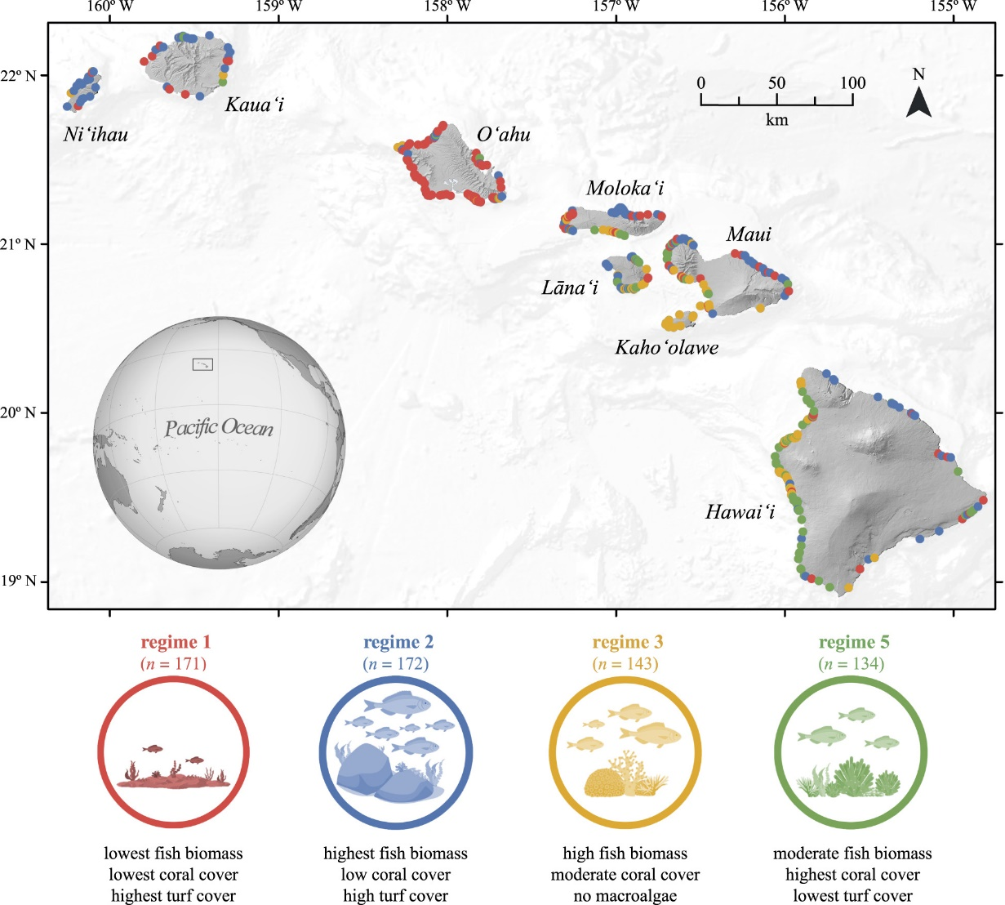

Figure 1. Hawaii's habitat regimes from Jouffray et al. (2019)

EPA/DOH data will be available in summary reports every two years. Other data, especially remotely sensed data, are available for download but will also require summarization and visualization. The most efficient way to analyze and summarize these data are in a geodatabase. That is a decision that I will leave to you to make based on the Council's capacity to host it.

In the interim, I present a draft template in summary form here. I understand that there will be a lot of comments and suggestions and that this will be the most challenging part of the project, so I have presented one region, Hawaii, as the model with which to base the other regions on.

Let us work closely together on this last part of the project. I have blackout dates from Feb 13th - 17th as I have another project that I will be working on exclusively for those dates, and from Feb 2

I am also currently drafting the policy for updating the habitat indicators, including timelines for agency contacts and data requests or data processing. Based on my communications with contacts thus far, at least some of the long term monitoring data will not be summarized but will be available annually (raw data), so discussing capacity for analyses is pertinent at this point.

**Region - Hawaii**

**Introduction – Essential Fish Habitat**

The Magnuson-Stevens Fishery Conservation and Management Act (MSA) recognizes the importance of and continued loss of fish habitat which impacts fish populations and fisheries. The Act requires the protection, conservation, and enhancement of "essential fish habitat" (EFH), defined as "those waters and substrate necessary to fish for spawning, breeding, feeding, or growth to maturity." In the Pacific Archipelagic regions, EFH for eggs, larvae, juveniles, and adults of many management unit species extend from the shoreline to depths of 100 - 200 m out to the EEZ boundary.

Adverse impacts or effects to EFH can vary widely and include (from NOAA Fisheries):

1. Direct impacts (e.g. changes in water quality, physical disturbance, etc.)
2. Indirect impacts (e.g. reduction in species fecundity, loss of prey, etc.)
3. Site-specific/habitat wide impacts, including individual, cumulative, or synergistic consequences of actions.

Fisheries habitat is federally managed through two mechanisms:

1. The Council’s mandate to minimize adverse impact on Essential Fish Habitat (EFH) from FEP-authorized fishing activities to the extent practicable through fisheries management measures; and
2. The EFH consultation mechanism.

Non-fishing adverse effects on EFH are a primary concern in the Western Pacific Region. To date, the only data stream on benthic habitat comes from the NOAA Pacific Islands Fisheries Science Center (PIFSC), Ecosystems Division’s (ESD; formerly CRED) Reef Assessment and Monitoring Program (RAMP) which surveys the US Pacific jurisdictions every three years (next in 2022) at an island scale using a random stratified sampling design, and provides quantitative benthic cover metrics as the indicator measure. *This information alone is insufficient to determine whether coral reef habitat condition is affecting fisheries productivity or signal if non-fishing activities may be adversely affecting the habitat.*

Various government and private organizations monitor coral reef resources throughout the region to meet diverse management objectives. These vary from the PIFSC CREP monitoring, designed to identify large scale trends in coral reefs of the region under the Coral Reef Conservation Act; to EPA monitoring and permit programs under the Clean Water Act, designed to detect public health and safety or water quality concerns; to local agency monitoring of their marine protected areas to determine if the MPA is meeting its site-specific management objectives. In addition, federal agencies are charged with assessing the cumulative impact of their actions on the environment and EFH in EFH assessments supporting consultations, and conversely, the Council must assess cumulative impact of stressors on EFH.

**Background – Literature and Discussion**

Benthic habitat data collected by the NOAA ESD/CRED RAMP expeditions has been employed in previous SAFE reports, so it is acknowledged here that their data will continue to be incorporated in future assessments. The next round of surveys is scheduled for 2022, and are scheduled every three years.

Assessing the cumulative impact of stressors to EFH will require indicator data from fish and benthic surveys, watershed, social, oceanographic, and climate indicators. These will need to be obtained from a suite of agencies, including federal (e.g. Environmental Protection Agency - EPA, NOAA, National Park Service - NPS, etc.), state (e.g. Division of Aquatic Resources - DAR, Department of Health - DOH, etc.), researchers, NGOs (The Nature Conservancy - TNC, etc.), cooperative databases (e.g. Hawai‘i Monitoring and Reporting Collaborative - HIMARC), global remotely sensed datasets, and potentially citizen science efforts (e.g. Hui O Ka Wai Ola). The agencies and groups involved will vary by archipelagic region, based on their involvement in ocean and watershed data collection and management. For example, in Hawai‘i, the EPA is involved in projects in some locations but the Hawai‘i Department of Health, Clean Water Branch, is the agency that collects *in situ* water quality data around the state.

The most reliable habitat indicator data to include in the habitat section of annual SAFE reports would be from regional long-term monitoring efforts due to the value of long term trend analysis, in addition to the island scale data from NOAA, with possible inclusion of relevant recent research efforts, and remotely sensed data that is available for all of the jurisdictions. The availability and types of *in situ* data from programs in different agencies/groups is variable. There will most likely be a time lag on the availability of these data streams, given data product processing time schedules and in some cases, data are withheld for a time frame (e.g. two years) for intellectual property.

Each archipelagic region has worked collaboratively with multiple partners through working groups and synthesis reports to collate ecological indicators and latent variables relevant to detect habitat trends (Burdick et al., 2011; Houk et al., 2015; Williams et al., 2015; Brown et al., 2016, Costa and Kendall, 2016, Donovan et al., 2018, Wedding et al., 2018, Gove et al., 2019, Jouffray 2019). Environmental variables are the predictors of biological variables so the need is to understand that relationship through the lens of long-term trends that elucidate change over time and recovery from disturbance, especially in proximity to human populations (Houk, personal communication; Houk et al, 2015, Williams et al, 2015b). Disturbance events that impact the composition of reef communities includes ocean warming events that lead to bleaching and disease outbreaks, storm events that increase sediment and pollution discharge, and *Acanthaster* *planci* outbreak events. Disturbance events are on the rise in both intensity and frequency due to global climate change, and this impact is magnified synergistically in concert with local stressors (Pandolfi et al, 2003; Houk et al, 2015; Smith et al, 2016). The ongoing data streams will dictate the suite of indicators available for use in the annual SAFE reports.

There has been substantive efforts to understand the drivers of fish biomass, community composition, capacities of different habitats to sustain fish stocks, and predictive efforts to understand what a natural standing stock would be for an area (Friedlander et al, 2003; Wedding et al, 2008; MacNeil et al, 2009; Gove et al, 2013; Williams et al, 2015; Gorospe et al, 2018; Donovan et al, 2018; Wedding et al, 2019). Environmental forcings and variability determine reef ecosystem structure and function, including coral reef extent, growth rates, and assemblages of reef organisms (Gove et al, 2013). Habitat complexity was found to be an important driver and even a predictor of fish biomass in marine protected areas (Friedlander et al, 2003; Wedding et al, 2008, 2019), because a more complex habitat provides more services and protection for fishes. Measures of complexity are collected in situ using a chain draped over the substrate to give a ratio value of distance to vertical height, or remotely using available LiDAR data. Additionally, slope of slope which can be derived from bathymetry contours in ArcMap has been shown to be a good indicator of habitat complexity (Wedding et al, 2019). Other environmental and social indicators such as wave energy, productivity, irradiance, pollution, and human population proximity also strongly influence the variability and distribution of fish biomass and functional groups. However, population and distance to humans has been shown to be the primary driver to influence fish biomass, especially piscivores across the US Pacific populated islands (Williams et al., 2015).

Habitat classification, the defining of a habitat type by the assemblages and/or habitat complexity, is a common practice in marine surveys. NOAA has a standardized habitat classification scheme for the Reef Assessment and Monitoring Program (RAMP) sites across the Pacific, which include the type of reef structure that they are found in (i.e. forereef, backreef, lagoon, etc.). This varies by groups, however, and over regions, but with some similarities. Recent work in Hawai‘i compiled in situ monitoring data from a consortium of organizations and determined through a suite of analyses found multiple major reef habitats or regimes (Jouffray et al, 2015, 2019; Donovan et al, 2018).

Functional groups play important roles on the reef. Functional diversity and functional redundancies are key resilience indicators and should be considered when assessing habitat trends. Major benthic functional groups include coral, macroalgae, turf algae, and crustose coralline algae (CCA). Fish assemblages are frequently broken into trophic groups, including herbivores (primary), omnivores (secondary), and predators. Herbivores are broken down further into grazers, scrapers/excavators, and browsers (Edwards, et al, 2014). Reef building organisms such as hermatypic corals and CCA are the best indicators for potential calcification and subsequent growth potential of a reef (Smith et al, 2016). Additionally, many species of CCA are suitable substrate preferred by coral recruits (Harrington et al, 2004; Price 2010). Reef accretion is an increasingly important factor in the longevity of coral reef habitats in the face of warming ocean temperatures that drive coral bleaching and subsequent increases in disease and mortality, and increasing ocean acidification. Additionally, herbivores play a disproportionately large functional role as mediators of algal growth on the reef. Large bodied herbivores such as parrotfish and grazing schools of surgeonfish play a critical role in facilitating coral recovery after disturbance by regulating algal/coral competition, and regulate community structure and function (Williams et al, 2015a). For example, large-bodied parrotfish in Hawai‘i show a strong linear relationship between area scraped (m/yr) and total length (Sparks et al, 2016). Smaller parrotfish become fish food in general, so the larger individuals are both important for creating suitable substrate for new life and are also the reproductive stock with exponentially higher fecundity than their smaller counterparts (Hixon et al, 2014).

A suite of environmental drivers that influence fish habitat are measurable using remotely sensed data, which has been compiled using long term averages in a number of recent studies across the Pacific jurisdictions (Tyberghein et al, 2012; Gove et al., 2013; Williams et al., 2015; Weijerman et al., 2015; Assis et al., 2017; Wedding et al., 2018). These include sea surface temperature (SST), chlorophyll-a (Chl-a), irradiance, pH, and wave energy, among others. This presents an easily accessible foundation of data from which to add new measurements each year for inclusion in the report. Gove et al (2013) did a comprehensive effort across the Pacific US jurisdictions which provides a strong baseline and methodology to follow. Existing data sources for global datasets include Bio-ORACLE, which includes both present day surface and benthic layers, as well as future predictive layers for 2040-2050 and 2090-2100 (Tyberghein et al, 2012; Assis et al, 2017).

Climate change impacts such as warm water anomalies, sea level rise, high intensity storm events, and ocean acidification must be considered in all habitat assessment efforts moving forward. Resilience indicators are the culmination of more than two decades of efforts based on the best available science to manage reefs in the face of global stressors, and also serve as indicators for local stressors at the same time. Coral bleaching events and disease outbreaks are expected to increase in frequency and prevalence, thereby making them important indicators of habitat longevity and complexity in a changing climate. Ocean acidification will shape habitats, species distributions, and even species recruitment and survival success in coming decades. Resilience indicators and surveys have been employed in Saipan, Tinian, and in Hawai‘i on the islands on Maui and Hawai‘i to date (McClanahan et al, 2012; Maynard et al, 2015, 2016, 2017) . Both in situ and remotely sensed measures can be incorporated into annual SAFE reports.

**Available Data – Current Monitoring Programs and Research**

Hawai‘i has been the focus of both statewide and regional (i.e. West Hawai‘i) collaborative efforts to bring all of the existing data sets together and through working groups and synthesis, have agreed upon indicators of both fish and benthic data, as well as oceanographic, anthropogenic, and other ecological indicators that influence fish habitats (Donovan et al., 2018; Wedding et al., 2018; Jouffray et al., 2015, 2019; Gove et al., 2019).

The [Ocean Tipping Points](http://oceantippingpoints.org/) (OTP) project produced a Hawai‘i case study that both brought together all of the existing monitoring data sets into one database known as the Hawai‘i Monitoring and Reporting Collaborative (HIMARC), and overlaid indicators in a marine spatial planning platform that are available to anyone from the [OTP Data Portal](https://www.pacioos.hawaii.edu/projects/oceantippingpoints/#data). The indicators used in the spatial assessment are included in Appendix A, a subset of which are recommended here (Table 1) for their relevance and ease of acquisition.

The Hawai‘i Monitoring and Reporting Collaborative, HIMARC, is the repository for all of the existing fish and benthic monitoring data in Hawai‘i. HIMARC synthesizes in situ survey data from various organizations in Hawai‘i, including:

* Hawai‘i DLNR Division of Aquatic Resources (DAR)
* NOAA – Ecosystems Division (formerly CRED)
* NOAA - Fish Habitat Utilization Surveys
* UH - Fisheries Ecology Research Laboratory
* Coral Reef Assessment and Monitoring Program (CRAMP)
* The Nature Conservancy (TNC)
* The National Park Service (NPS)

These groups reviewed a suite of 28 potential indicators and decided on nine (Table 1). *Content from the West Hawai‘i Integrated Ecosystem Assessment Status Report was copied by permission from Jamison Gove. Additional content was provided by the report authors.*

Six indicators based on fish data:

Total fish abundance

Defined as the total number of reef fish standardized by the unit area of reef, fish density is a major factor determining the functional role and influence of reef fishes in a coral reef ecosystem. Spatial and temporal variability in fish density is a product of numerous factors. For instance, fish abundance varies by habitat quality (Feary et al. 2007), environmental variability and its influence on population demography (i.e., recruitment and natural mortality) (Sale 2004), and fishing pressure (Friedlander & DeMartini 2002, Guillemot et al. 2014).

Total fish biomass

Total fish biomass conveys related but slightly different information compared to total fish abundance. Specifically, two reefs might have the same abundance but very different biomass estimates based on the size distribution of fishes in the assemblage. It is useful to consider biomass in addition to abundance because the ecological function or importance of fishes on a reef is often related to the size of fishes (see herbivore biomass description below). Biomass is derived from length measures in visual surveys using an allometric length-weight conversion formula described in Donovan et al. (2018).

Fish diversity

Coral reefs are renowned for being one of the most diverse and complex ecosystems on the planet, providing important ecosystem services. In addition to the aesthetic value, biodiversity is intrinsically linked to ecosystem function, and greater species diversity supports more productive fisheries (Moberg & Folke 1999, McClanahan et al. 2011).

Resource fish biomass

Resource fish biomass is a measure of targeted food fish present, where other fish species are ignored. In addition, the status of the fishery is more directly related to fish population biomass rather than solely on the number of fish (Guillemot et al. 2014).

Herbivore biomass

Herbivores (i.e., species for which plant material makes up a majority of their diet) comprise a large part of the fish community assemblage in Hawai‘i (Williams et al. 2015b). Herbivorous fishes are a key component and indicator of resilience. Resilience is defined as the ability of a reef to maintain or recover to a coral dominated state following disturbance and avoiding a phase-shift into algal dominance (Green & Bellwood 2009). Multiple anthropogenic drivers operating at various scales can undermine coral reef resilience, such as over-extraction of herbivores, pollution, and climate change. Of these, the diminished abundance of functionally important herbivores is one of the few drivers that is possible to ameliorate through local action.

Mean fish size

The mean length of adult fishes provides an indication of the size structure of the entire adult reef fish community. As fishing pressure increases, the average length of targeted species decreases (Ault et al. 2014, Guillemot et al. 2014; Nadon et al. 2015; Ingram et al. 2018). This relationship exists because fishers tend to target large fishes, and because fishing mortality reduces the number of fishes that reach older and larger life stages. Previous work has found that reductions in mean length of the whole assemblage are indicative of a shift towards smaller species and/or smaller individuals of the same species, and that this can be driven by moderate levels of fishing pressure (Guillemot et al. 2014).

Three indicators based on benthic data:

Percent coral cover

The total cover of hard coral (Scleractinian) in a given area generally corresponds with the amount of reef topographic complexity, habitat structure, reef accretion, and diversity and abundance of coral dependent species (McClanahan et al. 2011). Many reef-fish species are also heavily reliant on the availability of coral-dominated, structurally-complex areas, serving as the preferred habitat for fish recruitment and fish in juvenile stages (Walsh 1984).

Percent resistant coral cover

Coral species are variable in their life history traits including (but not limited to) growth form, reproductive mode, colony size, depth range, fecundity, growth rate, etc. These traits can provide some general rules and predictabilities with regard to their role in the ecological framework. Corals can be classified using a trait-based approach into competitive, stress tolerant, generalist, or weedy species (Darling et al. 2012). Donovan et al (2018) used this methodology to identify stress tolerant coral species and went a step further to incorporate additional information on bleaching tolerance to each species in Hawai‘i.

Ratio of calcifying to non-calcifying: (coral cover + cca cover)/(turf cover + macroalgal cover), ideally, *Halimeda* is not included in macroalgal cover.

Foundational benthic organisms that contribute to coral reef development and persistence are calcifying, serving a number of key ecological processes, including settlement, recruitment, and cementation of reef structure (Williams et al. 2015a). Fleshy algae directly compete with calcifying organisms for space, and in high abundance, can indicate a degraded ecological state (Hughes et al. 2010). The ratio of the combined cover of reef-building hard corals (Scleractinian) and calcifying algae (crustose coralline algae and *Halimeda*) to the combined cover of fleshy algae indicates benthic community dynamics and the extent to which a given system is dominated by reef-accreting benthic organisms. The relative dominance of reef builders to maintain net accretion is likely reef specific as oceanographic conditions, community structure, and local human impacts each play a role in overall reef growth. However, it seems logical that coral reef ecosystems with a greater abundance of reef builders will have higher rates of net reef growth and accretion compared to reefs dominated by non-calcifying organisms (Smith et al. 2016).

HIMARC is currently managed by Drs. Mary Donovan, Chelsie Counsell, and Megan Donahue. They will make the data available upon request, and create scientific analyses and products based on the data. Inquires can be made to [himarc.db@gmail.com](mailto:himarc.db@gmail.com). The full dataset currently includes more than 11,000 survey locations across the Hawaiian archipelago, and has data up to 2016. There is a time lag for acquiring the data from agencies and organizations based on their time frames. They expect to have the 2017 and 2018 datasets completed this fall (Counsell, personal communication). This database is the largest, most comprehensive, and most accessible marine dataset in the state of Hawai‘i. HIMARC is housed and operated through a partnership between the Hawaii Institute of Marine Biology and the Hawaii Division of Aquatic Resources. Funding is pursued on an annual basis through multiple avenues, which is subject to change over time (Donovan, personal communication).

Regionally, Gove et al., (2019) synthesized all of the research, modeling, and monitoring efforts in West Hawai‘i (Hawai‘i Island). This synthesis report was released recently, and presented 30 indicators which were chosen as indicators of ecosystem health. A number of the ecological indicators overlap with the indicators decided upon collaboratively for HIMARC. The environmental indicators are listed here. *Content was copied by permission from Jamison Gove, from the West Hawai‘i Integrated Ecosystem Assessment Status Report.*

Ocean and Climate Indicators

SST

Sea surface temperature (SST) plays an important role in a number of ecological processes in West Hawai‘i and varies on diel to decadal time scales. Anomalously warm SST can lead to high levels of thermal stress for corals and other marine organisms. (Ingram et al. 2018, Wedding et al. 2018)

Projections of Future Sea Surface Temperature

Climate change is warming SST across the world’s oceans, driving an increase in storms and thermal stress events that are causing coral damage and mass bleaching events. (van Hooidonk et al. 2016)

Rainfall

Changes in rainfall drive changes in ground water and surface water transport to the marine environment which impacts nearshore salinity, ocean temperature, suspended sediment, and nutrient concentrations. Monthly rainfall and the Standardized Precipitation Index (SPI) are provided to track the status of rainfall in West Hawai‘i. The SPI is a standardized index that characterizes periods of drought or abnormal wetness that correspond with the availability of different water resources (e.g., groundwater and river discharge). (Keyantash 2018, Kevin Kodoma of NWS Honolulu).

Sea Level

Tracking the status and trends in sea level is important for coastal communities and nearshore marine ecosystems. Over long time periods, sea level rise can lead to chronic coastal erosion, coastal flooding, and drainage problems and can exacerbate short-term fluctuations in coastal sea level driven by waves, storms, and extreme tides (Fletcher 2010, Ingram et al. 2018)

Social Indicators

Human population

Human population growth can put pressure on the ecosystem through overuse, habitat degradation, and fishing pressure. (Ingram et al. 2018)

Coastal development

Coastal development paves over natural land, and the resulting impervious surfaces increase the rate of pollution runoff from streets and sidewalks into the nearby ocean. (Ingram et al. 2018, Wedding et al. 2018)

Human wastewater

OSDS (e.g., cesspools and septic tanks) leach excess pollution and nutrients (e.g., nitrogen) into groundwater that flows to the ocean. This runoff from land can result in harmful algal blooms, fish kills, and potential disease threats to humans. We have included the current spatial distribution and historical time series of 3 indicators of OSDS: Total Number, Total Effluent, and Total Nitrogen Flux. (Smith et al. 1999, Anderson et al. 2002, Ingram et al. 2018, Wedding et al. 2018)

Water Quality

Water quality is an important indicator for reef ecosystem health and resilience. Several indicators are available from the remotely sensed datasets below. In situ information on water quality in Hawaii is available from the Hawaii Department of Health [Clean Water Branch website](http://cwb.doh.hawaii.gov/CleanWaterBranch/WaterQualityData/default.aspx), and they publish an [integrated report](http://health.hawaii.gov/cwb/clean-water-branch-home-page/integrated-report-and-total-maximum-daily-loads/) every two years that is also available [online](http://health.hawaii.gov/cwb/clean-water-branch-home-page/integrated-report-and-total-maximum-daily-loads/). There is a lag time in the report as it takes most of a year to complete before it is posted. However, the data is updated on the website frequently. Additionally, on Maui's leeward shore, a community volunteer group called Hui O Ka Wai Ola are working with the DOH to expand their capacity. Their data collection methodology has a quality assurance plan and is recognized by the DOH and EPA. They collect the same information as DOH. Their data is posted quarterly on the [Hui O Ka Wai Ola website](https://www.huiokawaiola.com/).

Data available include:

* Turbidity (total suspended solids)
* Ammonia (N)
* Nitrate/Nitrite (N)
* Total Nitrogen
* Total Phosphorous
* Silica
* Chl-a
* Enterococci
* Clostridium
* Temperature
* Salinity
* Dissolved oxygen
* pH

Remotely Sensed Indicators & Open Sources – Global Datasets

There are currently several remotely sensed indicators and sources relevant to understanding habitat health and stressors that have global datasets and can be used across all regions simultaneously which allows for comparability. In some instances, the pixel may be of a coarser resolution than preferred, however, for indicators and ease of acquisition these datasets are an excellent resource.

[Bio-ORACLE](http://www.bio-oracle.org/downloads-to-email.php) - Marine data layer for ecological modeling - has a downloadable layers page and an integration with R option. The unique aspect of Bio-ORACLE is the predictive layers based on future CO2 scenarios. In addition to present day, future options include (2040 - 2050) and (2090 - 2100). Also, there are options for surface measurements and at dept measures. A screenshot of available surface options:

MARSPEC - Ocean Climate layers for Marine Spatial Ecology - is the only high-resolution global marine dataset to combine benthic and pelagic variables in one dataset. Information on sea floor complexities is combined with SST and salinity and climatological layers for the world ocean.

SESYNC - National Socio-Environmental Synthesis Center - has specifically tried to fill the data gaps and not overlap with Bio-ORACLE or MARSPEC. This dataset has a spatial resolution that is a bit large for small islands, but is useful on larger ones and oceanographic indicators.

Relevant indicators

SST

SST is an indicator of coral health, temperature stress, influences primary production, and species migration patterns. Predictor of thermal tolerant species distributions.

Chl-a

Proxy for phytoplankton biomass (primary productivity) and changes in phytoplankton production; important predictor variable for fish, including piscivores (Williams et al, 2015)

Irradiance

Solar irradiance is the measure of light available for photosynthesis which can influence growth, oxidative stress, and light-induced damage that can exacerbate bleaching.

Wave Power

Driver of community composition and morphology

pH

Saturation state; accretion/dissolution

Nutrients

Indicates watershed management needs; related to population and as such population can serve as a proxy; sublethal effects on coral reef ecosystems; predictor of habitat regime. OSDS (e.g., cesspools and septic tanks) leach excess pollution and nutrients (e.g., nitrogen) into groundwater that flows to the ocean. Coastal development paves over natural land, and the resulting impervious surfaces increase the rate of pollution runoff from streets and sidewalks into the nearby ocean. This runoff from land can result in harmful algal blooms, fish kills, and potential disease threats to humans. (Smith et al. 1999, Anderson et al. 2002, Ingram et al. 2018, Wedding et al, 2018)

**Habitat Indicators, Definitions and Rationale**

Table 1. Hawai‘i Indicators - Reef Fish Community Integrity

*Content from the West Hawai‘i Integrated Ecosystem Assessment Status Report was copied by permission from Jamison Gove. Additional content was supplemented by report authors.*

|  |  |  |  |
| --- | --- | --- | --- |
| **Pressure or Attribute** | **Indicator** | **Rationale** | **Source Availability** |
| Reef Fish Community Integrity | Total Fish Abundance | The total number of reef fish standardized by the unit area of reef. Fish density is a major factor determining the influence reef fishes have in a coral reef ecosystem. Fish abundance varies by habitat quality, environmental variability, and its influence on population demography (i.e., recruitment and natural mortality) and fishing pressure (Friedlander & DeMartini 2002, Sale 2004, Feary et al. 2007, Guillemot et al. 2014). | HIMARC |
| Total Fish Biomass | The total weight of the entire fish assemblage per unit area. Ecological function of fishes is often related to size of fishes, and fish population biomass is reflective of the status of the fishery. (Guillemot et al. 2014). Biomass is derived from length measures in visual surveys using an allometric length-weight conversion formula described in Donovan et al. (2018). | HIMARC |
| Fish Diversity & Richness | Total number of species recorded per survey. Biodiversity is intrinsically linked to ecosystem function and greater species richness supports more productive fisheries. Furthermore, species richness is linked to diversity in responses to environmental change amongst species that perform similar ecosystem functions on a reef, and as such is considered a critical aspect of ecosystem resilience. (Moberg & Folke 1999, McClanahan et al. 2011) | HIMARC |
| Herbivore Biomass; Functional Redundancy | Weight per unit area of herbivorous fish and invertebrates. Can be inclusive of all major herbivore functional groups (scrapers, grazers, excavators, browsers) or can separate these. Herbivores (i.e., species for which plant material makes up a majority of their diet) are a key component of coral reef ecosystem resilience the ability of a reef to maintain or recover to a coral dominated state following disturbance, and avoid a phase-shift into algal dominance compromise. (Green & Bellwood 2009, Kittinger et al. 2015, Williams et al. 2015b; Maynard 2017) | HIMARC |
| Mean Fish Size | The mean length of adult fishes provides an indication of the size structure of the entire adult reef fish community. As fishing pressure increases, the average length of targeted species decreases (Ault et al. 2014, Guillemot et al. 2014, Nadon et al. 2015, Ingram et al. 2018) | HIMARC |

Table 1. (continued) Hawai‘i Indicators - Benthic Reef Community Integrity

*Content from the West Hawai‘i Integrated Ecosystem Assessment Status Report was copied by permission from Jamison Gove. Additional content was supplemented by report authors.*

|  |  |  |  |
| --- | --- | --- | --- |
| **Pressure or Attribute** | **Indicator** | **Rationale** | **Source Availability** |
| Benthic Reef Community Integrity | Percent Coral Cover | The percent cover of hard coral in a given area reflects the amount of reef topographic complexity, habitat structure, reef accretion, and diversity and abundance of coral-dependent species. (Walsh 1984, McClanahan et al. 2011, Williams et al, 2015; Ingram et al. 2018) | HIMARC |
| Percent Resistant Coral Cover | Coral species are variable in their life history traits including (but not limited to) growth form, reproductive mode, colony size, depth range, fecundity, growth rate, etc. These traits can provide some general rules and predictabilities with regard to their role in the ecological framework. Corals can be classified using a trait-based approach into competitive, stress tolerant, generalist, or weedy species (Darling et al. 2012). Donovan et al (2018) used this methodology to identify stress tolerant coral species and went a step further to incorporate additional information on bleaching tolerance to each species in Hawai‘i. (Donovan et al, 2018; Darling et al, 2012) | HIMARC |
| Fleshy Algal Cover | The percent cover of fleshy algae (macroalgae + turf algae) serves as an indicator for benthic community organization and health. Fleshy algae can grow rapidly and potentially inhibit coral recruitment and growth, and reduce coral survival. Tracking the abundance of fleshy algal cover can also indicate other important processes occurring within coral reef ecosystems, including nutrient enrichment and herbivory intensity.(McClanahan et al. 2002, Hughes et al. 2007, McClanahan et al. 2011) | HIMARC |
| Ratio of calcifyers to non calcifiers | The ratio of calcified to non-calcified organisms represents the combined cover of reef building hard corals (Scleractinian) and calcifying algae (crustose coralline algae and Halimeda) to the combined cover of turf and fleshy macroalgae. Tracking the calcified to non-calcified ratio of benthic organisms serves as an important indicator of coral reef community dynamics and the extent to which a given system is dominated by reef accreting versus non-accreting benthic organisms..(coral cover + cca cover)/(turf cover + macroalgal cover), ideally, Halimeda is not included in macroalgal cover. (Cinner et al. 2013; Williams et al. 2013; Donovan et al, 2018; Smith et al, 2016) | HIMARC |

Table 1. (continued) Hawai‘i Indicators - Social

*Content from the West Hawai‘i Integrated Ecosystem Assessment Status Report was copied by permission from Jamison Gove. Additional content was supplemented by report authors.*

|  |  |  |  |
| --- | --- | --- | --- |
| **Pressure or Attribute** | **Indicator** | **Rationale** | **Source Availability** |
| Social | Distance from Population | Proxy for fishing pressure; extraction; changes to fish community composition and sizes; related to nutrients (Williams et al, 2015; Wedding et al, 2018). | [NOAA Digital Coast](https://coast.noaa.gov/digitalcoast/data/)  [2010 Census](https://tigerweb.geo.census.gov/tigerwebmain/TIGERweb_tabblock_census2010.html)  [Census - Counties - Current](https://tigerweb.geo.census.gov/tigerwebmain/TIGERweb_counties_current.html) |
| Water Quality (Nitrogen, Phosphorous; Turbidity) | Indicates watershed management needs; related to population and as such population can serve as a proxy; sublethal effects on coral reef ecosystems; predictor of habitat regime. OSDS (e.g., cesspools and septic tanks) leach excess pollution and nutrients (e.g., nitrogen) into groundwater that flows to the ocean. Coastal development paves over natural land, and the resulting impervious surfaces increase the rate of pollution runoff from streets and sidewalks into the nearby ocean.This runoff from land can result in harmful algal blooms, fish kills,and potential disease threats to humans. (Smith et al. 1999, Anderson et al. 2002, Ingram et al. 2018, WWedding et al, 2018) | [NOAA’s Coastal Change Analysis Program (C-CAP) & Data storehouse](https://coast.noaa.gov/digitalcoast/data/home.html)  [Ocean Tipping Points (OTP)](https://www.pacioos.hawaii.edu/projects/oceantippingpoints/#data)  [Hawaii Dept of Health (DOH)](http://cwb.doh.hawaii.gov/CleanWaterBranch/WaterQualityData/default.aspx)  [Bio-ORACLE](http://www.bio-oracle.org/downloads-to-email.php) |

Table 1. (continued) Hawai‘i Indicators - Ocean and Climate

*Content from the West Hawai‘i Integrated Ecosystem Assessment Status Report was copied by permission from Jamison Gove. Additional content was supplemented by report authors.*

|  |  |  |  |
| --- | --- | --- | --- |
| **Pressure or Attribute** | **Indicator** | **Rationale** | **Source Availability** |
| Ocean and Climate | Sea Surface Temperature (SST) | SST is an indicator of coral health, temperature stress, influences primary production, and species migration patterns. Predictor of thermal tolerant species distributions. | [NOAA Coral Reef Watch (CRW) SST](https://coralreefwatch.noaa.gov/product/5km/index_5km_sst.php)  [NOAA CRW Virtual Stations - Graphs](https://coralreefwatch.noaa.gov/vs/timeseries/polynesia.php#hawaii)  [Bio-ORACLE](http://www.bio-oracle.org/downloads-to-email.php)  [PacIOOS](http://www.pacioos.hawaii.edu/waves/model-hawaii/) |
| Chlorophyll-a  (Chl-a) | Proxy for phytoplankton biomass (primary productivity) and changes in phytoplankton production;important predictor variable for fish, including piscivores (Williams et al, 2015) | [MODIS Aqua Satellite from the NASA Ocean Color](https://oceancolor.gsfc.nasa.gov/data/aqua/)  [NOAA Mapped Ocean Data (Near Real Time)](https://coastwatch.noaa.gov/cw_html/NearRealTimeSearch.html)  [NOAA Coast Watch Data Portal](https://coastwatch.noaa.gov/cw_html/cwViewer.html) |
| Irradiance (Photosynthetically Available/Active Radiation - PAR) | Solar irradiance is the measure of light available for photosynthesis which can influence growth, oxidative stress, and light-induced damage that can exacerbate bleaching. | [MODIS Aqua Satellite from the NASA Ocean Color website](https://oceancolor.gsfc.nasa.gov/data/aqua/).  [Bio-ORACLE](http://www.bio-oracle.org/downloads-to-email.php) |
| Wave Power | Driver of community composition and morphology | [PacIOOS](http://www.pacioos.hawaii.edu/waves/model-hawaii/) |
| pH | Saturation state; accretion/dissolution | [Bio-ORACLE](http://www.bio-oracle.org/downloads-to-email.php)*;  [Ocean Reports](https://www.marinecadastre.gov/oceanreports/@-10737743.881037742,4753280.983019757/6) |

*Bio-ORACLE layers can be accessed at http://www.bio-oracle.org/downloads-to-email.php with time period grain including Present (2000–2014) and future (2040–2050 and 2090–2100) environmental conditions based on monthly averages. Data layers are available for surface and benthic depths.

**Table 2. Indicator sources and schedule of updates and availability**

|  |  |  |
| --- | --- | --- |
| **Indicator** | **Data Source** | **Updates & Availability** |
| **Reef Fish Indicators** | HIMARC himarc.db@gmail.com | Every three years, with a one-year lag. Dependent upon funding. |
| **Benthic Community Indicators** | HIMARC himarc.db@gmail.com | Every three years, with a one-year lag. Dependent upon funding. |
| **Distance from Population** | [NOAA Digital Coast](https://coast.noaa.gov/digitalcoast/data/)  [2010 Census](https://tigerweb.geo.census.gov/tigerwebmain/TIGERweb_tabblock_census2010.html)  [Census - Counties - Current](https://tigerweb.geo.census.gov/tigerwebmain/TIGERweb_counties_current.html) | Census is surveyed every 10 years; however, population data estimates are updated each year in December, and detailed estimates are released by the following summer. https://www.census.gov/programs-surveys/popest/about/schedule.html |
| **Water Quality**  **(N, P; Turbidity)** | [NOAA’s Coastal Change Analysis Program (C-CAP) & Data storehouse](https://coast.noaa.gov/digitalcoast/data/home.html)  [Ocean Tipping Points (OTP)](https://www.pacioos.hawaii.edu/projects/oceantippingpoints/#data)  [Hawaii Dept of Health (DOH)](http://cwb.doh.hawaii.gov/CleanWaterBranch/WaterQualityData/default.aspx)  [Bio-ORACLE](http://www.bio-oracle.org/downloads-to-email.php) | OTP data layers were created in 2017. They are not scheduled to be updated, but the data and methods are available to anyone. They will be a relevant baseline for hotspots. Hawaii DOH data reports released every two years. Bio-ORACLE is a global model that has layers for present and future scenarios, for both surface and benthic layers. Scale is 5 arcmin (9.2 km at equator; Assis et al 2017); The NOAA Coastal Change Analysis Program uses standardized methods across localities at a 30m resolution. The last update was 2016. |
| **Sea Surface Temp**  **(SST)** | [NOAA Coral Reef Watch (CRW) SST](https://coralreefwatch.noaa.gov/product/5km/index_5km_sst.php)  [NOAA CRW Virtual Stations - Graphs](https://coralreefwatch.noaa.gov/vs/timeseries/polynesia.php#hawaii)  [Bio-ORACLE](http://www.bio-oracle.org/downloads-to-email.php)  [PacIOOS](http://www.pacioos.hawaii.edu/waves/model-hawaii/) | The NOAA Coral Reef Watch (CRW) daily global 5km Sea Surface Temperature (SST) product, also known as 'Coral Temp', shows the nighttime ocean temperature measured at the surface. The SST scale ranges from -2 to 35 °C. The product is updated each afternoon at about 13:30 U.S. Eastern Time. Bio-ORACLE is a global model that has layers for present and future scenarios, for both surface and benthic layers. Scale is 5 arcmin (9.2 km at equator; Assis et al 2017); |
| **Chlorophyll-a (Chl-a)** | [MODIS Aqua Satellite from the NASA Ocean Color](https://oceancolor.gsfc.nasa.gov/data/aqua/)  [NOAA Mapped Ocean Data (Near Real Time)](https://coastwatch.noaa.gov/cw_html/NearRealTimeSearch.html)  [NOAA Coast Watch Data Portal](https://coastwatch.noaa.gov/cw_html/cwViewer.html) | MODIS Aqua Satellite updates every 2 days & resolution is 1000m; Bio-ORACLE is a global model that has layers for present and future scenarios, for both surface and benthic layers. Scale is 5 arcmin (9.2 km at equator; Assis et al 2017); NOAA Mapped Ocean Data (VIIRS); Data Portal has many options with updates daily, weekly, and monthly. |
| **Wave Power** | [PacIOOS](http://www.pacioos.hawaii.edu/waves/model-hawaii/) | Wave information is near real time from buoys and forecasts for each region are five day with hourly updates. SST data is also available. |
| **pH** | [Bio-ORACLE](http://www.bio-oracle.org/downloads-to-email.php)*;  [Ocean Reports](https://www.marinecadastre.gov/oceanreports/@-10737743.881037742,4753280.983019757/6) | Ocean Reports includes saturation state (Ω) for each region. pH data can be acquired from the Hawaii DOH. |

*Bio-ORACLE layers can be accessed at http://www.bio-oracle.org/downloads-to-email.php with time period grain including Present (2000–2014) and future (2040–2050 and 2090–2100) environmental conditions based on monthly averages. Data layers are available for surface and benthic depths.

Additionally, NOAA's [National Centers for Environmental Information (NCEI)](https://www.ncei.noaa.gov/access), NOAA's [One Stop](https://data.noaa.gov/onestop/), and NOAA's [Data Discovery Portal](https://data.noaa.gov/datasetsearch/) are updated by agencies as required, including long term monitoring and individual projects that would be relevant to each region.

Ecological indicators - trends over time are key to understanding fish population health and recovery from disturbance, especially in proximity to human populations.

Insert: A map of each island with data locations and environmental indicator layers

Niihau (place holder map)

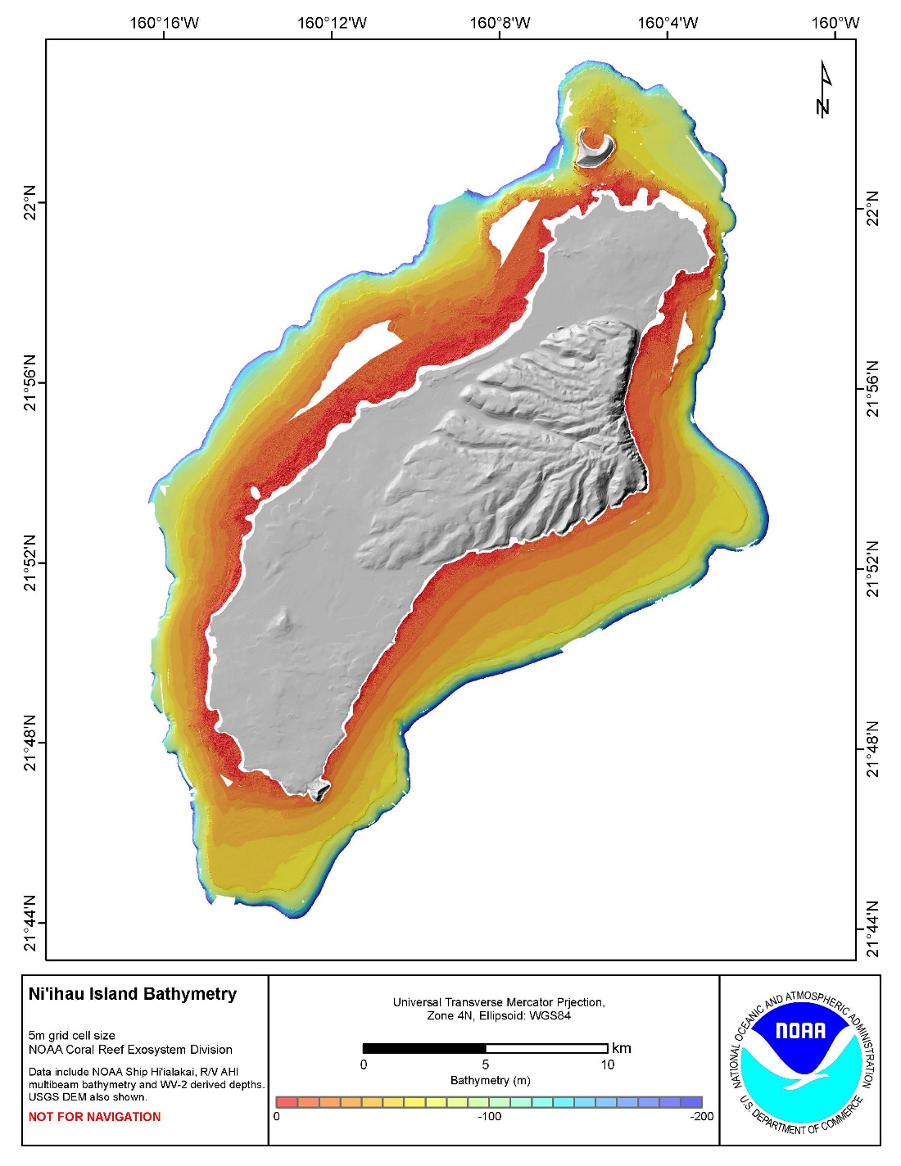

Insert: 2-4 maps of appropriate N-S-E-W coverage with smaller grain size and highlight sites with significant change or areas of interest or disturbance. Identify and highlight population centers, nutrient levels higher than the standards, known impaired water bodies, areas of low irradiance/high turbidity. Separate maps could indicate Chl-a (ocean color), irradiance, and pH.

Insert: graphs of each of the fish and benthic indicators over time by island. Include graphs with the major trophic guilds, and functional groups of herbivores. A lot of these indicator data are available going back several years so existing trends can be incorporated. This is a request that can be made to the HIMARC team since the data has already been transformed to be comparable, or the data is available for your own analysis. For ease of updating, working out an agreement with the HIMARC team is my suggestion.

Fish Data Indicators:

* total fish biomass,
* total fish abundance,
* fish diversity,
* resource fish biomass,
* herbivore biomass,
* mean fish size

Benthic Data Indicators:

* % coral cover,
* % resistant coral cover
* ratio of calcifiers (hard corals & CCA) to non-calcifiers (algae) - excluding *Halimeda*

Social Indicators:

* Distance from population - highlight population centers
* Water Quality - N, P, Turbidity

Ocean and Climate Indicators

* SST - noting anomalies, bleaching events, and a graph of the overall temperature for the year via NOAA CRW (see Figure 2.)
* 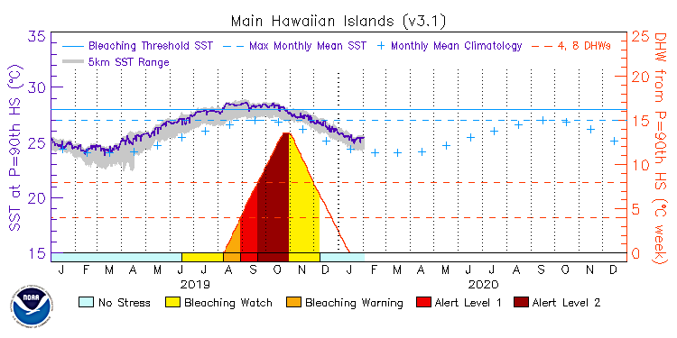Chl-a
* Irradiance
* Wave Power
* pH

Figure 2. NOAA Coral Reef Watch SST Multi-year graph for MHI 2019-2020. These are available by island. (<https://coralreefwatch.noaa.gov/satellite/vs/docs/list_vs_group_latlon_201103.php>)

Insert: graphs of each of the indicators over time by island. Include graphs with the major trophic guilds, functional diversity of herbivores, and

Insert: 2-4 maps of appropriate N-S-E-W coverage with smaller grain size and highlight sites with significant change.

Insert a table of change for each subregion deemed to be of appropriate scale for comparability. One good approach is by management status. Example: West Hawaii (Gove et al, 2019)

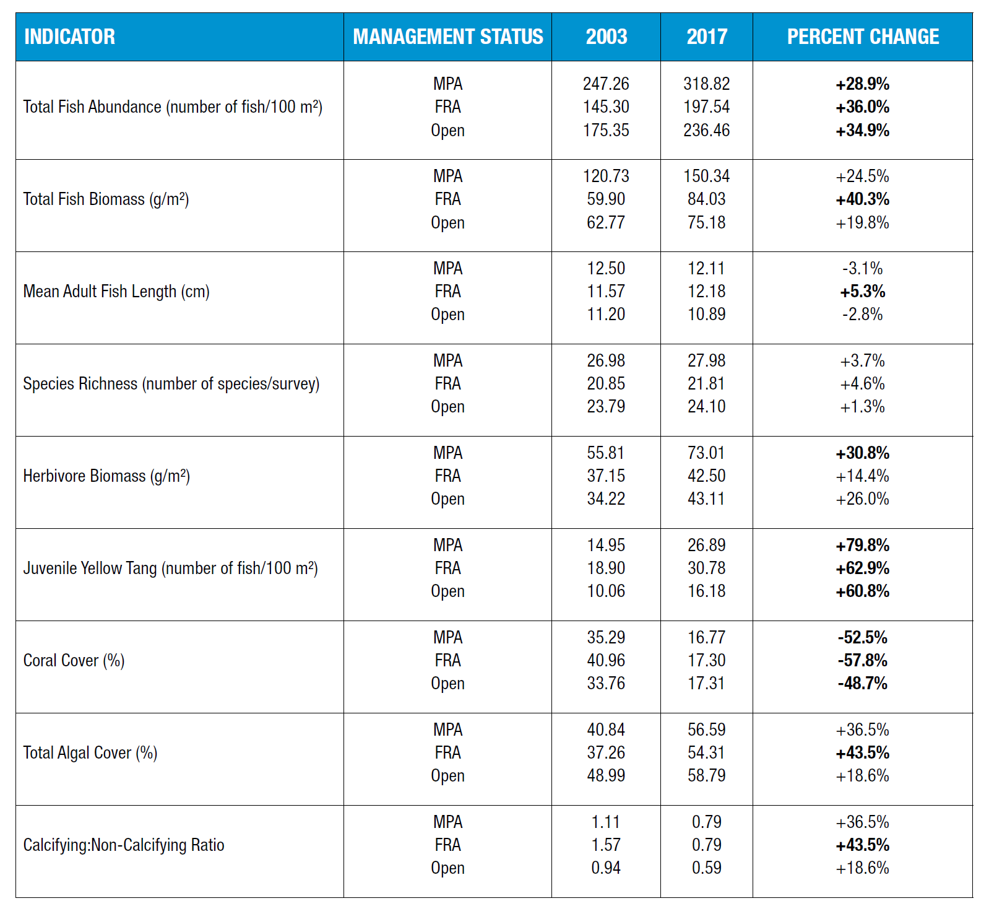

Discussion of data and any changes to the indicator. Include functional redundancy of herbivores and disturbances such as coral bleaching, storm events, and *Acanthaster planci* outbreaks.

The definition & rationale can be incorporated with the discussion or separately. Examples from Gove et al, 2019 (copied by permission):

Fish Data Indicators:

*Total Fish Biomass* – Total fish biomass conveys related but slightly different information compared to total fish abun­dance. Specifically, two reefs might have the same abundance but very different biomass estimates based on the size distribution of fishes in the assemblage. It is useful to consider biomass in addition to abundance because the ecologi­cal function or importance of fishes on a reef is often related to the size of fishes (see herbivore biomass description below). In addition, the status of the fishery is more directly related to fish population biomass rather than solely on the number of fish (Guillemot et al. 2014).

Total fish biomass, which is the body weight of the entire reef-fish assemblage per unit area, has increased in FRAs by nearly 40% since 2003 (Figure 2.1, *Total Biomass*; Table 1). Total biomass showed no significant change in MPAs or open areas over the same time period (Table 1). The most recent survey indicated that total fish biomass in MPAs was nearly 80% higher compared to FRAs and twice the biomass in open areas (Table 2).

*Total Abundance* – Fish density is a major factor determining the functional role and influence of reef fishes. Spatial and temporal variability in fish density is a product of numerous factors. For instance, fish abundance varies by habi­tat quality (Feary et al. 2007), environmental variability and its influence on population demography (i.e., recruitment and natural mortality) (Sale 2004), and fishing pressure (Friedlander & DeMartini 2002, Guillemot et al. 2014).

The total abundance of nearshore fishes has shown a positive trend in all management areas— MPAs, FRAs, and open areas—across West Hawai‘i since 2003 (Figure 2.1, Total Abundance). Total abundance has increased by 28.9%, 36.0%, and 34.9% in MPAs, FRAs, and open areas, respectively (Table 2.1). Total abundance of fishes differed based on management status. For example, the total abundance of fish in 2017 was greater in MPAs compared to FRAs and open areas by 61.4% and 34.8% (Table 2.2). An anomalous recruitment pulse was observed in 2014 across a number of locations in the state (Talbot 2014) and in West Hawai‘i (Walsh 2014). The recent increase in fish abundance observed across management areas may be attributed in part to high levels of recruitment in 2014.

*Species Richness* – Coral reefs are renowned for being one of the most diverse and complex ecosystems on the planet, providing important ecosystem services. The majority of tourists that visit Hawai‘i engage in marine-based activities, including diving and snorkeling (Beukering & Cesar 2004), and fish diversity is one amongst a variety of factors that drives visitor destination choice (Uyarra et al. 2005). In addition to the aesthetic value, biodiversity is intrinsically linked to ecosystem function, and greater species diversity supports more productive fisheries (Moberg & Folke 1999, McClanahan et al. 2011).

Species richness, or the total number of species present per survey, has not changed within each management area over the last 15 years (Figure 2.1, *Species Richness*; Table 2.1). As with other fish indicators, species richness in 2017 was greatest in MPAs compared to FRAs and open areas (Table 2.2). Note: visual surveys of reef fishes do not capture all species present in an area; therefore, the data here are considered a relative measure of species richness, which is one measure of biological diversity.

resource fish biomass, (no example from this study)

*Herbivore Biomass* – Herbivores (i.e., species for which plant material makes up a majority of their diet) comprise a large part of the fish community assemblage in Hawai‘i (Williams et al. 2015b). Herbivorous fishes are a key compo­nent and indicator of resilience. Resilience is defined as the ability of a reef to maintain or recover to a coral domi­nated state following disturbance and avoiding a phase-shift into algal dominance (Green & Bellwood 2009). Multiple anthropogenic drivers operating at various scales can undermine coral reef resilience, such as over-extraction of herbivores, pollution, and climate change. Of these, the diminished abundance of functionally important herbivores is one of the few drivers that is possible to ameliorate through local action.

Herbivore biomass, which represents the total weight of herbivorous fishes per unit area, increased by 30.8% in MPAs from 2003 to 2017 (Figure 2.1, *Herbivore Biomass*; Table 2.1). FRAs and open areas have shown no change in herbi­vore biomass over the same time period. Herbivore biomass was approximately 70% greater in MPAs over FRAs and open areas in the most recent survey (Table 2.2). Of note, herbivores in West Hawai‘i constitute roughly half of the total biomass in each of the management areas.

*Adult Fish Mean Length* – As fishing pressure increases, the average length of targeted species decreases (Ault et al. 2014, Nadon et al. 2015). This relationship exists because fishers tend to target large fishes, and because fishing mortality reduces the number of fishes that reach older and larger life stages. Previous work has found that reductions in mean length of the whole assemblage are indicative of a shift towards smaller species and/or smaller individuals of the same species, and that this can be driven by moderate levels of fishing pressure (Guillemot et al. 2014).

Adult fish length, or the mean length (cm) of mature fishes (i.e., fishes reaching ≥40% of their maximum length), increased by 5.3% in FRAs with no significant change in MPAs or open areas since 2003 (Figure 2.1, *Adult Fish Length*; Table 2.1). In terms of management status, adult fish length in 2017 was approximately 11% greater in MPAs and FRAs compared to open areas (Table 2.2).

Benthic Data Indicators:

*Hard Coral Cover* – The total cover of hard coral (Scleractinian) in a given area generally corresponds with the amount of reef topographic complexity, habitat structure, reef accretion, and diversity and abundance of coral-dependent species (McClanahan et al. 2011). Many reef-fish species are also heavily reliant on the availability of coral-dominated, structurally-complex areas, serving as the preferred habitat for fish recruitment and fish in juvenile stages (Walsh 1984).

The total cover of hard coral across West Hawai‘i was approximately 18% in 2017, representing a relative change of -52.5%, -57.8%, and -48.7% in MPAs, FRAs, and open areas since 2003, respectively (Figure 2.3, *Hard Coral Cover*; Table 2.1). Much of the coral loss can be attributed to a thermal stress event in 2015, when up to 90% of corals bleached across West Hawai‘i (Kramer et al. 2016 - see Section 3 for more detail on the thermal stress event). It is important to note that coral cover was as high as 80% in specific locations (e.g., Puakō) in the 1970s, indicating dra­matic losses in coral cover in at least some locations over the past 40–50 years (Minton et al. 2012, Walsh et al. 2018).

% resistant coral cover (no example from this study)

*Calcified to Non-calcified Ratio* – Foundational benthic organisms that contribute to coral reef development and per­sistence are calcifying, serving a number of key ecological processes, including settlement, recruitment, and cementa­tion of reef structure (Williams et al. 2015a). Fleshy algae directly compete with calcifying organisms for space, and in high abundance, can indicate a degraded ecological state (Hughes et al. 2010). The ratio of the combined cover of reef-building hard corals (Scleractinian) and calcifying algae (crustose coralline algae and Halimeda) to the combined cover of fleshy algae indicates benthic community dynamics and the extent to which a given system is dominated by reef-accreting benthic organisms.

In 2017, the ratio of calcified to non-calcified cover across West Hawai‘i was ≤1 (Figure 2.3, *Calcified to Non-calcified Ratio*). This threshold represents a relative dominance of non-calcifying benthic organisms. The relative dominance of reef builders to maintain net accretion is likely reef specific as oceanographic conditions, community structure, and local human impacts each play a role in overall reef growth. However, it seems logical that coral reef ecosystems with a greater abundance of reef builders will have higher rates of net reef growth and accretion compared to reefs dominated by non-calcifying organisms (Smith et al. 2016).

In lieu of copying the other indicator examples, Gove et al 2019 makes a pretty great template. I had left off sea level rise and rainfall from the tables for simplification, however they both impact turbidity and if you would like them added back in, that can be arranged.

Repeat for each island:

Kauai

Oahu

Maui

Molokai

Lanai

Kahoolawe

Hawaii

Thoughts?

I will leave the references for the final draft.

I have also spent an inordinate amount of time with some of the weblinks that no longer work because of recent changes to the federal websites. That still needs some tweaking.

Implications and Outlook

Management Needs

Implementation / Adaptive Management Course

Summary